Attorneys at Law


Erik M. Pelton PO Box 100637 Benjamin D. Pelton** Arlington, VA 22210
of counsel
®

Tel 703.525.8009 * NJ DC Bar
Fax 703.997.5349 ** VA DC & NY Bar

November 27, 2013

SENT VIA EMAIL TO TMFeedback@uspto.gov

Comments of Erik M. Pelton & Associates, PLLC® Regarding: “R quest for Comments: Post Registration Amendments to
Identifications of Goods and Services Due to Technology Evolution”

The following are comments of the law firm of Erik M. Pelton & Associates, PLLC® of Falls Church, Virginia (“EMP&A”), in response to the request for comments regarding post- registration amendments to identifications of goods and services due to technology evolution. Since 1999, EMP&A has represented hundreds of clients, including many small businesses, in
U.S. trademark prosecution, maintenance, and disputes. EMP&A clients have been issued nearly 2,000 U.S. trademark registrations. Erik M. Pelton, the firm’s founder, worked as a USPTO Examiner from 1997 to 1999.

Summary

Because of the significant benefits obtained from an accurate and reliable register and the

minimal burdens im identifications of go
osed on consumers and the USPTO, we support allowing amendments to ds and services in registrations based on changes in the manner or medium

by which products and services are offered for sale and provided to consumers.

Permitting a registrant to change the identification of goods of a registration from an outdated product to the current substitute product will not subvert the public policy objective of ensuring notice of the coverage afforded under a registration if: 1) the originally registered goods or services are no longer provided in connection with the mark, 2) the proposed amended goods or services have replaced the originally registered goods or services in the marketplace, 3) the buying public is likely to think that the replacement goods or services emanate from the same source as the originally registered goods or services, and 4) the changes are published in the Official Gazette.

Economic Value of an Accurate Trademark Register

Intellect
al property is a significant and growing component of the U.S. economy. It accounts for

an increasing percentage of jobs created in the U.S. as well as exports to other countries. According to President Obama: “Our single greatest asset is the innovation and the ingenuity and

creativit
of the Am
rican people. It is essential to our prosperity and it will only become more





so in this century” (March 11, 2010).

Trademark rights are no exception and the benefits of the trademark system extend beyond the right-holders themselves.
Registration of a trademark, in addition to serving the interests of the registrant by providing constructive notice, serves the interests of other participants in the

marketplace. Entrepreneurs, for example, who plan to promote and to sell a new product under a fanciful mark, should be able to rely on a search of the trademark registry and their own knowledge of whether the mark has been used so that what may be substantial expenditures of money promoting the mark will not be wasted. Consumers are also benefitted by the registration of national trademarks, because such registration helps to prevent confusion about the source of products sold under a trademark and to instill in consumers the confidence that inferior goods are not being passed off by use of a familiar trademark.
Natural Footwear Ltd. v. Hart, Schaffner & Marx, 760 F.2d 1383, 1395, 225 USPQ 1104, 1111- 12 (3d Cir.1985) (emphasis added) (citing Weiner King, Inc. v. The Wiener King Corp., 615 F.2d 512, 523-24, 204 USPQ 820, 830-31 (CCPA 1980)).

These benefits to registrants, entrepreneurs, and the public are predicated on the accuracy of the trademark register. In re International Flavors & Fragrances, Inc., 183 F. 3d 1361, 1368 (Fed. Cir. 1999) (“In order to make this constructive notice meaningful, the mark, as registered, must accurately reflect the way it is used in commerce so that someone who searches the registry for the mark, or a similar mark, will locate the registered mark.”). An accurate register of trademarks is one of the pillars of our intellectual property system. A register burdened with inaccuracies affects the selection and clearance of new marks, the prosecution of trademark applications, decisions about whether to initiate disputes, and other strategic decisions that extend far beyond the legal rights of any individual trademark registrant. As a result, an accurate register is absolutely essential, and failure to enact changes that would make the register more accurate would be a disservice to the public, trademark owners, and trademark applicants.

Maintaining an Accurate Register

An essential step toward ensuring the accuracy of the trademark register is the implementation of policies to efficiently rid the register of abandoned, improperly issued, or excessively broad registrations. Allowing amendments to identifications of goods and services in registrations based on changes in the manner or medium by which products and services are offered for sale and provided to consumers would help increase the register’s accuracy.

Under the current regime, if technological advancements necessitate a change in the medium through which a registrant’s goods or services are provided, the registrant has only two options, each of which create inaccuracies in the register. First, a registrant could abandon the obsolete registration and file a new application identifying the new mediums through which their goods or services are provided. This option could lead to deadwood because the original registration may remain on the register from the time originally registered goods or services are no longer being provided until it is abandoned.

Second, the registrant could disingenuously renew the obsolete registration with evidence generated for the sole purpose of filing a renewal in order to preserve its priority date even though the identified goods or services are no longer provided. This situation is worse than the former because it results in deadwood that remains in existence as long as the registrant chooses to falsely maintain it.

Under the proposed new regime, registrants would have the option to amend their registrations with changing technology to precisely reflect the goods and services they provide instead of abandoning or maintaining obsolete registrations and filing anew. This would reduce inaccuracies and gaps in the register.
The proposed new regime would also incentivize a more accurate register while saving registrants money. Because registrants could simply amend instead of renewing and filing anew, they would save money. These savings would provide an incentive for registrants to amend their registrations and keep them accurate instead of bloating the register with new registrations for the same marks.

Finally, the option to amend would eliminate gaps in the registration of marks that have been continuously used in the marketplace. Avoiding the need to file a new application to cover new goods or services that have replaced originally registered goods or services would enable registrations to reflect continuity of use of the relevant mark while eliminating any gaps in registration that would otherwise be created during the prosecution of new applications. The resulting increase in accuracy of the register would benefit all stakeholders.

Responses to Particular Inquiries

- Please identify your relevant background on this issue, including whether you are a trademark owner or practitioner, and the general size and nature of your business or trademark practice, including the number of trademark applications and registrations your business has, or your practice handles.
See above.

- Do you think the USPTO should allow amendments to identifications of goods/services in registrations based on changes in the manner or medium by which products and services are offered for sale and provided to consumers?
Yes, provided that the originally registered goods or services are no longer provided in connection with the mark, the proposed amended goods or services have replaced the originally
registered goods or services in the marketplace, the buying public is likely to think that the replacement goods or services emanate from the same source as the originally registered goods or services, and the amendments to the registration are published. See above and response (4) below.

- If such amendments are permitted, should they only be allowed post registration to account for changes in technology following registration, or should similar amendments be permitted in applications prior to registration (see 37 C.F.R. §2.71(a), stating that prior to registration, an applicant may clarify or limit, but not broaden, the identification)?
Similar amendments should be permitted in applications prior to registration, provided that the mark is republished, if applicable, after the change is applied.

- What type of showing should be required for such amendments? Should a special process be required to file such amendments, apart from a request for amendment under §7?
Four showings should be required:
  - The originally registered (or applied-for) goods or services are no longer provided in connection with the mark;
  - The proposed amended goods or services have replaced the originally registered goods or services;
  - Consumers are likely to think that the proposed amended goods or services emanate from the same source as the originally registered goods or services; and
  - The changes to the identification of goods or recitation of services are published in the Official Gazette.
A showing of these elements will ensure that: 1) continuity of good will is not broken, 2) consumers will not be confused as to the source of the amended goods or service, 3) the public has sufficient notice of the coverage afforded under a registration, and 4) the register will be more accurate than it is under the current regime.

- Should such amendments be limited to certain goods, services or fields (such as computer software, music, etc.), and if so, how should the determination be made as to which goods, services or fields?
The elements outlined in the response to (4) above eliminate the need to limit the contemplated amendments to certain goods, services, or fields.

- Should a distinction be made between products that have been phased out (such as eight-track tapes), as opposed to products for which the technology is evolving (such as on-line magazines), or should amendments be permitted for both categories of products?
The elements outlined in the response to (4) above eliminate the need to make a distinction between products that have been phased out, as opposed to products for which the technology is evolving.

- Do you believe the scope of protection in an identification of goods/services is expanded if an amendment is allowed to alter the medium of the goods/services?
The contemplated amendments will not substantively change or alter the scope of protection, provided that the elements outlined in the response to (4) above are satisfied. Specifically, if elements 1, 2, and 3 are satisfied, then the scope of protection, although changed, will not be
expanded or substantively changed.

- Would the original dates of use remain accurate if such amendments are permitted? Yes. However, new dates of use for the amended goods or services should be added to the registration certificate and online records to fully reflect the changes and history.

- What would the impact of such amendments be on the public policy objective of ensuring notice of the coverage afforded under a registration?
A showing of the elements outlined in the response to (4) above would ensure that the public has notice of the coverage afforded under the amended registrations. Element 4 specifically requires publication of the changes in the Official Gazette.

- Please provide any additional comments you may have.
None.

Conclusion

Applicants, potential applicants, and brand owners choosing new names and performing clearance searches benefit from the accuracy of the data available from the USPTO. Uncertainty is created whenever rights granted by the USPTO are overbroad, unclear, out of date, or inaccurate.

Permitting amendments to identifications of goods and services in registrations based on changes in the manner or medium by which products and services are offered for sale and provided to
consumers would help to create a more accurate register, encourage candor in submitting

specime
s, and simplify maintenance and policing. Applicants and registrants stand to benefit

from adoption of the proposed new regime because the register will be more accurate, and all legitimate stakeholders in the trademark system will benefit from a more accurate register. Therefore, we support adoption of the proposed allowance of amendments.

Thank you for the opportunity to comment. If you have any questions, please contact the undersigned at 703-525-8009.

Respectfully submitted,
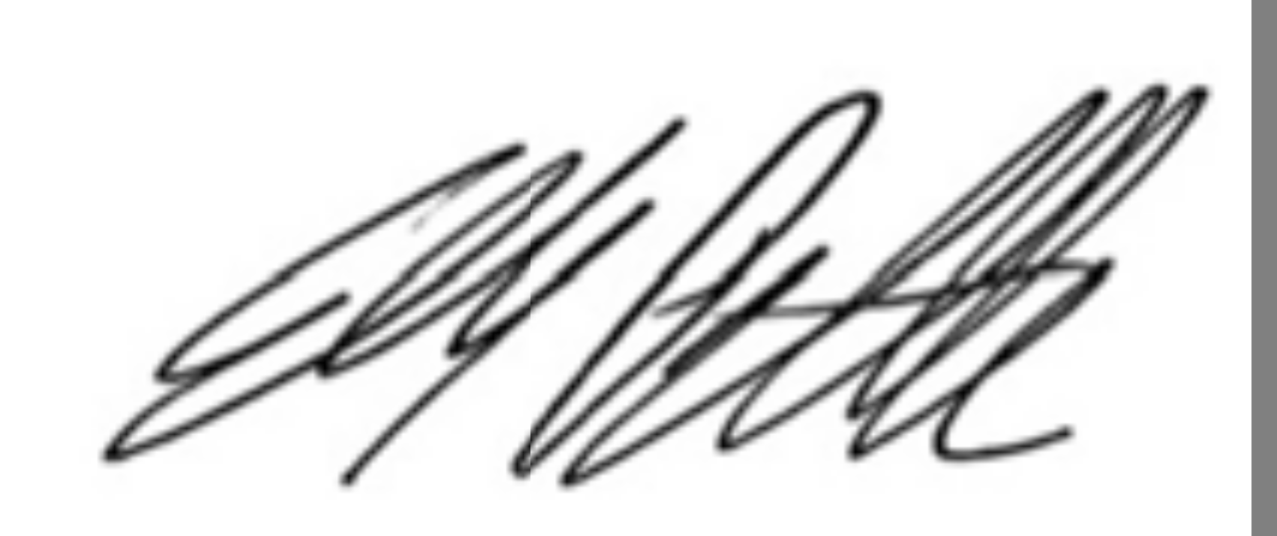
Erik M. Pelton
ERIK M. PELTON & ASSOCIATES, PLLC

