Introduction to the Trademark Policy Collaboration Tool (IdeaScale)
The United States Patent and Trademark Office (USPTO) uses the IdeaScale online collaboration tool to solicit input from its trademark stakeholder community on selected sections of the Trademark Manual of Examining Procedure (TMEP), Trademark Trial and Appeal Board Manual of Procedure (TBMP), as well as draft versions of policy guidance. IdeaScale allows users to:
- Post comments about individual TMEP and TBMP sections, suggest clarifications, and add examples of interpretations.
- Comment on draft policy guidance before it becomes official.
- Discuss and debate topics such as how to interpret recent court decisions.
- Comment and vote on ideas submitted by other community members.

How to Register

To use the trademark policy collaboration tool to comment on the TMEP and/or draft policy guidance, you must be registered with and logged on to the IdeaScale webpage at http://uspto-tmep.ideascale.com/. To comment on the TBMP, you must be registered with and logged on to the IdeaScale webpage at http://uspto-tbmp.ideascale.com/.
To register, click on the "Register" link in the upper-right corner of the webpage.
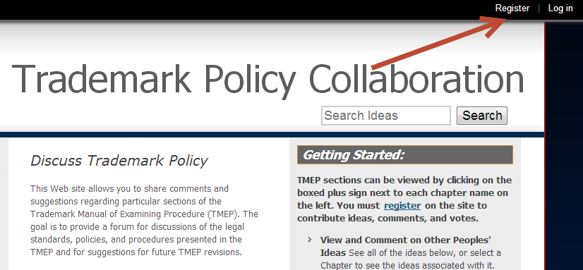
Enter your e-mail address, solve a simple math problem (for spam bot prevention), and agree to the Terms of Service by checking a box. Then click on "Register."

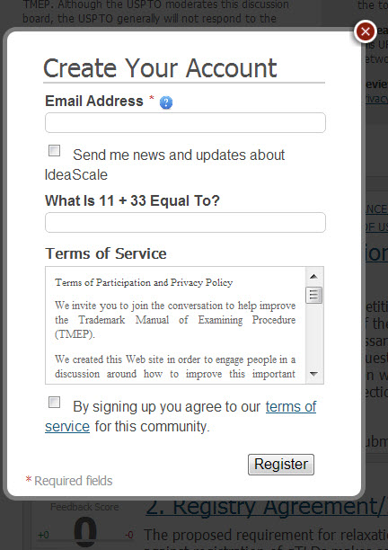

If registration is successful, the account creation box will disappear, and you will immediately receive the following notification at the top of the IdeaScale page.

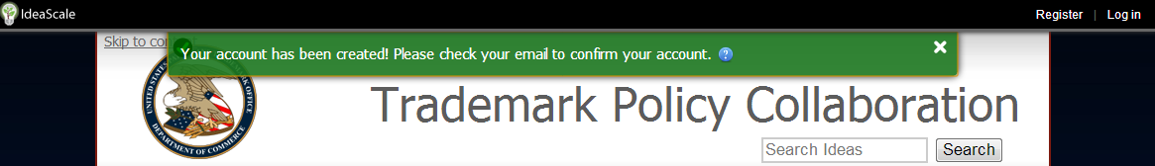

Shortly after completing the registration page, you will receive an e-mail verifying your account and allowing you to create a password. Check your e-mail for the confirmation. Please note that it may show up in your spam folder or in one of your secondary mail tabs. Click on the "Yes, this is my email!" link.

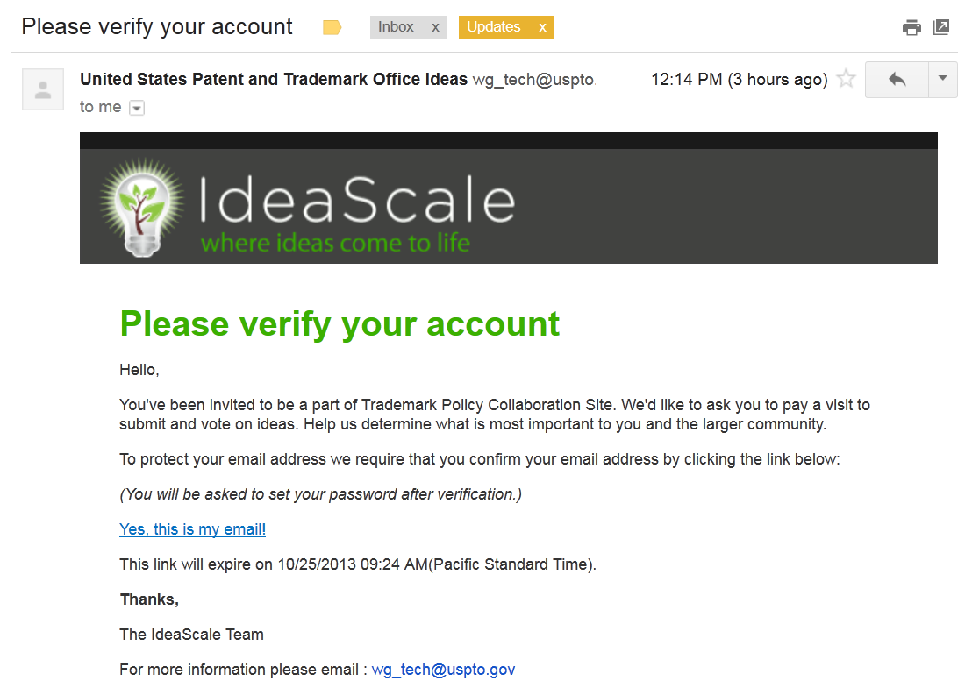

Once you click on the link, you will be taken back to IdeaScale. The system will then allow you to create a password and confirm the password. Your password must be at least 8-20 characters long and contain one or more of each of the following:
- Digits (0-9)
- Upper case letters
- Lower case letters
- Special characters (e.g., asterisks)
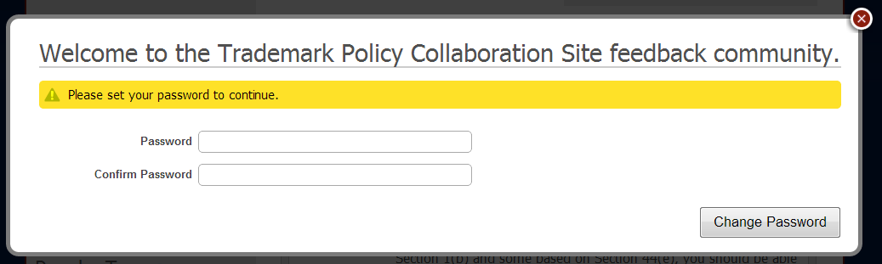

If your password is accepted, you will receive a pop-up message indicating that the password has been updated. Click "Continue."

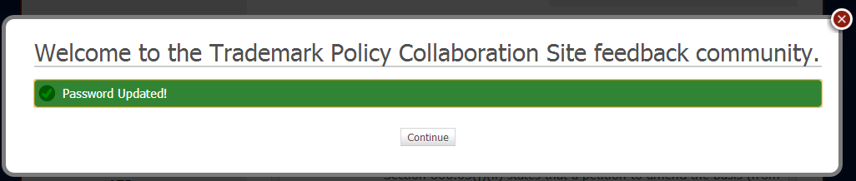

You are now ready to use the website. The next step is learning how to create ideas, comment, and vote.

Participating in the Community

On the left side of the webpage, you will see an “Active Campaigns” menu displaying the topics available for comment. Click on the plus symbol(s) next to the heading(s) to expand the menu and display the various subsections. To submit a new comment on a particular section, click on the “Submit New Idea” button above the menu and ensure that the correct section of the document is selected in the drop-down menu under “Campaign.” To submit a general comment about the document, select “General Comments” in the drop-down menu. If you click on one of the IdeaScale hyperlinks in the draft document, the appropriate section of the guide will be pre-selected in the drop-down menu.
If you would like to submit a test idea or test comment, you can try doing so at the "Discuss this Discussion Tool" link. Click on that link in the upper left corner of your window. Other topics that are currently being discussed are also visible in that region of the page.

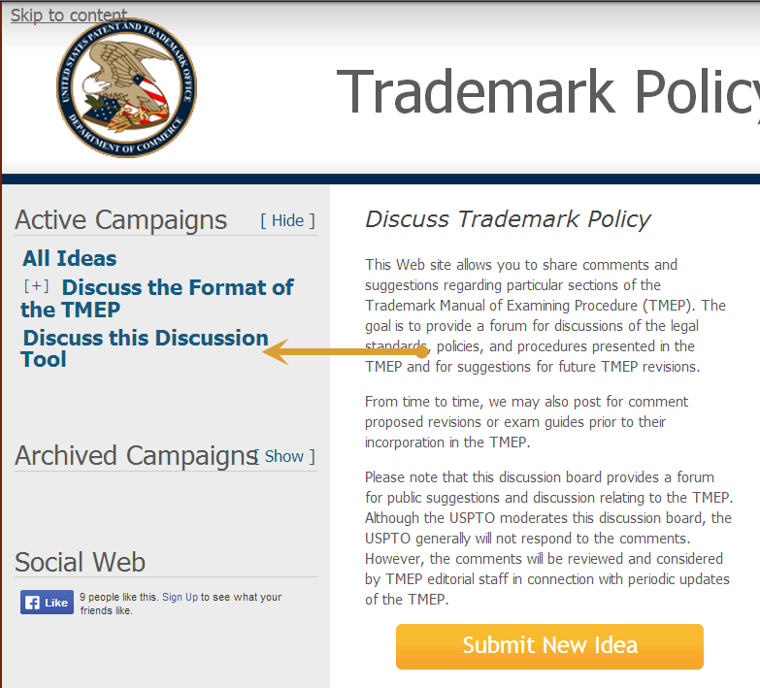

To create a new idea, click on the “Submit New Idea” button.
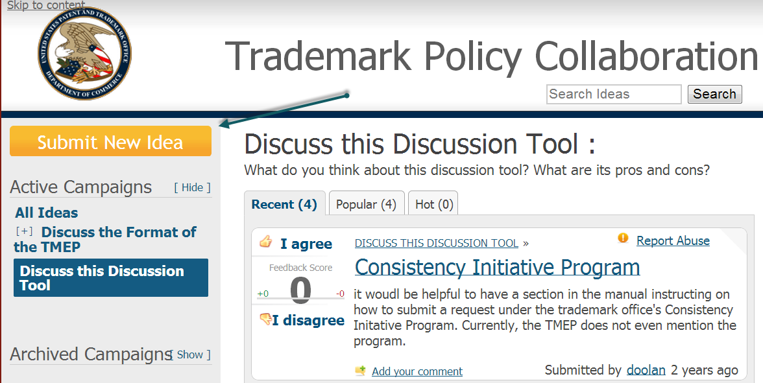

A box will pop up where you can enter the title of your idea and its content. As you type in the title of your comment, IdeaScale will automatically suggest potentially similar ideas to comment and vote on.
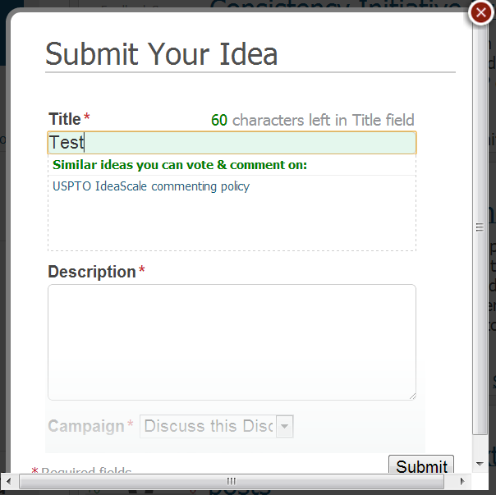

Fill in the "Description" field with the content of your comment. The "campaign" field will be filled in with the name of the campaign you're currently viewing, but it can be changed if you so desire. You will need to fill in the "Tags" field with the subtopic on which you would like to comment. The field will fill itself in as you type, though, so you should only need to type in the first few letters/numbers of the word before you will be able to select your tag. In the below example, the letters "Di" were entered and IdeaScale filled in the rest of the tag. All you have to do is click that suggestion and you are done.
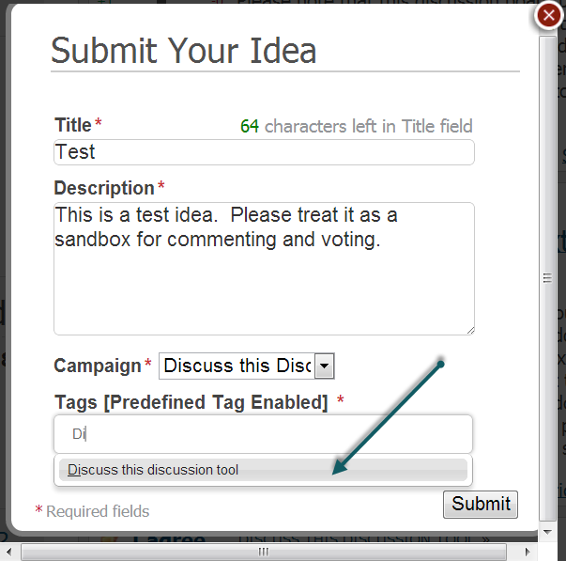

Once you are satisfied with what you have written, click "Submit" and it will be posted. If the posting is successful, you will get a confirmation message stating “Your idea has been submitted!” See the below screenshot.
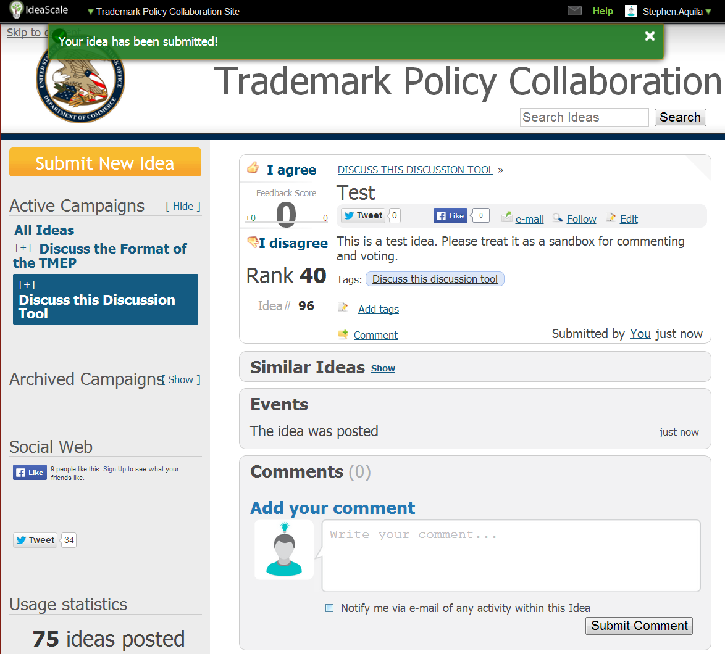

Besides posting your own ideas, you can also vote on the ideas of others. This allows you to register your approval or disapproval of the idea with one click, and it also helps the USPTO gauge how popular a suggestion is. If you would like to vote on an idea, just click the "I agree" or "I disagree" buttons next to the idea. Its score will change in real time according to how you vote.

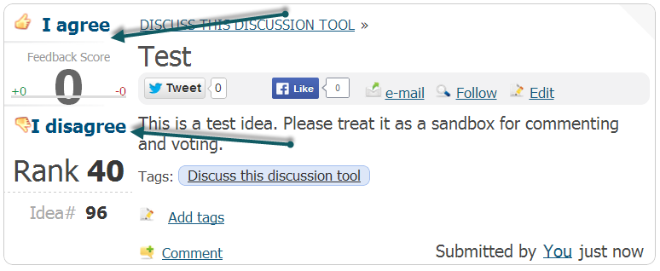

If you would like to leave a more detailed response than a simple up or down vote on an idea, you can leave a comment, instead. Commenting allows you to write more complex thoughts on a topic and bring up your own points or counterpoints. Choose an idea on which you'd like to comment and enter your text in the comment box below. Then, hit "Submit Comment."
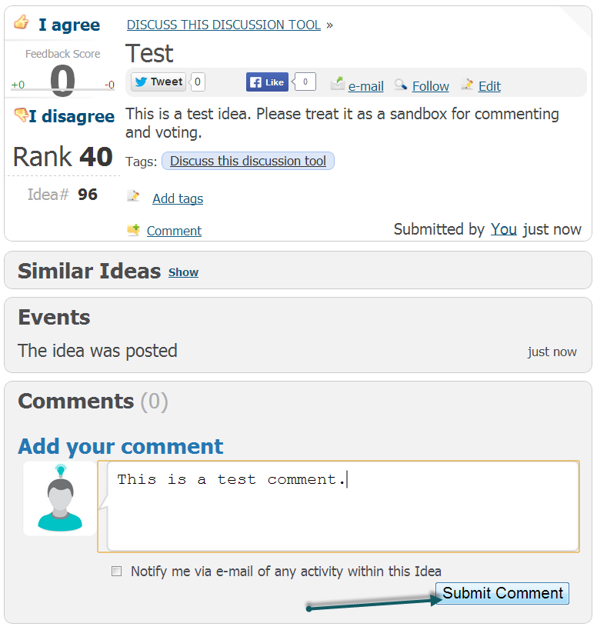

If your posting is successful, you'll see the comment appear below the idea like this. If you would like to vote on a comment, just click on the "thumbs-up" or "thumbs" down icons in that comment.

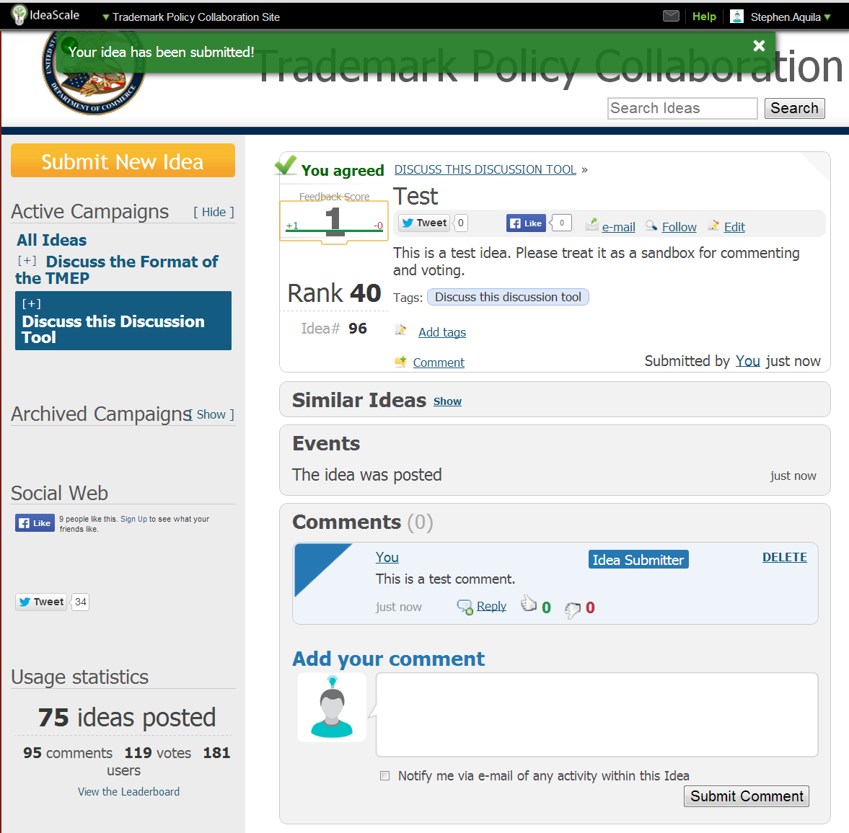

Contact Information

If you need assistance with this software, have trouble registering, see objectionable content, or have any other comments or questions, please contact the Trademark Legal Policy Office at TMPolicy@USPTO.GOV.

