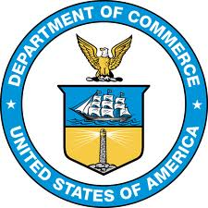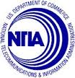

Green Paper Roundtable

With the help of the
Berkman Center for Internet & Society at Harvard University

June 25, 2014, 8:30 a.m. – 3:00 p.m.

Harvard University Law School
Wasserstein Hall
1585 Massachusetts Ave.
Cambridge, MA 02138

Webcast available at: http://video.isites.harvard.edu/liveVideo/liveView.do?name=uspto

8.30 – 9.00 Registration and administrative matters

9:00 – 9:15 Opening statements and introductions

9:15 – 10:15 The legal framework for the creation of remixes

Allan Adler—Association of American Publishers
Chris Brown—Brown & Rosen LLC
Kyle Courtney—Harvard University
Anne Gilliland—UNC Chapel Hill
David Herlihy—Northeastern University
Walter McDonough—Future of Music Coalition
Jay Rosenthal--NMPA

10:15 – 10:30 Contributions from observers at the event and online

10:30 – 11:00 Coffee Break

11:00 – 12:00 Statutory damages
George Borkowksi—RIAA
Ronald Coleman—Geotz Fitzpatrick
Jodie Griffin—Public Knowledge
Alan Harrison—IP Attorney
David Herlihy-- Northeastern University
Meg Kribble—American Association of Law Libraries
Jay Rosenthal—NMPA
Jason Schultz—NYU School of Law
Don Webber—Don Webber IP LLC

12:00 – 12:15 Contributions from observers at the event and online

12:15 – 1:15 LUNCH

1:15 – 2:30 The first sale doctrine in the digital environment

Allan Adler--Association of American Publishers
Kyle Courtney—Harvard University
Alan Harrison—IP Attorney
Meg Kribble—American Association of Law Libraries
Keith Kupferschmid—SIIA
David Newhoff—Writer, Filmmaker, Blogger of “Illusion of More”
Jason Schultz—NYU School of Law
Ben Sheffner, MPAA
Ed Shems, Graphic Artists Guild

2:30 -2:45 Contributions from observers at the event and online

2:45 – 3:00 Closing Remarks

