A REGISTRATION CERTIFICATE IS FOREVER*
How do you want to be remembered?

Like this?


Or like this?


Not everyone has a graphic artist on staff. But there are some easy steps you can take to vastly improve the visual quality of your mark as it appears on the Registration Certificate.

Tip Number 1: Consider using graphic design software widely available through most word processing programs.

Tip Number 2: If scanning the mark is unavoidable, use a high-quality original and scan at a high resolution. If at all possible, do not scan a photocopy of the drawing. The USPTO can shrink drawings to fit, but enlarging small images results in ugly, jagged, pixilated drawings.

High resolution scan, shrink-to-fit

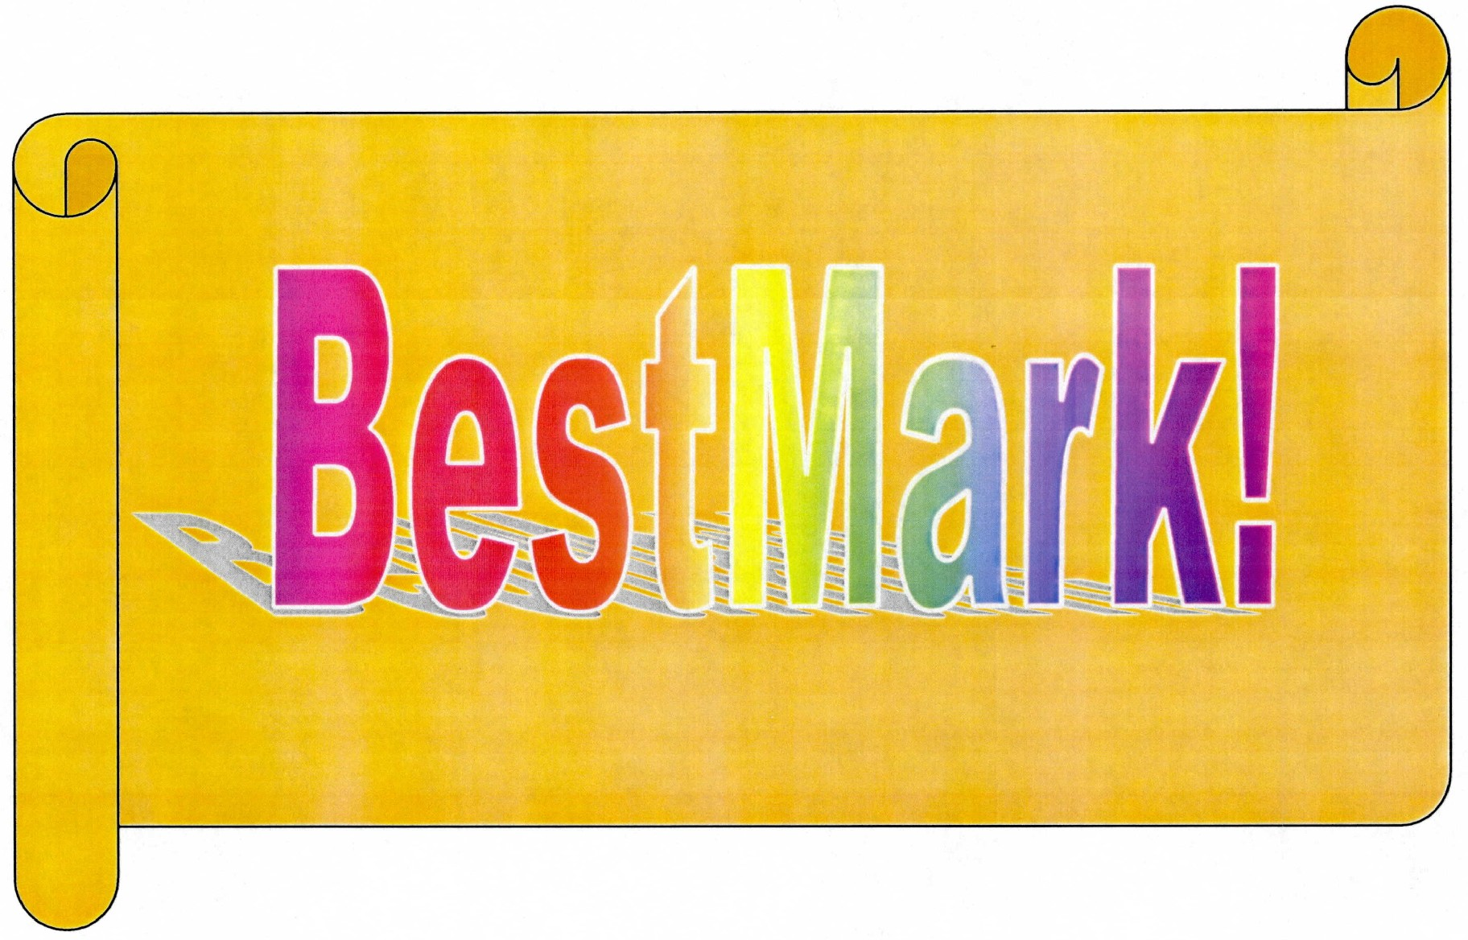

Low resolution scan, expanded-to-fit



Tip Number 3: Use your scanning software to crop, center, and adjust the scanned images properly, such that the mark image encompasses the entire JPEG view. Failure to do so may result in a drawing that is too small, off center, or inclusive of non-mark matter.
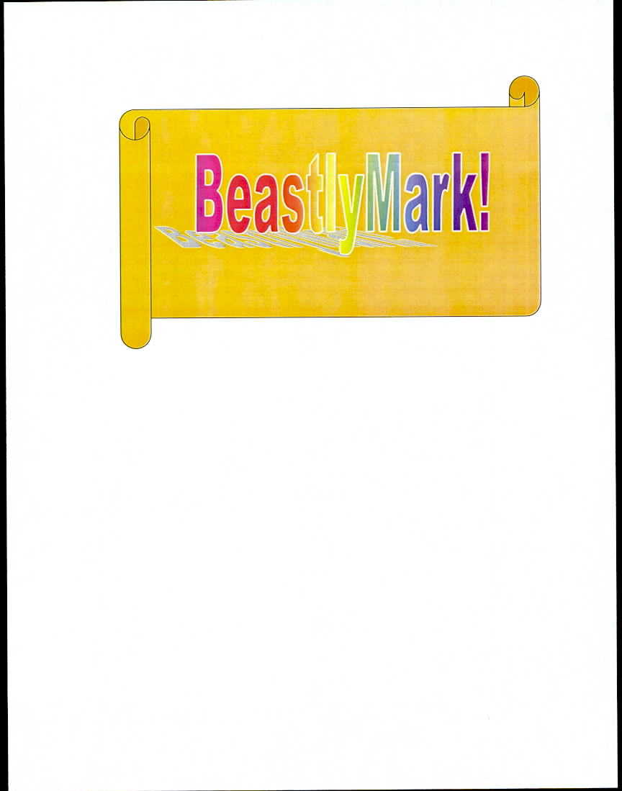

Uncropped drawing:
Note small size of mark, large amount of extraneous white space, and visible edges of paper

Tip Number 4: If at all possible, avoid using drawings transmitted via facsimile machines. Fax machines scan at a very low resolution, and the movement of paper across the scanning head often results in “artifacts” not meant to be part of the mark.

Tip Number 5: Use TEAS whenever possible! TEAS loads images directly to the USPTO databases without the error-producing steps of printing and scanning.

To recap: ►If possible, stay all-electronic

►If you must scan, use a high-quality original

►Scan at a high pixel count

►Use your scanning software to crop, resize, and otherwise adjust the image

►Avoid fax machines!

* As long as the registration is properly maintained. Be diligent in your filings!

