WEBCAST INSTRUCTIONS

Public Meeting on TTAB’s Notice of Proposed Rulemaking
June 24, 2016; 1:00 pm – 3:00 pm, ET
Global Intellectual Property Academy (GIPA)
Paris/Berne Rooms
Password: 1111
To watch the public session online using WebEx, please follow the instructions below.
- Click on https://uspto-events.webex.com/uspto-events/onstage/g.php?MTID=eeb8cb020faa140c6762a384a53c3a84e
- Once the event has been opened, sign-in using your first name, last name and email address and event password: 1111
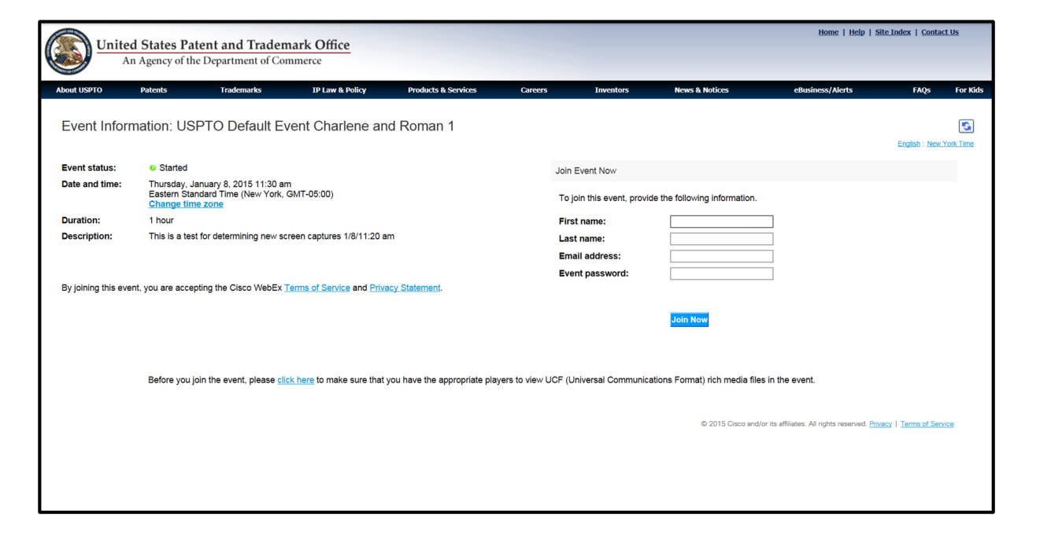
- Click on the “Join Now” button.

- You should see the “Starting WebEx” screen:

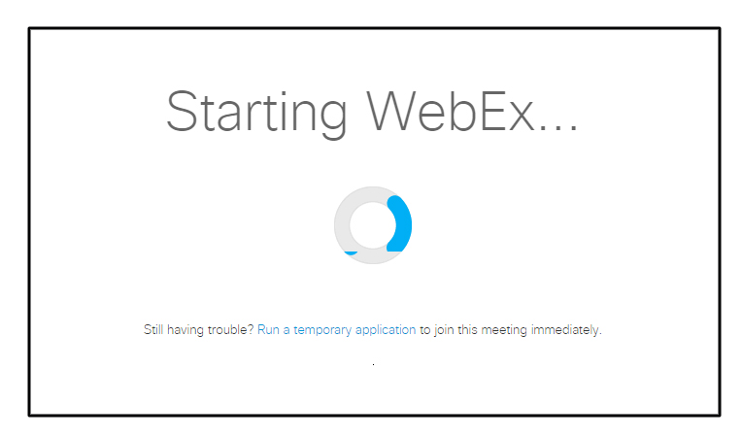

- You are in.

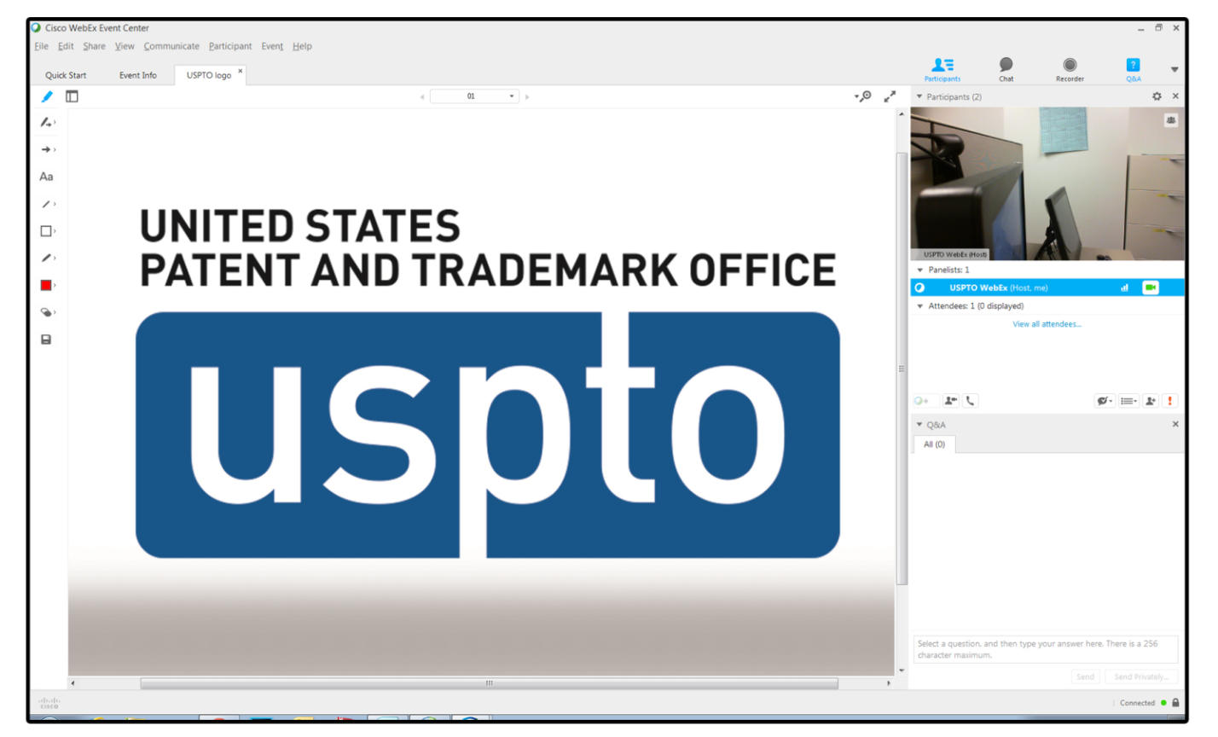

- Audio conference is Voice over IP (VOIP) only. Audio will be through your computer speakers.

- Type any questions for the panelists in the Chat box.

Assistance:
The playback of UCF (Universal Communications Format) rich media files requires appropriate players. To view this type of rich media files in the meeting, please check whether you have the players installed on your computer by going to https://uspto-events.webex.com/uspto-events/onstage/systemdiagnosis.php.

If you need assistance with login or if there is a problem with the webcast, please contact the OCIO Service Desk at 571-272-9000.

