CPM Workshop Materials

Sample Claim & Excerpt from Specification

Claim 1. A communication device comprising:
a housing;
a sensor disposed on a surface of the housing and responsive to a user macro-manipulation of the communication device to provide a sensor output, the sensor comprising carbon fiber strips disposed on the housing; and
a processor disposed within the housing, the processor operably responsive to receiving the sensor output to initiate a predefined communication associated with receipt of the sensor output.

Excerpt: Communication devices have become smaller with the advance of communication technology. For example, cellular telephone handsets have in recent years become increasingly smaller with a corresponding reduction in the size of the key pad buttons. Some cellular telephone handsets no longer include a numeric key pad and instead provide a liquid crystal display (LCD) touch screen interface for accepting user input. These traditional user input devices do not offer the user the opportunity to place a call from the handset silently and even in total darkness without looking at it, speaking to it or identifying and pressing one particular signal key.
A user of a communication device may initiate a communication, i.e., a telephone call, a text message, a page, an alert and the like, via a macro manipulation of the device, silently and in a clandestine manner without having to identify and activate a particularly button or sequence of buttons on the communication device. The communication device may include housing into which is disposed a sensor that is actuated by the user. An input from the sensor is associated with a particular communication context. Responsive to the input from the sensor, the communication device initiates the communication according to the define context.
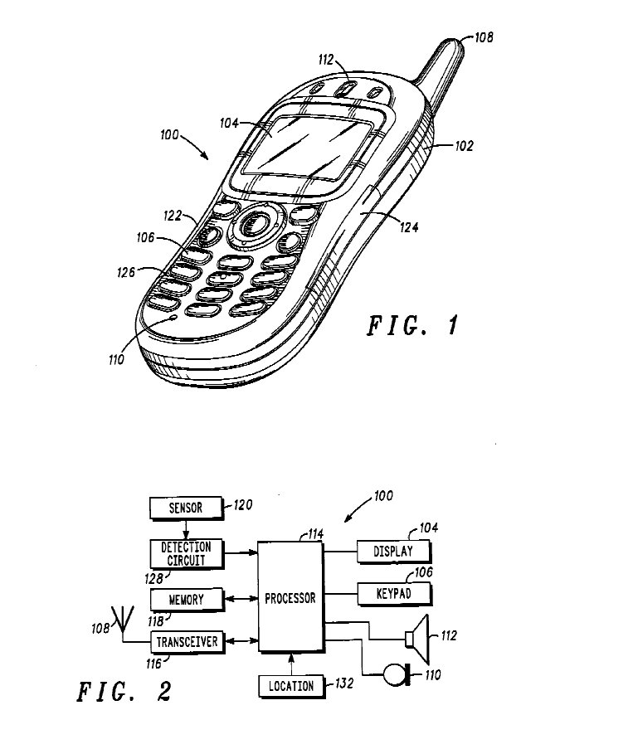

Prior Art:
Davis (U.S. Patent 6,292,674)
Naboulsi (U.S. PGPub 2004/0209594)
Kim (U.S. Patent 4,503,416)
Stein (U.S. Patent 5,404,067)

