New Private PAIR Enhancements | Quick  Start  Guide
eCommerce Modernization (eMod)

eCommerce Modernization Overview

eMod (eCommerce Modernization) is an exciting project to improve the electronic patent application process by modernizing its filing and viewing systems. This effort will enhance patent submission, review, and management processes by improving user interfaces, increasing functionality, and updating infrastructure. The purpose is to enrich the user experience by enabling more efficient system integration and expanding system usefulness.

Changes to Private PAIR
New Private PAIR features developed for the eMod Text Pilot Program include enhanced download methods on the IFW tab and for both the View Outgoing Correspondence and View e-Office Action Notification searches. The IFW tab, the View Outgoing Correspondence and e-Office Action Notification search result pages now include hyperlinks to download in PDF, and when available the corresponding DOCX and XML file. Download options for single, multiple, or all documents are also enhanced.

IFW Tab

- From the Private PAIR Select New Case page, the user can either search by Application Number under Search for Application or by Applications by Customer Number under Search by Customer Number to view the contents of the application.
- The user will select the IFW tab to view download options.
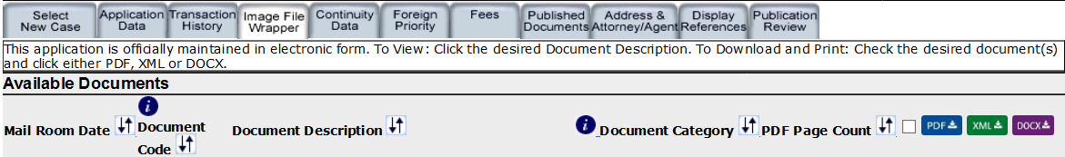
- On the right hand side of the screen, there are now two methods to download PDF, XML, and DOCX.
  - The user can select the 1-click PDF hyperlink to download a single PDF file. If the corresponding XML/DOCX file is available, an XML/DOCX hyperlink is displayed.
  - The user can also choose one, multiple or the Select All files option then click on the respective PDF/XML/DOCX download button option. When available, downloaded XML or DOCX files will be packaged in a zip file. Selecting the respective download button only downloads the corresponding file mime type. Please note that the XML and DOCX download button options displayed in the IFW tab are only active for applications associated to a customer number enrolled in the eMod Text Pilot Program and when XML/DOCX hyperlinks are present.
- If the application was originally filed with DOCX under a customer number in the Text Pilot Program and the correspondence address has since been changed to a customer number not enrolled in the Text Pilot Program or the pilot user removes the customer number from the Text Pilot Program, only the originally filed documents will be available in XML/DOCX.
- Any application associated to a customer number in the Text Pilot Program that has outgoing correspondence having DOCX/XML options will only display the PDF option following a correspondence address change to a customer number not enrolled in the pilot program.
- If the user views an application associated to a customer number that is not participating in the Text Pilot Program, the IFW tab search will only display PDF download options.
- During the eMod Text Pilot Program some of the submissions through EFS-Web may fail to generate the XML. The PDF and DOCX will continue to be created for review.

Outgoing Correspondence

- From the Private PAIR Select New Case page, the user will select the Search by Customer Number option and then View Outgoing Correspondence.
- The user will select the search parameters available, such as whether they want results for a single customer number or all customer numbers, the past number of days, how to sort the search results and then the user will select Search.

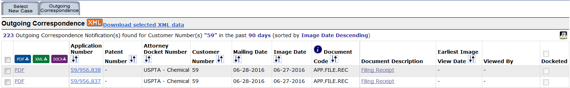

- Similar to the IFW tab but on the left hand side of the screen, there are now two methods to download PDF, XML, and DOCX.
  - The user can select the 1-click PDF hyperlink to download a single PDF file. If the corresponding XML/DOCX file is available, an XML/DOCX hyperlink is displayed.
  - The user can also choose one, multiple or the Select All option then click on the respective PDF/XML/DOCX download button option. When available, downloaded XML or DOCX files will be packaged in a zip file. Selecting the respective download button only downloads the corresponding file mime type. Please note that the XML and DOCX download button options displayed in the Outgoing Correspondence Search are only active for applications associated to a customer number enrolled in the eMod Text Pilot Program and when XML/DOCX hyperlinks are present.
- If the application was originally filed with DOCX under a customer number in the Text Pilot Program and the correspondence address has since been changed to a customer number not enrolled in the Text Pilot Program or the pilot user removes the customer number from the Text Pilot Program, only the originally filed documents will be available in XML/DOCX.
- If the pilot user removes the customer number from the Text Pilot Program, any applications with outgoing correspondence that previously displayed XML/DOCX will now only display PDF.
- If the user views outgoing correspondence belonging to a customer number that is not participating in the Text Pilot Program, the Outgoing Correspondence search will only display PDF download options.

e-Office Action Notifications

- From the Private PAIR Select New Case page, the user will select the Search by Customer Number option and then View e-Office Action Notifications.
- The user will select the search parameters, a Specific Date or provide a Date Range and how to sort the results and the user will select Search.

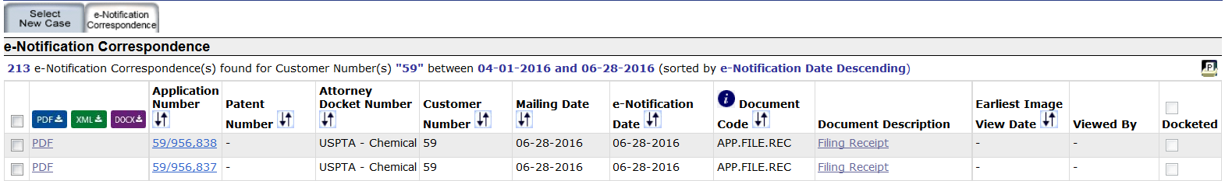
- Similar to the Outgoing Correspondence Search, on the left hand side of the screen, there are now two methods to download PDF, XML, and DOCX.
  - The user can select the 1-click PDF hyperlink to download a single PDF file. If the corresponding XML / DOCX file is available, an XML / DOCX hyperlink is displayed.
  - The user can also choose one, multiple or the Select All option then click on the respective PDF/XML/DOCX download button option. When available, downloaded XML or DOCX files will be packaged in a zip file. Selecting the respective download button only downloads the corresponding file mime type. Please note that the XML and DOCX download button options displayed in the e-Office Action Notification Search are only active for applications associated to a customer number enrolled in the eMod Text Pilot Program and when XML/DOCX hyperlinks are present.
- If the application was filed under a customer number in the Text Pilot Program and the correspondence address has since been changed to a customer number not currently enrolled in the Text Pilot Program, any e-notified correspondence that previously displayed XML/DOCX will now only display PDF.
- If the pilot user removes the customer number from the eMod Text Pilot Program, any applications with e-notified correspondence that previously displayed XML/DOCX will now only display PDF.
- If the user views correspondence belonging to a customer number that is not participating in the Text Pilot Program, the e-Notification search will only display PDF download options.

Questions and Support
If you have any questions, please contact the Patent Electronic Business Center (EBC) at 866-217-9197 (toll-free) or 571-272- 4100 from 6 a.m. to 12 Midnight Eastern Time, Monday - Friday or e-mail the EBC at ebc@uspto.gov.

