Quick Start Guide
Text Intake in EFS-Web

Contents
1. Introduction 3
2. Basic Requirements for Submitting Text in EFS-Web 3
3. Filing an Utility Nonprovisional Application including Text Documents 4
3.1 Initiating the filing process 4
3.2 Application Data 5
3.3 Attaching Documents 5
3.3.1 Attach Application Parts – Specification, Claims and Abstract 6
3.3.2 Attach Additional PDF or TXT Documents 8
3.4 Reviewing .docx Documents 8
3.5 Calculate Fees 9
3.6 Confirm & Submit 10
3.7 Save Submission Feature for Registered eFilers 11
4. eMod Text Pilot Program Guidelines 14

Introduction

This Quick Start Guide provides information needed to understand how to file .docx documents and includes a brief overview of the process and screen shots that identify critical aspects of the submission.

eMod (eCommerce Modernization) Text Pilot Program participants will be able to submit and receive text via EFS-Web and Private PAIR. During the eMod Text Pilot Program, the existing electronic patent application filing and viewing tools, EFS-Web and Private PAIR, will be leveraged to learn about the text usage to include into Patent Center. The goal of the eMod Text Pilot Program is to have applicants utilize new features to file patent applications (specifically specification, claims and abstract for new utility applications) in text, and provide feedback to the eMod Team for further improvements. eMod Text Pilot Program guidelines are provided at the end of this document.

A more comprehensive guide on how to use EFS-Web can be found at the EFS-Web Guidance and Resources page located at: http://www.uspto.gov/patents-application-process/applying-online/efs-web-guidance-and-resources.

Additional information concerning the eMod Text Pilot Program, including instructions on how to sign up to participate in this and future USPTO pilot efforts, may be found at http://www.uspto.gov/patent/emod.

Basic Requirements for Submitting Text in EFS-Web

- You must be able to access EFS-Web.

- You must be a Registered eFiler who has opted in to the eMod Text Pilot Program via Customer Number. Registered eFilers may save a submission as a work-in-progress for up to 7 days.

- The text intake feature is only available for new Utility Nonprovisional submissions. It is currently unavailable for all other submission types.

- All required fields must be completed in order to proceed with the submission. The required fields are indicated with an asterisk.

- Submissions under a Secrecy Order may not be filed electronically.

NOTE: EFS-Web sessions will time-out after one hour of inactivity. A Web-based ADS that has not been submitted or saved after one hour of inactivity will be lost. You will need to login to EFS-Web again and re-enter the information from the start.

Filing an Utility Nonprovisional Application including Text Documents

Initiating the filing process
Once you have signed on to EFS-Web as a Registered eFiler, you will need to certify that you are the certificate holder or working under the authority of the certificate holder. Registered eFilers who authenticate can save “In-progress” submissions and return to make edits prior to completing the submission, but any required payment will be due upon filing of the completed submission.

To submit a new utility nonprovisional application via EFS-Web select the “New application/Proceeding” radio button, the Web screen will then expand to display additional options. Select the radio button for Utility and then the radio button located next to “Nonprovisional Application under 35 USC 111(a)” and click Continue.

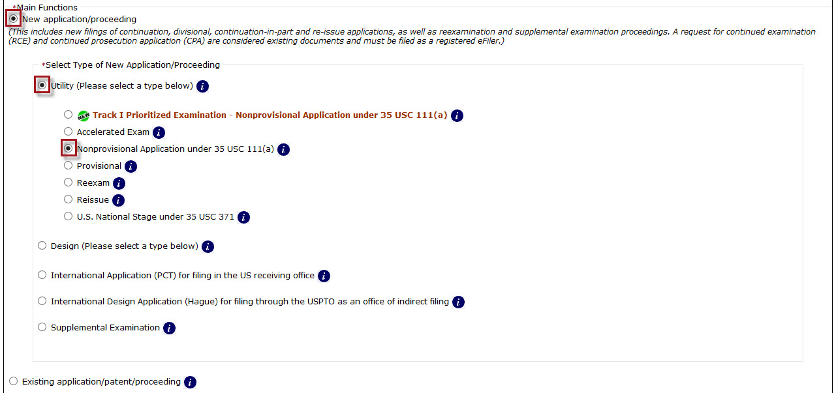

Application Data

On the Application Data tab, you must specify the title of your invention, the first named inventor, and a correspondence address. To take advantage of the new text intake functionality, the entered correspondence address MUST be a customer number which has been opted in to the eMod Text Pilot Program. The selected/entered customer number must also be associated to the PKI certificate used to access EFS-Web Registered.

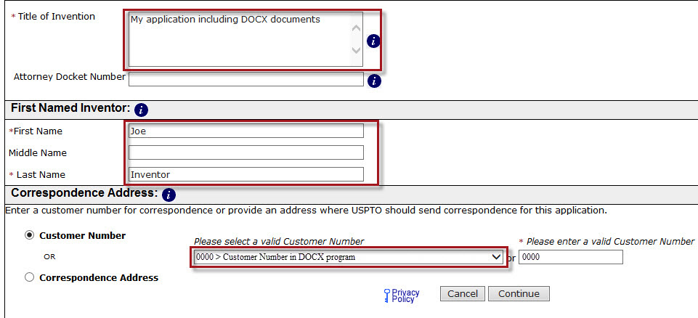

NOTE: If a customer number that has been opted in to the eMod Text Pilot Program is manually entered as the correspondence address but is not associated to the PKI certificate used to login, the ability to attach text documents to your filing will not be available.

If you need to make any corrections, you can go back to the Application Data screen by clicking on the Application Data tab at the top of the screen. You may also click the “Application Data” hyperlink above the displayed Bibliographic Data. After making any corrections, you must click on the Continue button located at the bottom of the “Application Data” screen in order to apply any changes.

Attaching Documents

On the “Attach Documents” screen, you can upload documents for a utility nonprovisional application filing. The “Attach Documents” screen has two different sections for attaching documents: (1) “Attach Application Parts – Specification, Claims and Abstract;” and (2) “Attach Additional PDF or TXT Documents.” These sections are discussed in detail below.

Attach Application Parts – Specification, Claims and Abstract

Application Parts (specifically Specification, Claims, and Abstract) may be submitted in text format as a part of the eMod Text Pilot Program. At this time, these documents must be attached individually, for the Specification, Claims, and Abstract. The recommended order of the sections is listed above.

Technical requirements for .docx files are as follows. A word processor that can create and save Office Open XML (docx):

- Microsoft Word 2007 or higher
- Google Docs
- Office Online
- LibreOffice
- Pages for Mac

The procedure for attaching .docx documents via the “Attach Application Parts – Specification, Claims and Abstract” is as follows:

- Step 1: Click on the “Add File” button and a file search field will be made available.
- Step 2: Click the “Browse” button to search your computer for the document to be uploaded. Note: it might be beneficial to use a file name representative of the document being uploaded (e.g., “Specification.docx” for a .docx file containing specification information).

Additional documents may be attached by clicking the “Add File” button. You will need to repeat Steps 1 and 2 for each document being attached.

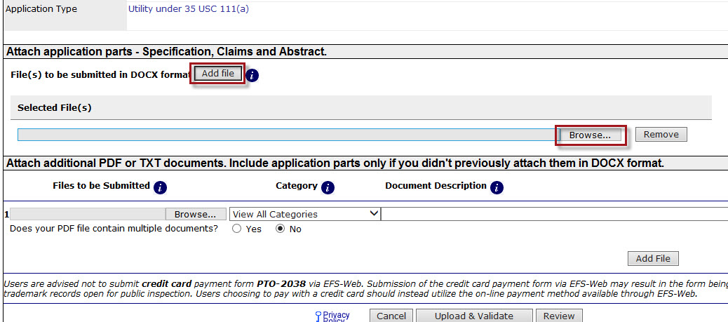

Attach Additional PDF or TXT Documents

The “Attach Additional PDF or TXT Documents” section is used for attaching documents other than text documents, such as the “Application Data Sheet” (AIA/14 form) and any additional application documents needed for the Utility Nonprovisional filing. Legacy text documents, such as sequence listing and tables may still be attached in this section.

The procedure for attaching documents via the “Attach Additional PDF or TXT Documents” is as follows:

- Step 1: Click on the “Browse/Choose File” button to search your computer for the document to be uploaded. Note: it might be beneficial to use a file name representative of the document being uploaded (e.g., “Jones.pdf” for a copy of a document authored by Jones).
- Step 2: Once the document is uploaded, you will need to index it correctly. The “Category” drop down menu allows document descriptions to be narrowed down based on file being attached. The “Document Description” drop down menu represents how the document will be indexed once submitted.

Additional documents may be attached by clicking the “Add File” button. You will need to repeat Steps 1 and 2 for each document being attached.

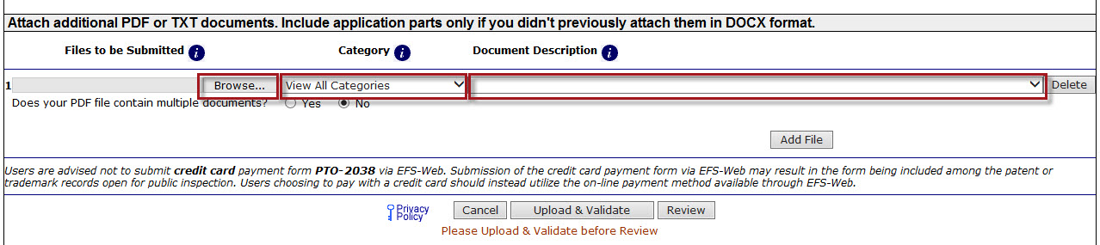

After all application documents have been attached click the “Upload & Validate” button to perform document validations and proceed with the filing process.

Reviewing .docx Documents

On the “Review Documents” screen, confirm that all of the necessary documents uploaded properly. If you receive any validation errors you will not be able to proceed to the next screen until the errors are fixed. However, you will be able to proceed to the next screen if you receive any validation warnings.

The following items within a document will generate a warning message, viewable at the time of upload and on the acknowledgement receipt:

- Track changes*
- Comments*
- Bookmarks*
- Hidden Items*
- Continuous line numbering*
- Text decorations*
- Unused invalid fonts*
- Unnecessary document properties*
- Abstract word count over 150
- Unsupported OLE Objects (Supported OLE Objects include Visio.Drawing.11, Equation.DSMT4, ACD.ChemSketch.20, ChemDraw.Document.6.0, Equation.3)

An asterisk indicates the system will automatically make changes to the document. Please review the generated files prior to submission as stated in the “eMod Text Pilot Program Guidelines.”

The following items will generate an error message and you will not be able to continue unless it is corrected:

- Duplicate application parts
- Invalid Page Size – cannot exceed Letter or A4
- Contains Content control
- Contains Custom XML
- Invalid font

Recommended fonts include:
- Georgia
- Times New Roman
- Arial
- Arial Black
- Arial Narrow
- Arial Rounded MT Bold
- Tahoma
- Verdana
- Trebuchet MS
- Courier New
- Calibri

International Fonts:
- PMingLiU,
- SimSun
- MS Mincho
- Batang

A feedback document is generated when applicable to show where any warnings or errors are located within the document. Please note that the feedback document is only available during the submission process, and will not be saved to or shown within Private Pair.

Attached .docx file(s) will create a PDF equivalent which will be displayed for review.

Calculate Fees

The “Calculate Fees” screen allows eFilers to select the appropriate entity status in the top left hand corner of the screen. In addition, fees are dynamically generated based on the values entered. After all applicable fees have been selected and/or entered, click the “Calculate” button to display the “Total Fees Due.” After verifying selected fees, click “Continue” to proceed to the next section.

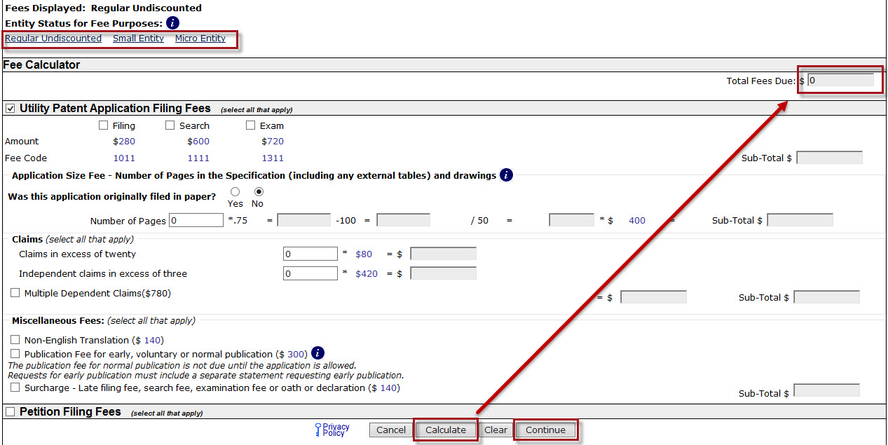

Confirm & Submit

On the “Confirm & Submit” screen, you will be presented with a review of the content provided for the utility nonprovisional application including text submission. This will include all information entered on the “Application Data” screen, the fee(s) indicated on the “Calculate Fees” screen, as well as documents uploaded on the “Attach Documents” screen.
Ensure Bibliographic Data is correct; all documents have been attached; then click on the “Submit” button once.

Save Submission Feature for Registered eFilers

You have the option of saving the submission for later as a Registered eFiler. All of the required ADS fields on the “Application Data” tab must be completed. The save option is located on the “Confirm & Submit” screen.

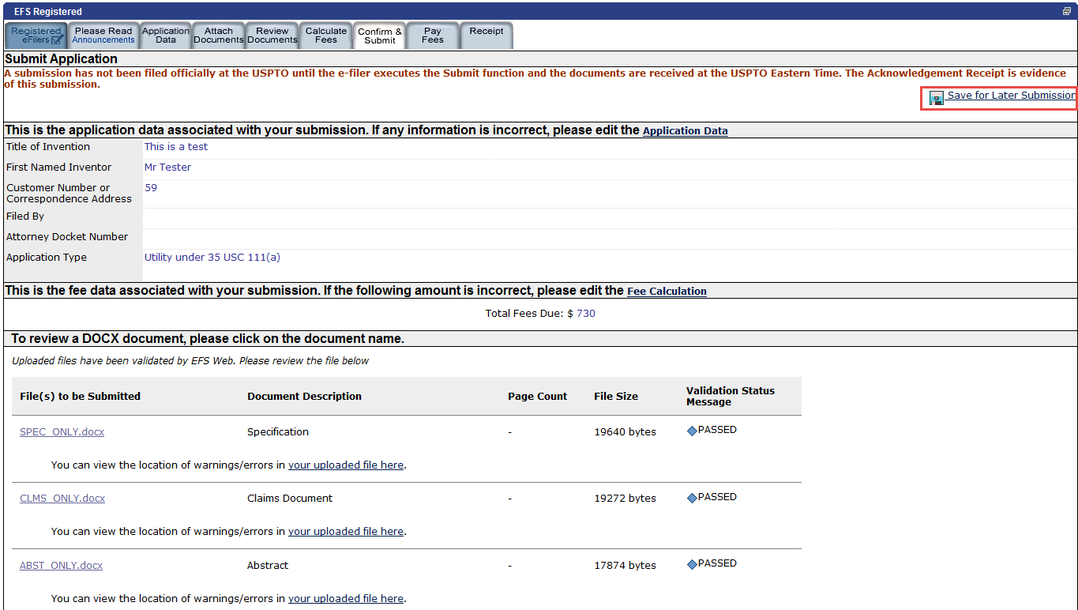
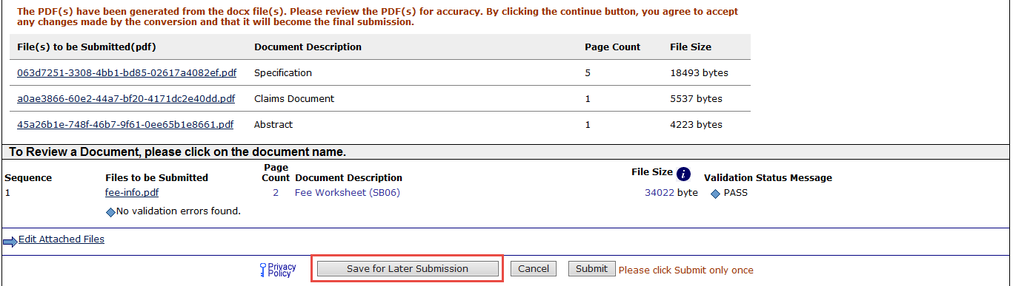
After clicking on the “Save for Later” button, the next screen will display the details of the saved submission. There is a notification statement that explains that the submission has not been filed officially at the USPTO until the Submit function is executed. A statement at the bottom of the screen details that the submission will be saved for up to 7 days.

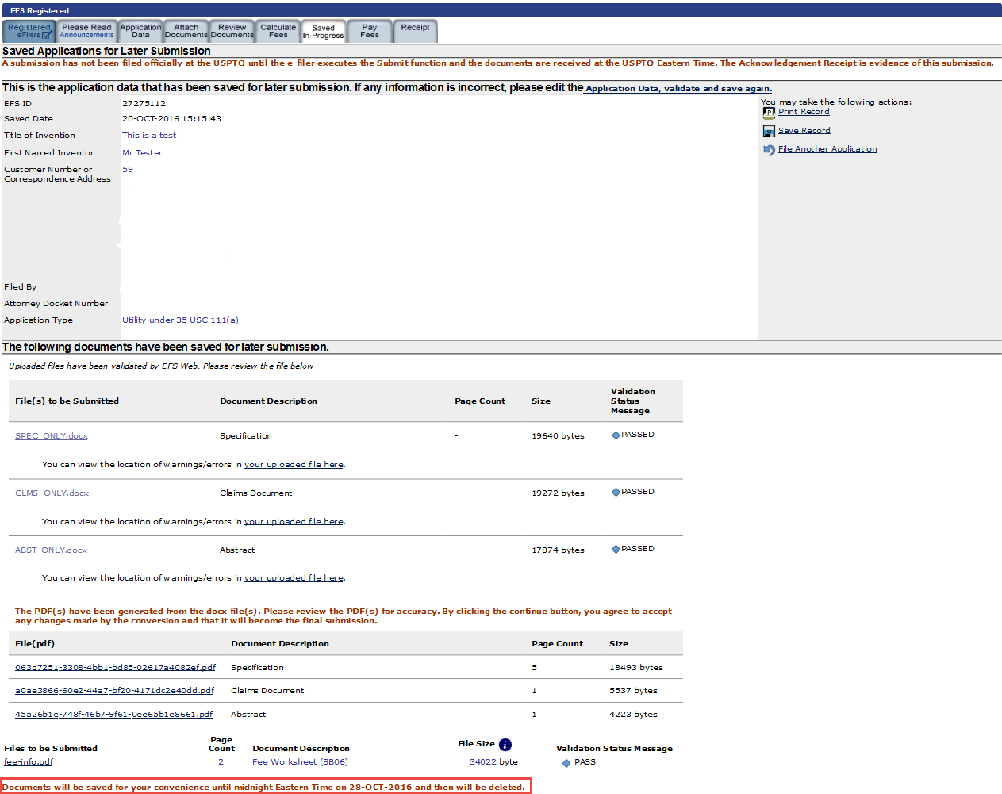

In order to later retrieve your saved submission package, you must log in to EFS-Web as a Registered eFiler. On the EFS-Web page you must select “My Workplace” and then click on the “Saved Submission Package” link. Next, select “My Saved Packages” and click on the drop down menu to select an eFiler and click on the “Retrieve” button. This will retrieve your saved submission packages. Fill in the radio button under “Select” in order to choose the particular saved submission package and click the “Continue” button.

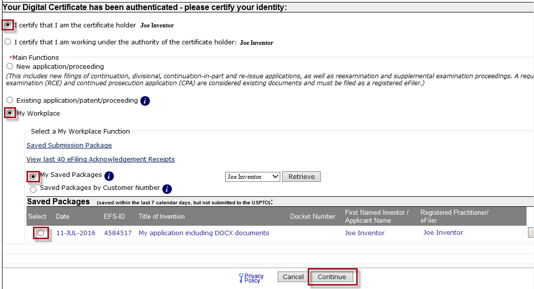

If you have any questions or concerns regarding filing in EFS-Web, please contact the Patent EBC Monday - Friday, from 6:00 a.m. to 12 Midnight Eastern Time, by email ebc@uspto.gov or telephone 866-217-9197.

eMod Text Pilot Program Guidelines

By agreeing to participate in the eMod Text Pilot Program, participants are expected to follow the guidelines defined below. Participants who do not abide by these guidelines may be removed from the eMod Text Pilot Program.

- Participants are encouraged to submit .docx documents for new utility applications. Docx application parts are limited to the Specification, Claims, and Abstract for the first phase of the eMod Text Pilot Program. All other applications parts will be submitted as .pdf. Please refrain from submitting both .docx and .pdf for the same documents associated with application parts listed above.
- Participants have the responsibility of reviewing all documents prior to final submission.
- Participants understand that the .docx requirements are still the same as the current efiling and paper filing requirements listed in the MPEP.
- Participants understand that the Text functionality used during the eMod Text Pilot Program is experimental.
- Participants agree to use the Text features frequently during the eMod Text Pilot Program.
- Participants are aware that they have the ability to opt-in or opt-out of the eMod Text Pilot Program at any time for any discrete action, but are strongly encouraged to maintain their opt-in status during the pilot phase.
- Participants are aware that if they opt-out of the eMod Text Pilot Program that they will not be automatically re-enrolled upon request.
- Participants agree to receive training prior to and/or during the eMod Text Pilot Program.
- Training materials, Quick Start Guides and EBC support will be made available for how to file in .docx in the eMod Text Pilot Program.
- Participants understand that eMod Text Pilot Program incentives will only be available for customer numbers participating in the pilot program including filing .docx and receiving Office actions in structured text. If the customer number is removed from the pilot program after filing .docx, the Office actions will be available only in .pdf.
- Participants understand that once they have approved and submitted a generated PDF, that PDF will replace all previously submitted .docx and become the final submission.
- Participants understand that the original word documents attached in EFS-Web, prior to the system check, will be saved for the eMod team to study so future enhancements can be implemented. These documents will be saved for up to 6 months, or until no longer needed for Agency/IT administrative purposes, whichever is sooner.
- Participants are urged to complete actions using Text functionality in the same way the existing EFS-Web and PAIR systems features have been used, and to note that use of the electronic filing and viewing systems will not change any statutory requirements.
- Participants agree to fill out and submit the “eMod Text Pilot Program Report Form” via email, as provided by the USPTO eCommerce Modernization project team, to document errors, problems, or questions during the pilot program period.
- Participants understand that any discrepancies should be brought to the attention of the USPTO eCommerce Modernization project team for investigation.
- Participants agree to participate in a survey, as provided by the USPTO eCommerce Modernization project team, to document the overall user experience during the pilot program period.
- Participants in the eMod Text Pilot Program will have priority for participation in the upcoming Patent Center Beta Program, which is soon to be announced.

Thank you for your interest in participating in this exciting USPTO eMod Project to enhance the patent submission and review processes for applicants, by leveraging text.

