International Design Application (Hague)

Quick Start Guide April 22, 2017

Quick Start Guide
International Design Application (Hague) for filing through the USPTO as an office of indirect filing

Entity Status Change

Quick Start Guide

Quick Start Guide

Contents
- Introduction 3
- Basic Guidelines for Filing an International Design Application Through the USPTO 3
- Filing an International Design Application Through the USPTO 4
  - Signing-On to EFS-Web 4
    - Registered eFiler 4
    - Unregistered eFiler 6
  - Entering Data for an International Design Application 7
    - Title of Invention 8
    - Attorney Docket Number 8
    - Applicant Name 8
    - Correspondence Address 9
  - Attaching Documents 11
    - Attaching Documents other than Reproductions 11
    - Attaching Reproductions 12
  - Review Documents 14
  - Calculate Fees 15
  - Confirm and Submit 19
  - Pay Fees 20
  - Acknowledgement Receipt 20
  - Save Submission Feature for Registered eFilers 21
  - Follow-On Submissions 23

Quick Start Guide

Introduction

This guide is for submitting international design applications through the USPTO via EFS-Web. For general information on submitting applications electronically via EFS-Web please review the EFS- Web Quick Start Guide located at http://www.uspto.gov/patents/process/file/efs/guidance/EFS- WebQuickStartGuide.pdf

The Geneva Act of the Hague Agreement Concerning the International Registration of Industrial Designs (“Hague Agreement”) allows applicants to apply for protection for up to 100 designs in the Contracting Parties to the Hague Agreement by filing a single standardized international design application in a single language. The international design application may be filed indirectly through the office of the applicant’s Contracting Party or directly with the International Bureau. To file an international design application through the USPTO as an office of indirect filing, the applicant, or each applicant if there is more than one applicant, must be a national of the United States or have a domicile, a habitual residence, or a real and effective industrial or commercial establishment in the United States. In addition, the applicant, or each applicant if there is more than one applicant, must indicate the United States as their Contracting Party.

This Quick Start Guide will provide you with the information you need in order to rapidly understand how to file an international design application through the USPTO as an office of indirect filing, including a brief overview of the process and screen shots that identify critical aspects of the submission process.

A more comprehensive guide on how to use EFS-Web can be found at the EFS-Web Guidance and Resources page located at: http://www.uspto.gov/patents-application-process/applying- online/efs-web-guidance-and-resources.

Additional information concerning the Hague Agreement, including a list of countries that are Contracting Parties to the Hague Agreement, can be found on the website of the World Intellectual Property Organization (WIPO) at http://www.wipo.int/hague/en/. In addition, a resource page for international design applications can be found on the website of the USPTO at: http://www.uspto.gov/patent/initiatives/hague-agreement-concerning-international-registration- industrial-designs.

Basic Guidelines for Filing an International Design Application Through the USPTO

  - You must be able to access EFS-Web.

  - The radio button “International Design Application (Hague) for filing through the USPTO as an Office of Indirect Filing” must be selected.

  - You can be either a Registered or Unregistered eFiler. Only Registered eFilers may:
    - Save a submission as a work-in-progress for up to 7 days

Quick Start Guide

    - Submit follow-on documents and/or fees into an existing Hague filing via the Electronic Filing System
    - View an international design application in Private Patent Application Information Retrieval (PAIR) upon association of the Registered eFiler’s digital certificate with a customer number

  - Consult the current fee schedule available at http://www.uspto.gov/learning-and- resources/fees-and-payments for the correct transmittal fee amount required by the USPTO for transmitting an international design application to the International Bureau of WIPO.

  - Fees associated with the filing of an international design application, other than the transmittal fee, are payable to WIPO and can be calculated using the WIPO Hague System Fee Calculator currently available at: http://www.wipo.int/hague/en/fees/calculator.jsp.

Warning: EFS-Web sessions will time-out after one hour of inactivity. A Hague Submission that has not been submitted or saved after one hour of inactivity will be lost. You will need to login to EFS- Web again and re-enter the information from the start.

Filing an International Design Application Through the USPTO

Signing-On to EFS-Web

Persons filing international design applications have the option of signing-on to EFS-Web as either a Registered or Unregistered eFiler.

Registered eFiler

Once you have signed-on to EFS-Web as a Registered eFiler, you will need to certify that you are the certificate holder or working under the authority of the certificate holder. Registered eFilers who authenticate can save “In-progress” submissions and return to edit them prior to completing the submission, but any required payment will be due upon filing of the completed submission.

Quick Start Guide

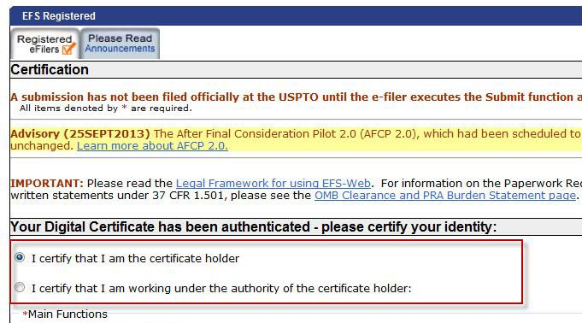

To submit a new international design application via EFS-Web select the “New application/Proceeding” radio button, the Web screen will then expand to display additional options. Select the radio button located next to “International Design Application (Hague) for filing through the USPTO as an office of indirect Filing” and click Continue.

Quick Start Guide

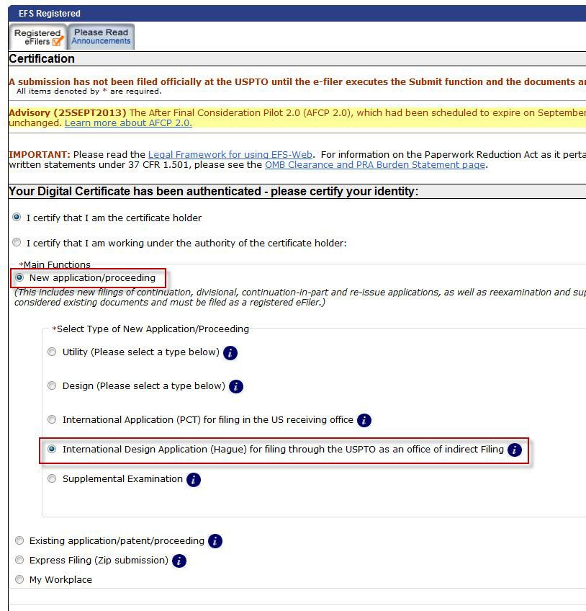

Unregistered eFiler

Once you have signed-on to EFS-Web as an Unregistered eFiler, you will need to enter your last name, first name and e-mail address.

To submit a new international design application via EFS-Web select the “New application/Proceeding” radio button, the Web screen will then expand to display additional options. Select the radio button located next to “International Design Application (Hague) for filing through the USPTO as an office of indirect Filing” and click Continue.

Quick Start Guide

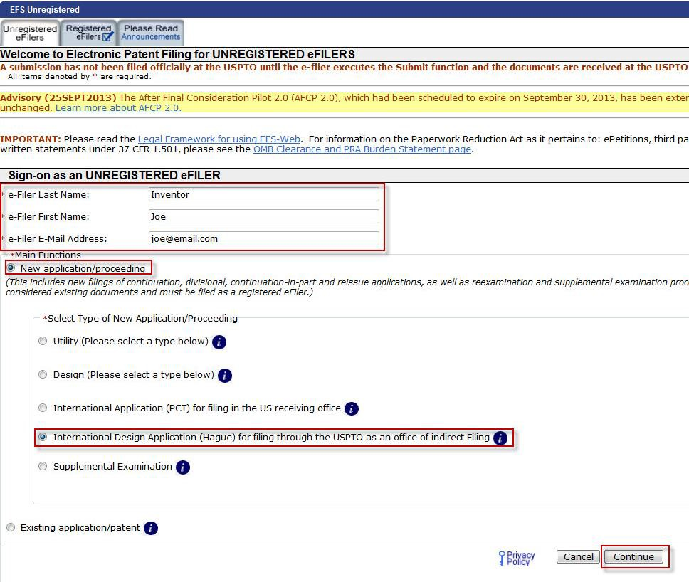

Entering Data for an International Design Application

On the “Application Data” page, the following sections shall be available for completion:

- Application Data
- Applicant Name
  - Natural Person
  - Legal Entity
- Correspondence Address
  - Customer Number

Quick Start Guide

o Correspondence Address

Title of Invention

The title of the invention may be provided but is not required. If provided, the title of the invention may not exceed 500 characters in length and must be as short and specific as possible. Characters that cannot be captured and recorded in the Office’s automated information systems may not be reflected in the Office’s records in such systems or in documents created by the Office. View list of valid characters for a patent title.

Note: If the United States is designated, a title furnished via EFS-Web may be used as the title in communications sent by the USPTO as a designated office.

Attorney Docket Number

An Attorney Docket Number is a Reference text of up to 25 alphanumeric characters that is used to identify a patent application. This number is not assigned by the USPTO and can be any combination of numbers and letters.

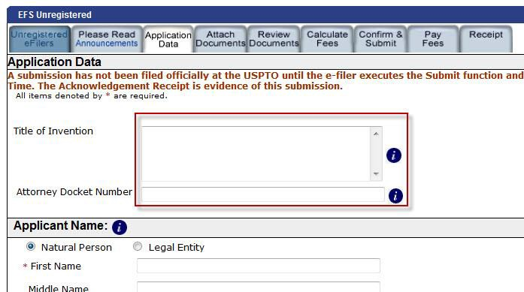

Applicant Name

Names of natural persons shall be indicated by the person's family name and given name(s), the family name being indicated before the given name(s). When the Natural Person radio button is selected the First name and Last name fields must be completed.

Quick Start Guide

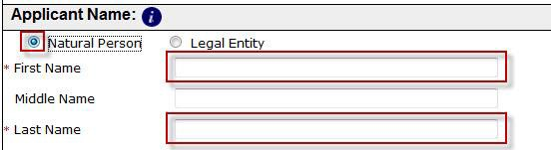

Names of legal entities shall be indicated by their full, official designations. When the Legal Entity
radio button is selected the Name field must be completed.

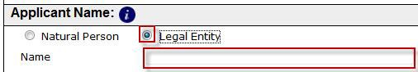

Correspondence Address

The correspondence address for an international design application may be indicated by a customer number or by entering a correspondence address.

If the Customer Number radio button is selected, the user may either select their customer number from the provided dropdown list or manually enter the number.

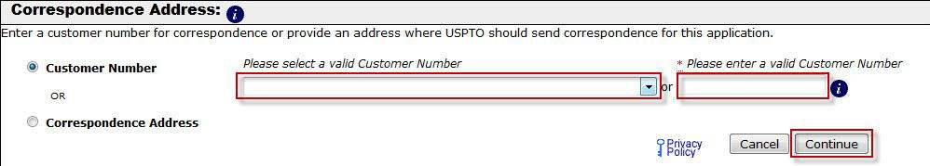

If the Correspondence Address radio button is selected, the user must complete the following required fields:
      - Name 1
      - Street Address 1
      - City
      - Country

Quick Start Guide

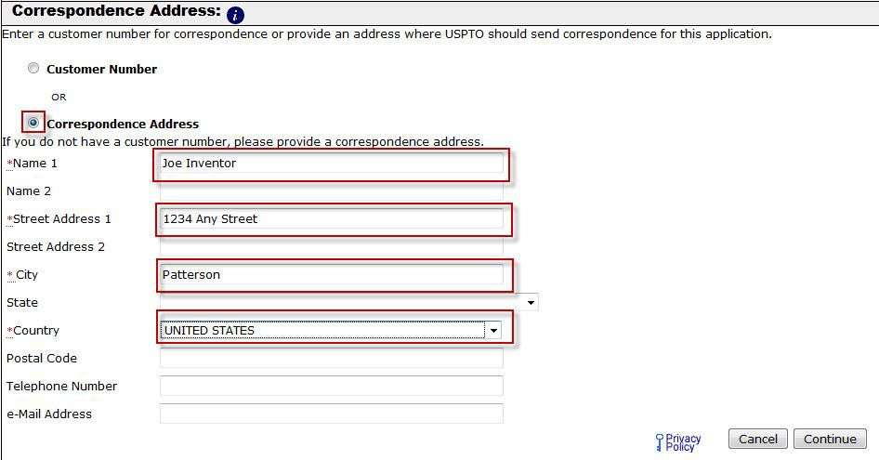

Once the appropriate fields have been completed, click on the “Continue” button to proceed.

Note: If a customer number is not entered, then the submitted application will not be associated with the Registered eFiler’s digital certificate and will not be viewable in Private PAIR.

Warning: A customer number should not be used to specify a correspondence address in the “Application for International Registration” (DM/1 form), as the address fields in the DM/1 form are for use by the International Bureau, which does not recognize customer numbers. Rather, the customer number should be furnished in a separate signed document, such as a transmittal letter, that accompanies the DM/1 form.

If you need to make any corrections, go back to the “Application Data” screen by clicking on the “Application Data” tab at the top of the screen. You may also click the “Application Data” hyperlink above the displayed Bibliographic Data. After making any corrections, you must click on the “Continue” button located at the bottom of the “Application Data” screen in order to apply any changes.

Quick Start Guide

Attaching Documents

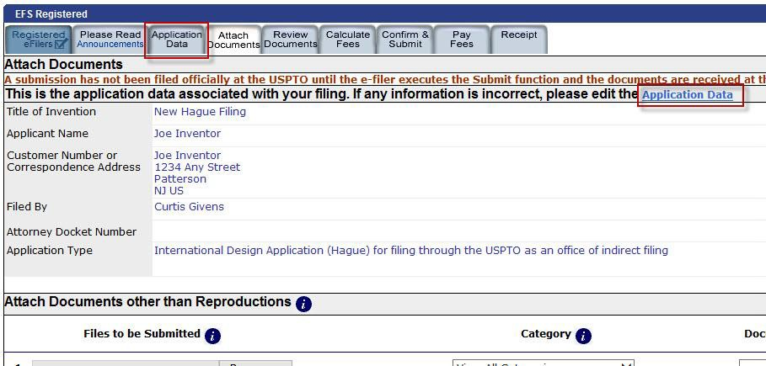

On the “Attach Documents” screen, you can upload documents for an international design application filing. The “Attach Documents” screen has two different sections for attaching documents: (1) “Attach Documents other than Reproductions;” and (2) “Attach Reproductions.” These sections are discussed in detail below.

Attaching Documents other than Reproductions

The “Attach Documents other than Reproductions” section is used for attaching documents other than reproductions (drawings), such as the “Application for International Registration” (DM/1 form) and any annexes to the DM/1 form. The DM/1 form and annexes are available on the website of WIPO at http://www.wipo.int/hague/en/forms/.

New international design applications filed through the USPTO should always include the DM/1 form (or a form having the same format and contents as the DM/1 form). The DM/1 form includes boxes for indicating the applicant, applicant’s entitlement to file an international design application, applicant’s Contracting Party, the creator, designations of Contracting Parties, and other relevant information. The document description “App for Intl Registration (DM/1 or equiv)” should be used when attaching the DM/1 form in EFS-Web.

Warning: To file an international design application through the USPTO as an office of indirect filing, each applicant must be a national of the United States or have a domicile, a habitual residence, or a real and effective industrial or commercial establishment in the United States. In addition, the United States must be indicated as each applicant’s Contracting Party. These indications should appear in the appropriate sections of the DM/1 Form.

Quick Start Guide

Any annexes to the DM/1 form should be attached in EFS-Web using the document description “Annex(es) to the DM/1 or equivalent”.

Annexes relevant to the designation of the United States include annexes for submitting the inventor’s oath or declaration, a micro entity certification, and an information disclosure statement (IDS).

Note: An IDS may be submitted directly to the USPTO after WIPO publication of the international registration. The IDS will be considered by the USPTO if filed within three months from the date of publication of the international registration, or after such three-month period as provided in 37 CFR 1.97.

The procedure for attaching documents via the “Attach Documents other than Reproductions” is as follows:

Step 1: Click on the “Browse/Choose File” button to search your computer for the document to be uploaded. Note: it might be beneficial to use a file name representative of the document being uploaded (e.g., “Jones.pdf” for a copy of a document authored by Jones).

Step 2: Once the document is uploaded, you will need to index it correctly. The “Category” drop down menu allows document descriptions to be narrowed down based on file being attached. The “Document Description” drop down menu represents how the document will be indexed once submitted.

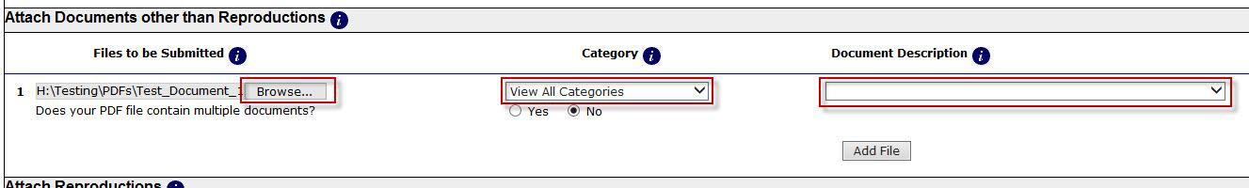

Additional documents may be attached by clicking the “Add File” button. You will need to repeat Steps 1 and 2 for each document being attached.

Attaching Reproductions

Reproductions may be submitted as drawings, photographs, or a combination thereof, and may be in black and white or in color. Technical requirements regarding image files such as resolution, minimum and maximum image size, border width, etc., are set forth on the WIPO website at http://www.wipo.int/hague/en/how_to/file/prepare.html.

Reproductions should be submitted as single page PDF or JPEG files by attaching the file(s) using the “Attach Reproductions” section of the “Attach Documents” screen. While it is possible to submit reproductions as a PDF using the “Attach Documents other than Reproductions” section, it is strongly recommended that reproductions be submitted using the “Attach Reproductions”

Quick Start Guide

section, rather than the “Attach Documents other than Reproductions”, as this may help to avoid incurring additional per page publication fees that might otherwise be required by the International Bureau.

Warning: Reproductions should be attached via the “Attach Reproductions” section. Reproductions attached via the “Attach Documents other than Reproductions” may be treated by the International Bureau as being submitted on paper, and thus subject to the additional per page publication fees for reproductions submitted on paper.

Each single page PDF or JPEG file attached through the “Attach Reproductions” section cannot exceed a file size of two megabytes. In addition, each image file should contain only one view of the design and should not include any numbering of the reproduction in the image. Reproduction numbering is accomplished by the “Attach Reproductions” section, which prompts input of a design and view number for each file attached under this section. For JPEG submissions, EFS-Web will provide warnings where requirements pertaining to image resolution and minimum and maximum dimensions have not been satisfied; EFS-Web does not check color mode or border size for JPEG images. For PDF submissions via the “Attach Reproductions” section, EFS-Web will not permit submission of any PDF file that is more than one page. However, EFS-Web does not check color mode, border size, resolution, or maximum or minimum dimensions of the reproduction (other than certain minimum and maximum page size dimensions) for PDF images.

The document description “drawings – only black and white line drawings” or “drawing – other than black and white line drawings” should be used, as appropriate, when attaching reproductions. EFS-Web will provide a warning where a new international design application submission does not contain an indication that at least one reproduction is attached.

The procedure for attaching the reproductions via the “Attach Reproductions” section is as follows:

Step 1: Click on the “Browse/Choose File” button to search your computer for the document to be uploaded. Note: Only images in JPEG or PDF format may be attached in this section.

Step 2: Once the document is uploaded, you will need to index it correctly. When attaching views the “Category” drop down menu will not be available as the only application part being attached in this section is Drawings. Using the “Document Description” drop down menu indicate whether the drawing being attached is Black and White or Other than Black and White.

Quick Start Guide

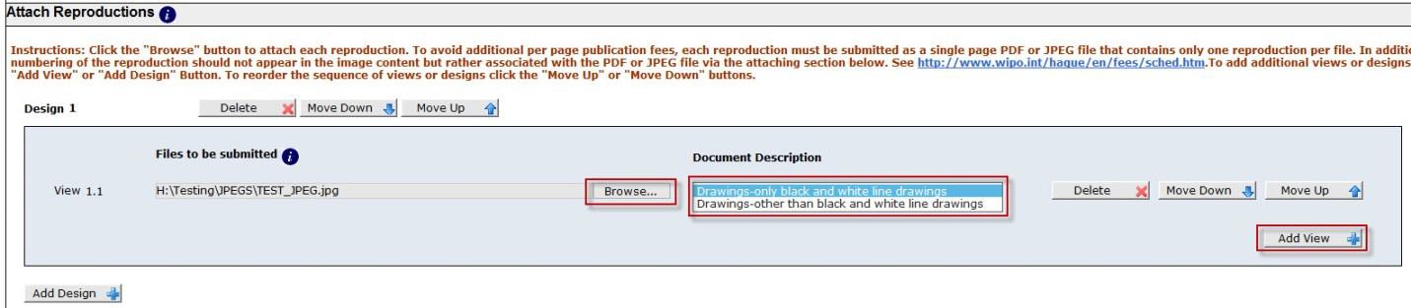

Additional views may be added to a Design by clicking the “Add View” button. Additional Designs may be added to a submission by clicking the “Add Design” button.

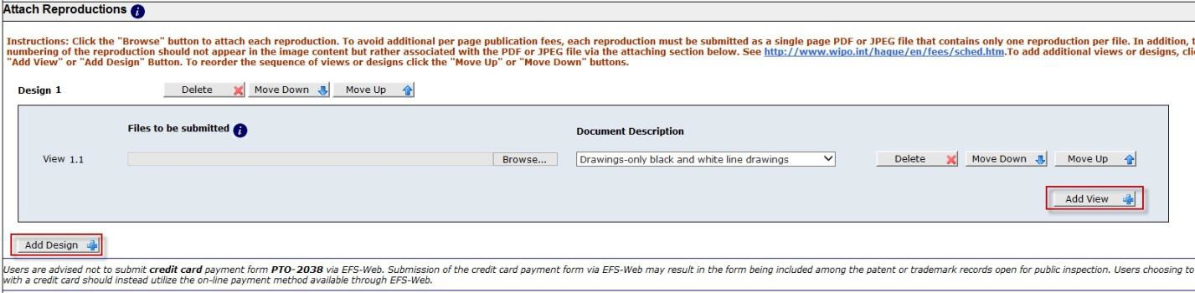

You will need to repeat Steps 1 and 2 for each view being attached.
Click on the “Upload &Validate” button after all documents have been uploaded.

Moving of Views: Once views have been attached the option to move up and down within a Design is made possible by clicking the “Move Down” or “Move Up” buttons to the right of the view.

Review Documents

On the “Review Documents” screen, confirm that all of the necessary documents uploaded properly. If you receive any validation errors you will not be able to proceed to the next screen until the errors are fixed. However, you will be able to proceed to the next screen if you receive any validation warnings.

Once you have uploaded all of the necessary documents for your submission and received no validation errors, click on the “Continue” button to advance to the next screen.

Quick Start Guide

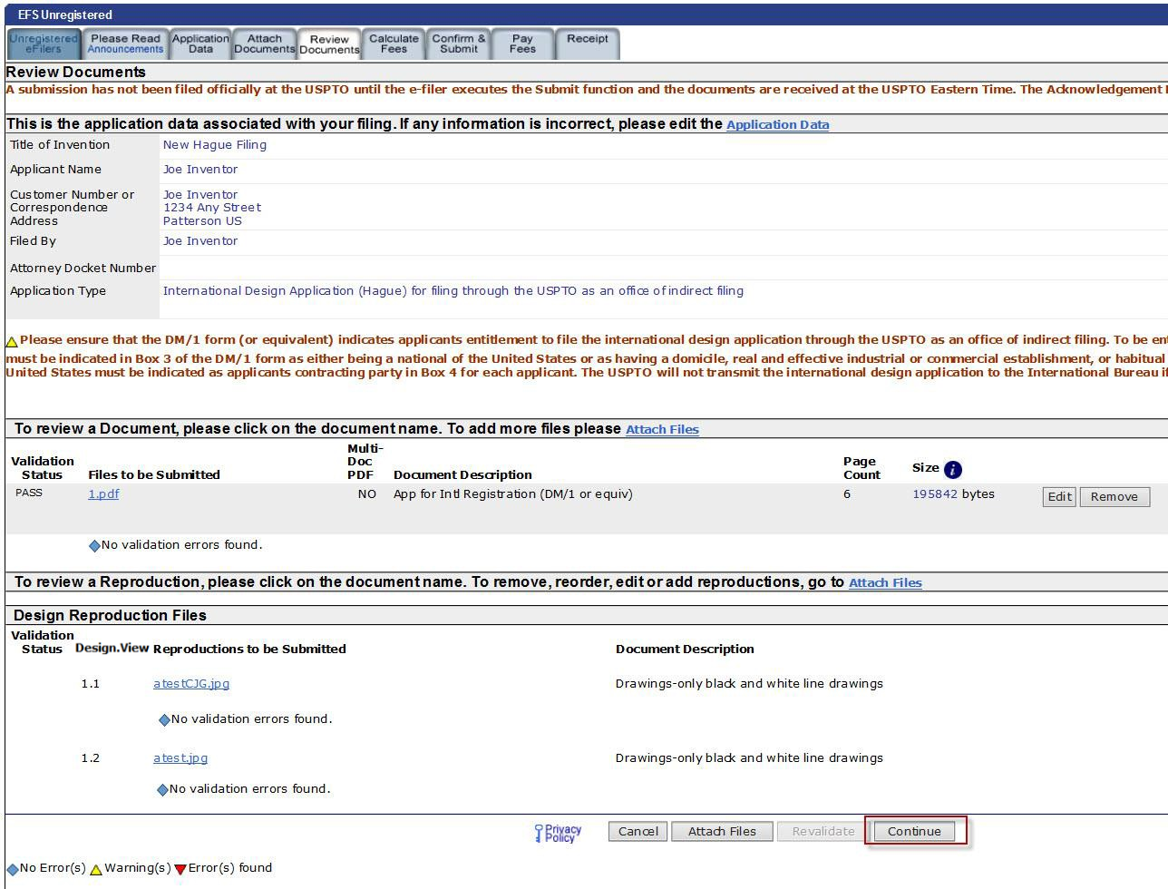

If your document could not be validated, an error message will appear informing you of the reason for the validation failure. Attaching a document that is not a PDF or JPEG will cause a failure to validate, as will not choosing a document description. For more information, please review the EFS-Web Quick Start guide located at http://www.uspto.gov/patents/process/file/efs/guidance/EFS-WebQuickStartGuide.pdf.

Calculate Fees

An international design application filed with the USPTO as an office of indirect filing is subject to payment of a transmittal fee to the USPTO, in addition to the applicable international fees payable to the International Bureau. The transmittal fee may be paid via EFS-Web using online payment screens that interface with the Revenue Accounting and Management (RAM) system. The USPTO will not transmit the international design application to the International Bureau if the transmittal fee has not been paid to the USPTO.

Quick Start Guide

Warning: An international design application not received by the International Bureau within six months from the date the international design application is received by the USPTO will not be entitled to a filing date as of the date of receipt by the USPTO.

Certain international design application fees payable to the International Bureau may be paid through the USPTO as an office of indirect filing provided that such fees are paid no later than the date of payment of the transmittal fee. Applicants are not required to pay such fees through the USPTO but rather may pay such fees directly to the International Bureau. Furthermore, any payment of such fees through the USPTO must be in U.S. dollars. As all payments made to the International Bureau must be in Swiss currency, the U.S. dollar amount collected may, when converted to Swiss currency, be different than the required Swiss currency amount. Accordingly, applicants are cautioned that paying such fees through the USPTO may still result in a requirement by the International Bureau to pay additional amounts where the conversion from U.S. dollars to Swiss currency results in the International Bureau receiving less than the prescribed amounts. For additional information regarding how to pay WIPO application fees directly to the International Bureau, see http://www.wipo.int/about-wipo/en/finance/hague.html.

International fees payable to WIPO include the basic fee, designation fee(s), publication fee, and a fee for a description exceeding 100 words. The “Calculate Fees” screen of EFS-Web does not provide for individual selection of these fees but rather provides for input of one lump sum in Swiss francs. The screen includes a link to the WIPO Hague System Fee Calculator (http://www.wipo.int/hague/en/fees/calculator.jsp). Clicking this link will open the WIPO Fee Calculator, as seen below, in a new browser window.

Quick Start Guide

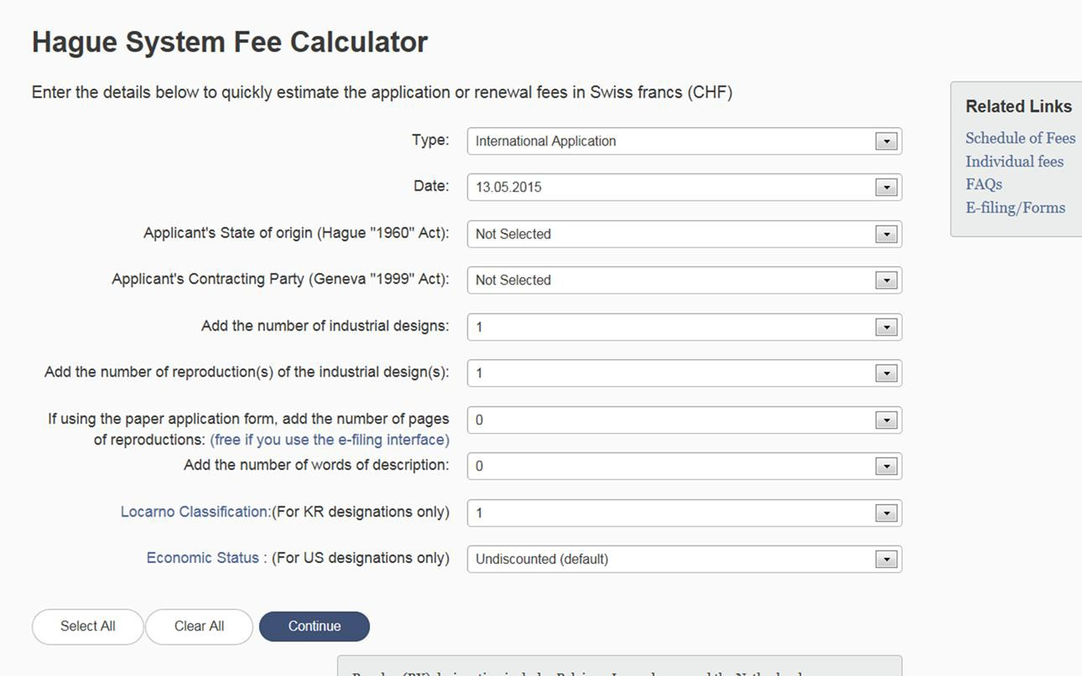

The WIPO Fee Calculator can be used to determine the total amount of international fees payable to the International Bureau in Swiss francs. Note that the “Economic Status” indicator on the WIPO Fee Calculator can be used to indicate, for purposes of the designation of the United States, applicant’s entity status as undiscounted, small entity, or micro entity, and the appropriate amount of the first part of the individual designation fee for the United States will be automatically determined. The total amount of the application fees payable to the International Bureau in Swiss francs can then be copied and pasted into the “International Fees Payable to WIPO (CHF)” field of the EFS-Web Calculate Fees screen, and EFS-Web will calculate the U.S. dollar amount based on current exchange rates. EFS-Web will only permit payment of the international fees that are payable to the International Bureau until 12 midnight Eastern Time of the date of payment of the transmittal fee.

The “Calculate Fees” screen allows eFilers to select the appropriate entity status in the top left hand corner of the screen. However, please note that at present there is no entity-based discount available with respect to the transmittal fee. In addition, clicking the appropriate entity status will not change the total amount of the international fees payable to the International Bureau as determined by the WIPO Fee Calculator, as any reduction in the designation fee for the United States based on small or micro entity status should already be accounted for by the WIPO Fee Calculator, as set forth above.

Quick Start Guide

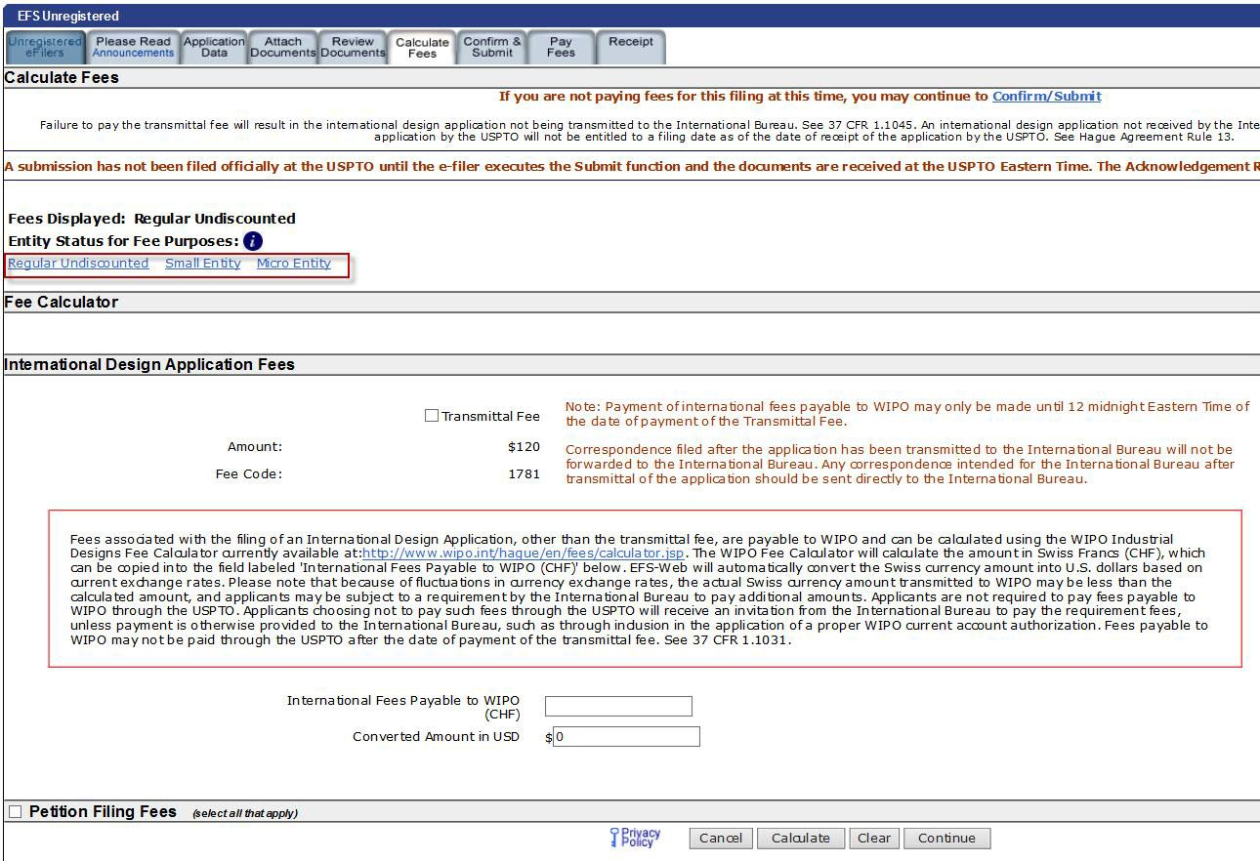

After fees have been entered/selected click the “Calculate” button, so submission fees are summed in the “Total Fees Due” field. Then click “Continue” to proceed.

Quick Start Guide

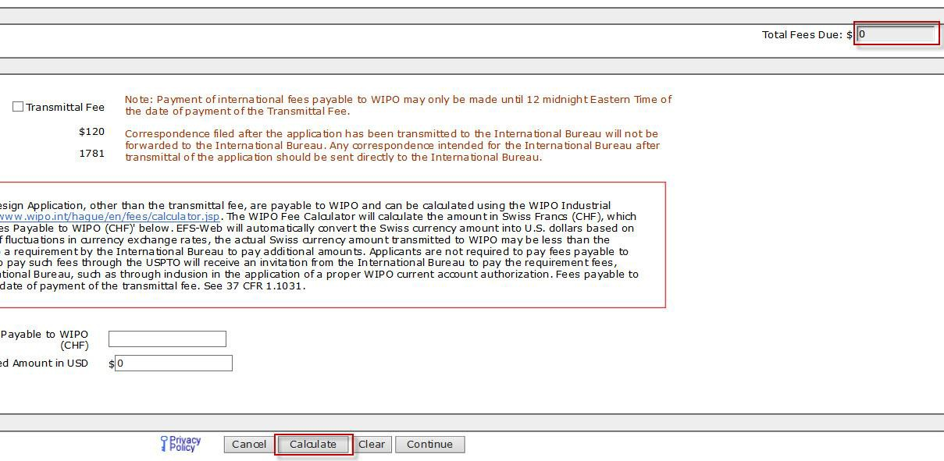

Confirm and Submit

On the “Confirm & Submit” screen, you will be presented with a review of the content provided for the international design application submission. This will include all information entered on the “Application Data” screen, the fee(s) indicated on the “Calculate Fees” screen, as well as documents uploaded on the “Attach Documents” screen.

Ensure Bibliographic Data is correct; all documents have been attached; then click on the “Submit” button once.
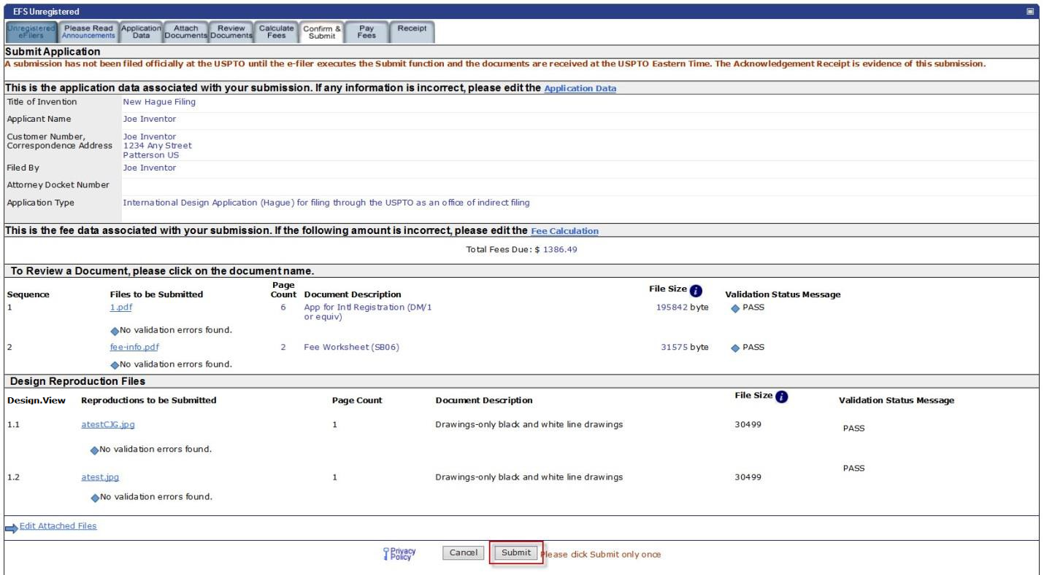

Quick Start Guide

Pay Fees

On the “Pay Fees” screen, you have the option of paying via “USPTO Deposit Account,” “Credit/Debit Card,” or “Electronic Funds Transfer.”

To make a payment, click the “Pay with the New USPTO Payment System” button located at the bottom of the screen to be directed to Financial Manager. Once on the Financial Manager page you will be able to make payment with a Credit/Debit Card as Guest, or sign in with a MyUSPTO.gov account to make payment with a stored Credit/Debit Card, Deposit Account, or EFT account.

Note: You will not be able to view the “Pay Fees” screen if fees were not previously calculated. Instead you will be forwarded to the “Receipt” screen.

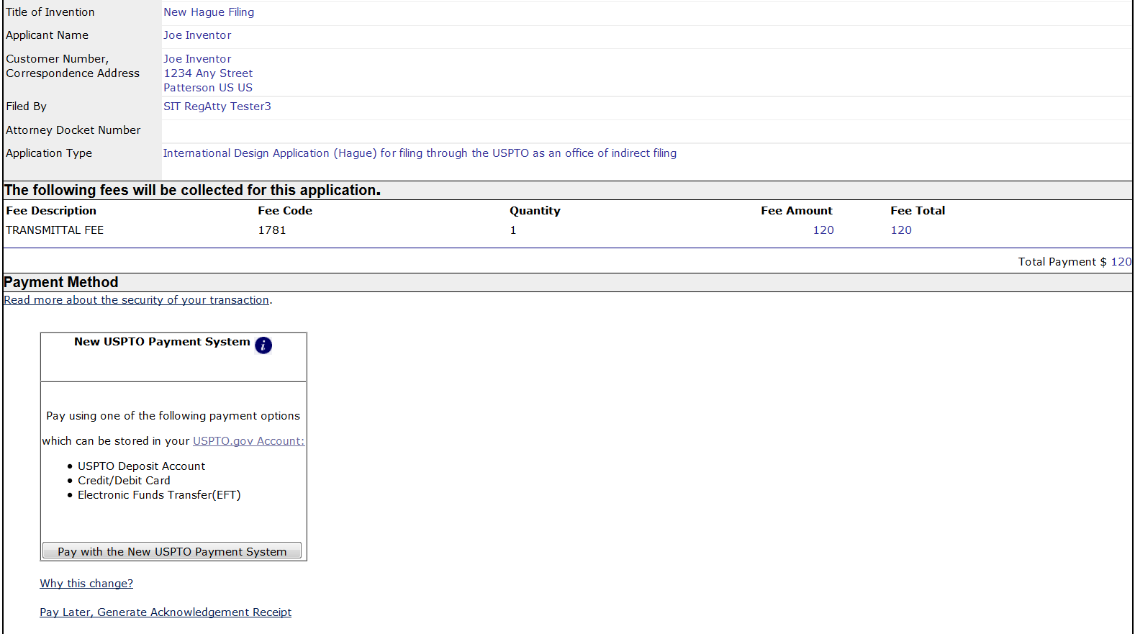

Acknowledgement Receipt

Once you have provided all of the necessary payment information and your payment is processed successfully, you will receive your Acknowledgement Receipt on the “Receipt” screen. You may print or save the receipt. Registered eFilers will also have the option of viewing the Acknowledgement Receipt under “My Workplace” on EFS-Web. The Acknowledgement Receipt displays the details of the submission, such as the file names of the uploaded documents and design reproduction files, time stamp, and total amount paid.

Quick Start Guide

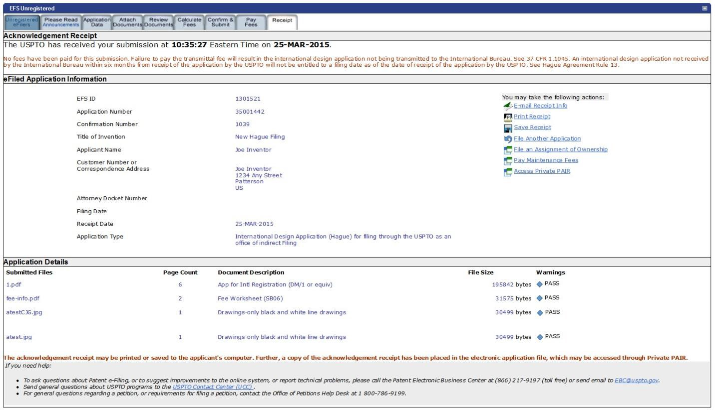

Save Submission Feature for Registered eFilers

When preparing an international design application submission, you have the option of saving the submission for later if you are a Registered eFiler. You must complete all of the required fields on the “Application Data” screen and attach at least one document on the “Attach Documents” screen in order to save the submission. At the bottom of the “Confirm & Submit” screen there will be a “Save for Later Submission” button available.

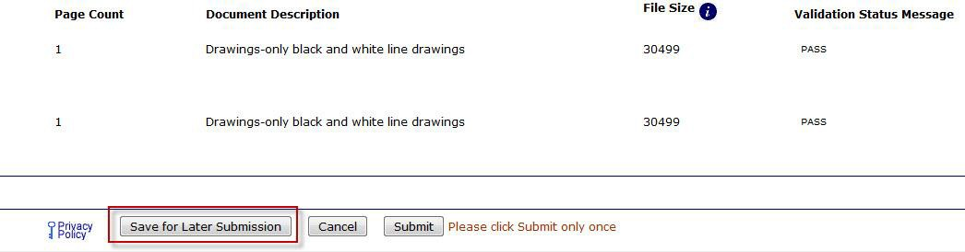

If you click on “Save for Later Submission” the following pop-up warnings will appear.

Quick Start Guide

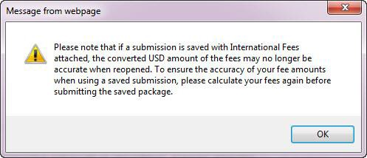

The first message warns you that if fees were calculated in the save submission package they may not be accurate at the time of submission, and recommends recalculating fees. Click “OK.”

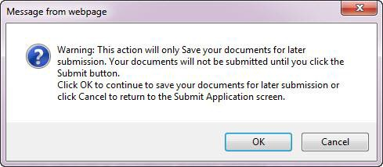

After clicking on the “OK” button, the next screen will display the saved application for later submission. There is a notification statement that explains that the submission has not been filed officially at the USPTO until the Submit function is executed. A statement at the bottom of the screen details that the submission will be saved for up to 7 days.

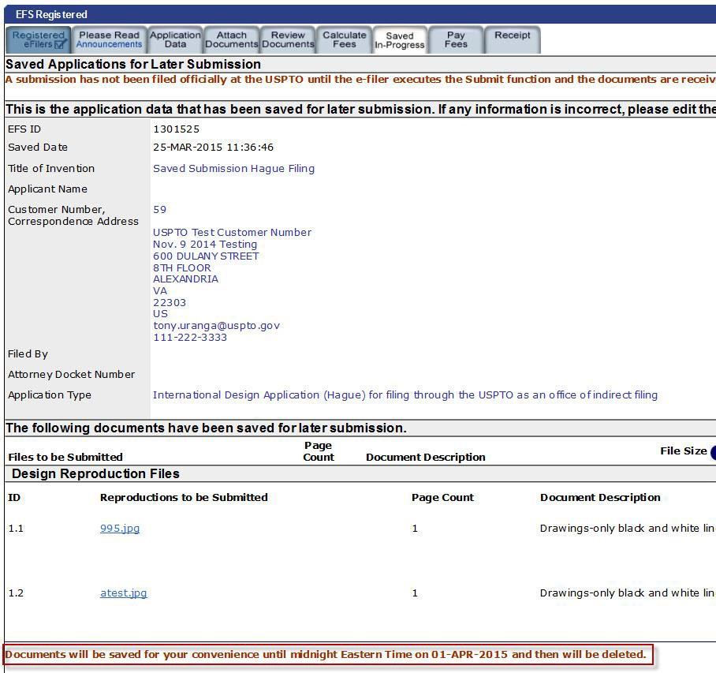

Quick Start Guide

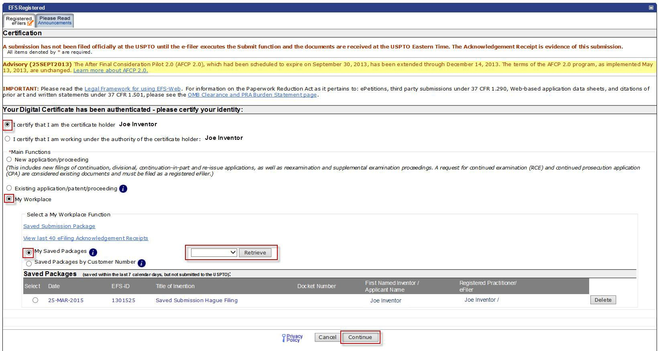

In order to later retrieve your saved submission package, you must log in to EFS-Web as a Registered eFiler. On the EFS-Web page you must select “My Workplace”, and then click on the “Saved Submission Package” link. Next, select “My Saved Packages” and click on the drop down menu to select an eFiler and click on the “Retrieve” button. This will retrieve your saved submission packages. Fill in the radio button under “Select” in order to choose the particular saved submission package and click the “Continue” button.

Follow-On Submissions

Registered eFilers may file follow-on submissions in international design applications through EFS- Web. Please note, however, that the USPTO will not forward to the International Bureau follow-on submissions that are received after an international design application has been transmitted to the International Bureau. Thus, for example, where the International Bureau has sent an invitation requiring compliance with a requirement under the Hague Agreement, the applicant must file any reply to that invitation directly with the International Bureau to avoid abandonment or other loss of rights under the treaty.

The available document descriptions and fees that may be paid through EFS-Web will differ depending on the stage of the international design application. As previously indicated, after the date of payment of the transmittal fee, the international fees payable to the International Bureau may not be paid through the USPTO. Furthermore, after transmittal of the international design

Quick Start Guide

application to the International Bureau has occurred, the document descriptions and fees that may be paid through EFS-Web include only those that would be relevant for U.S. national processing and examination. Follow-on submissions filed after transmittal of the international design application to the International Bureau but prior to WIPO publication of the international design application designating the United States will generally be presumed to have been intended for consideration by the USPTO acting as an examining office for the application. Accordingly, action by the Office on any such submission will generally be taken after receipt of the WIPO publication of the international design application designating the United States.

No follow-on submission or fee payment is required from the applicant to initiate examination of an international design application that designates the United States. Upon receipt by the Office of the WIPO publication of an international design application designating the United States, the Office will prepare the application file for examination. Registered eFilers may file follow-on submissions in the international design application via EFS-Web relevant to U.S. national processing and examination. Reproductions amended pursuant to 37 CFR 1.121 may be submitted via EFS-Web as either PDF or JPEG electronic files. Any such JPEG file must be attached to the EFS-Web submission using the “Attach JPEG Reproductions” section of the “Attach Documents” EFS-Web screen.

If you have any questions or concerns regarding filing in EFS-Web, please contact the Patent EBC Monday - Friday, from 6:00 a.m. to 12 Midnight Eastern Time, by email ebc@uspto.gov or telephone 866-217-9197.

