

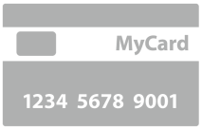



FINANCIAL MANAGER

User Guide

Table of Contents
Part One: Introduction 4
Welcome to Financial Manager 5
What is Financial Manager? 5
Getting Started with Financial Manager 6
Create your USPTO.gov Account 6
Sign in to Financial Manager 8
Key Terms 9
How to Use this Guide 10
Formatting Hints 10
Navigating Financial Manager 11
Navigation Tools 11
Tool Tips 12
Forms 13
Tables 15
Stored Payment Methods 20
Introduction to Stored Payment Methods 20
My Payment Methods Page 21

PART TWO: I’m a new user. What do I need to know? 23
Stored Payment Methods 24
Add a Payment Method Page 24
Add a Payment Method 25
Stored Payment Method Summary Page 30
User Permissions 32
Introduction to User Permissions 32

PART THREE: I’m an Administrator. What do I need to know? 34
The Administrator Role 35
View and Modify Administrative Details 35
Payment Method Administrative Details 35
Recent Transactions 36
Administrative History Page 37
Delete and Close Stored Payment Methods 39
Grant and Remove User Permissions 42
User Permissions Page 42
Manage Deposit Accounts 46

PART FOUR: I’m a Fee Payer. What do I need to know? 47
The Fee Payer Role 48
View Administrative Details 48
Payment Method Administrative Details 48
Submit Payments to the USPTO 48
Checking Out 48
Shopping Cart 49
USPTO Payment Page 51

PART FIVE: I’m a Reporter. What do I need to know? 53
The Reporter Role 54
View Administrative Details 54
Payment Method Administrative Details 54
Develop, View, and Download Transaction Reports 54
Recent Transactions, Transaction Reports, and Monthly Statements 54

PART SIX: I’m a Funds Manager. What do I need to know? 61
The Funds Manager Role 62
View Administrative Details 62
Payment Method Administrative Details 62
Add Funds to a Deposit Account 62
Replenish a Deposit Account 62
Set Up and Modify Deposit Account Auto-Replenishment 64
Withdraw Funds From Deposit Accounts 66

PART SEVEN: Appendix 68
Stored Payment Method Status Definitions 69
Transacation Types Available in Transaction Search Reports 71
USPTO Shopping Cart Services 71
Deposit Account Replenishment Time 71
Contact Us 72

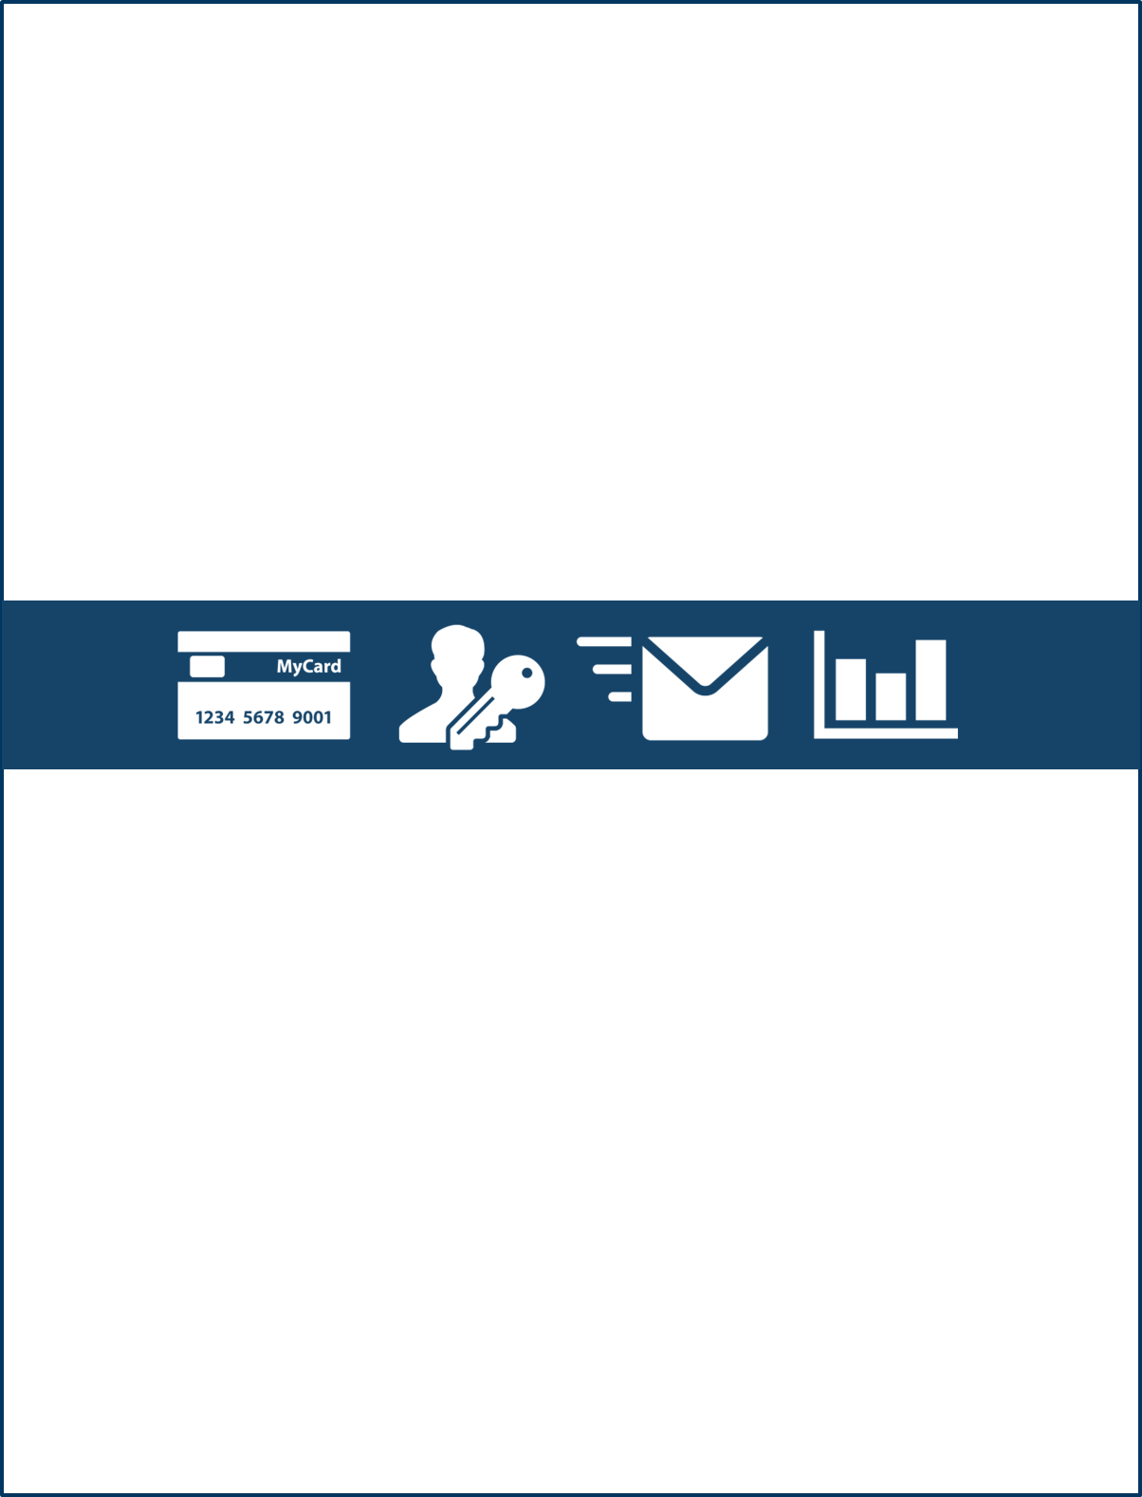
Part One

Introduction

Welcome to Financial Manager

What is Financial Manager?
Financial Manager is the USPTO’s fee payment management tool. Financial Manager allows you to do more business with the USPTO online, making it fast and easy for you to access the services and information you need to protect your intellectual property.
As a Financial Manager user, you can:
- Store and manage electronic payment methods, including credit/debit cards, deposit accounts, and electronic funds transfers (EFTs)
- Submit online payments to the USPTO without having to enter payment information for each transaction
- Assign user permissions, allowing other Financial Manager users to access, use, and/or manage your stored payment methods
- Search administrative history and generate transaction reports for your stored payment methods
- Receive administrative notifications to help you manage your stored payment methods
In Financial Manager, you can keep track of transactions you’ve completed with the USPTO and quickly submit payments with just a few clicks. Moreover, the user permissions feature gives you even more security and removes the burden of uncertainty – you’ll always know who did what, when.

Getting Started with Financial Manager

Create your USPTO.gov Account
To access Financial Manager, you will need to create a uspto.gov account. Your uspto.gov account will one day be your primary means of accessing USPTO services and applications online. After creating your uspto.gov account, you will be ready to access special features and online tools, like Financial Manager, as they become available.
- Navigate to the uspto.gov account welcome page: https://my.uspto.gov.
- On the uspto.gov account welcompage, select the  button.
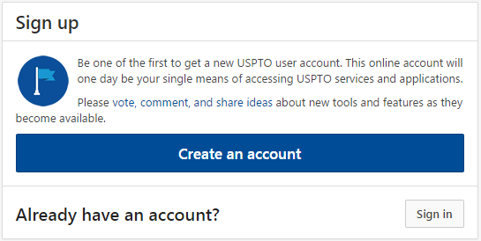
- Complete the Create an account form by entering your email address and full name. You’ll also need to complete the reCaptcha verification and check the box indicating that you understand and agree to the USPTO’s Terms of Use and Privacy Policy.
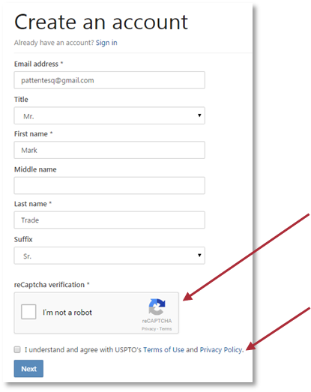
You’ll also need to check the box agreeing to the USPTO’s Terms of Use and Privacy Policy.

To complete the Create an account form, the following information is required (*):
- Email address
- First name
- Last Name
Check the reCaptcha verification box and complete the activity described to indicate that you are not a robot.

- Check your email and follow the link provided to navigate to the Activate your account form.
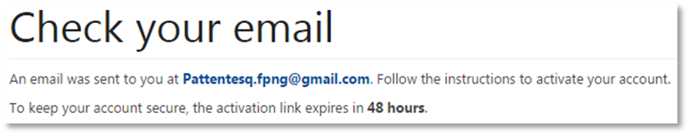
- Complete the Activate your account form, creating a new password and three security questions for your account.
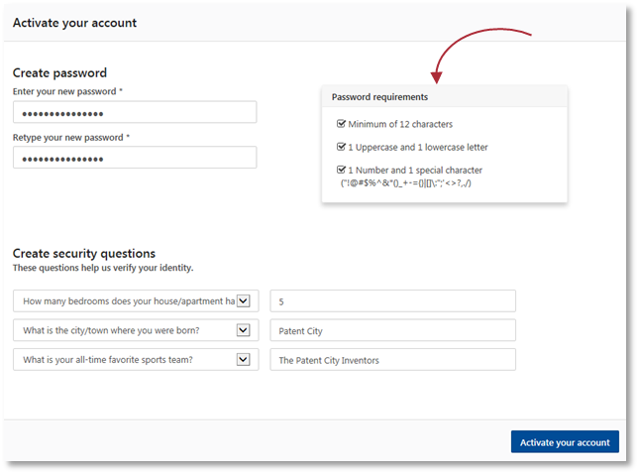
Your password must meet the following requirements:
- Minimum of 12 characters
- 1 uppercase and 1 lowercase letter
- 1 number and 1 special character
This checklist will automatically update as your password meets each requirement.
- Select the button to complete the account activation process and return to the uspto.gov account Sign in page.
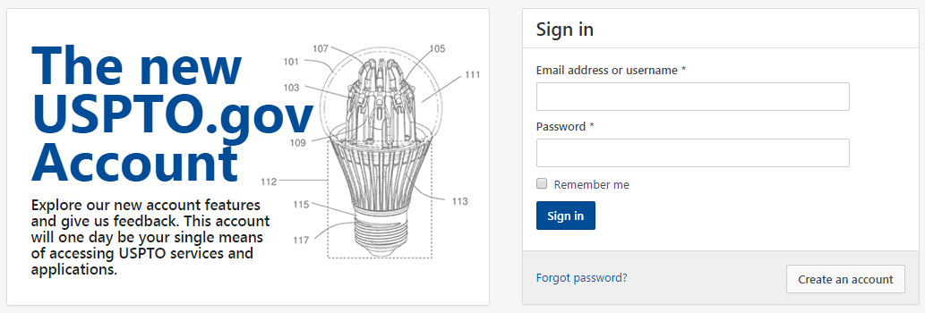

Sign in to Financial Manager
- Navigate to the Financial Manager homepage: https://fees.uspto.gov/FinancialManager
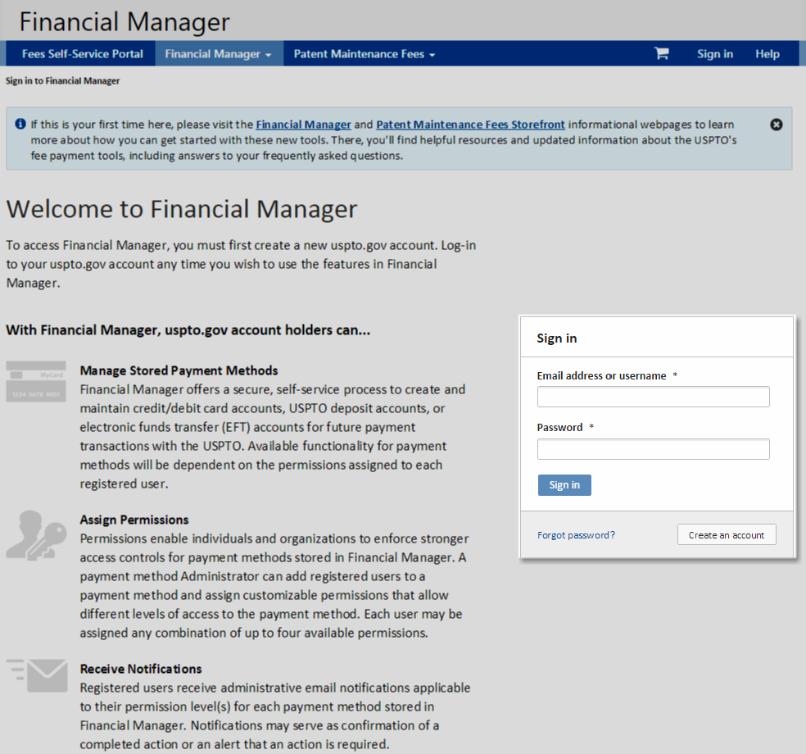
- Complete the Sign in form, entering the email address and password associated with your uspto.gov account.
- Select the button. This will take you to the My Payment Methods page.

Key Terms

Administrative History
Administrative history documents manual changes that have been made to your stored payment methods by an Administrator and automated changes recorded by the Financial Manager system. Examples include changes to user permissions, payment method status (e.g. active, inactive, etc.), and payment method details (e.g. correspondence address, nickname, etc.).

Deposit Account
Deposit accounts are pre-paid fund reserves that customers can establish with the USPTO, which eliminate the need to submit a check, credit/debit card, or other payment information each time a fee payment is required. Furthermore, in an instance of miscalculation of a fee due, the balance required may be charged to the deposit account to preserve the date of filing, if a general authorization or fee preauthorization is established against the deposit account.

EFT
An electronic funds transfer (EFT) is a payment method that electronically transfers funds from a U.S. financial institution to the USPTO.

General Authorization
A general authorization, also known as a fee preauthorization, is a blanket approval that you may give the USPTO to charge your deposit account for specific Patent or Trademark fee deficiencies or underpayments.

Nickname
A nickname is an alternate name an Administrator may assign a stored payment method to help distinguish it from other stored payment methods in Financial Manager.

Storefront
At the USPTO, a storefront is an online shopping page that customers use to pay fees. The USPTO has several storefronts, each corresponding to different types of fees. For example, the Patent Maintenance Fees Storefront allows customers to pay maintenance fees for patents. EFS-Web is another storefront that allows customers to pay patent filing fees.

Uspto.gov Account
Your uspto.gov account is your online portal for all things USPTO. After creating your uspto.gov account, you’ll have access to new tools, like Financial Manager, that make doing business with the USPTO fast and easy.

User
A Financial Manager user is anyone who has created a uspto.gov account and has permissions to access a stored payment method in Financial Manager.

User Permissions
User permissions are the distinct settings you can apply in order to assign other Financial Manager users varying levels of access to your stored payment method(s).

How to Use this Guide
This user guide is structured in seven main sections.
- Sections 1-2 provide basic information that applies to all Financial Manager users.
- Sections 3-6 outline functionality based on Financial Manager’s user permission settings.
- Section 7 is the appendix.
This user guide is best viewed electronically, as it includes clickable hyperlinks that can help you quickly navigate to the information you need.

Formatting Hints
Like Financial Manager, this user guide is formatted to help you find the information you need quickly and easily.
Example | Description | Explanation
 | Letters in Yellow Circles | Correspond to explanations of diagrams and screenshots
 | Red Rectangles | Highlight important fields or buttons in Financial Manager
Return to the table of contents. | Underlined Text | Hyperlink to more information on a related topic; you can select the underlined text to be redirected to information about that topic
Text within a yellow text box provides helpful hints or important caveats. | Yellow Textboxes | Provide helpful hints or important caveats

Navigating Financial Manager

Navigation Tools
The main navigation menu is located in a blue bar towards the top of the page.
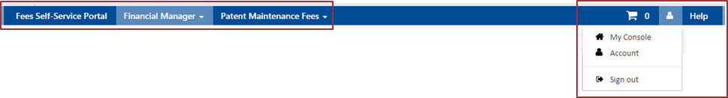
There are three primary navigation options:  - Fees Self-Service Portal  - Financial Manager  - Patent Maintenance Fees | To the right, are three additional options:  - Shopping cart  - Account management  - Help
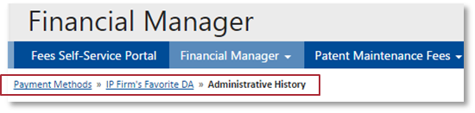
Each page also includes breadcrumbs below the main navigation menu. Breadcrumbs map out the trail or pathway to your current page in Financial Manager. You can use breadcrumbs to navigate back to previous pages.
On some pages, a series of tabs provide additional menu options, as in the example below. 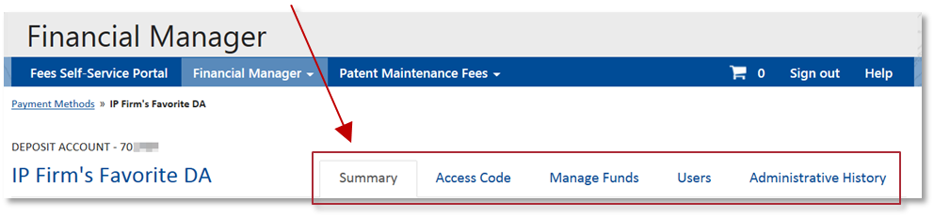
Some pages include a left column that offers additional information and functional options.
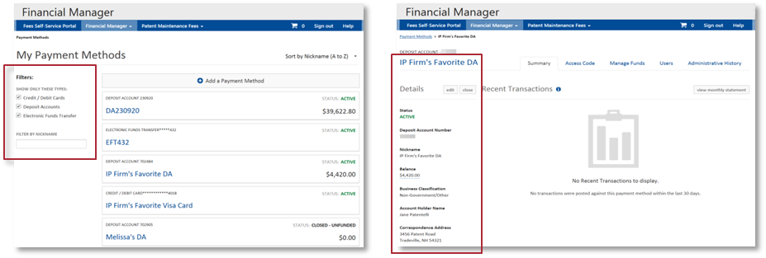

Tool Tips
Financial Manager includes in-application tool tips that provide helpful information about its features. Tool tips are indicated by icons or dashed underlined text throughout the application. A tool tip is activated when you hover your mouse over the icon or dashed underlined text, as in the example below.
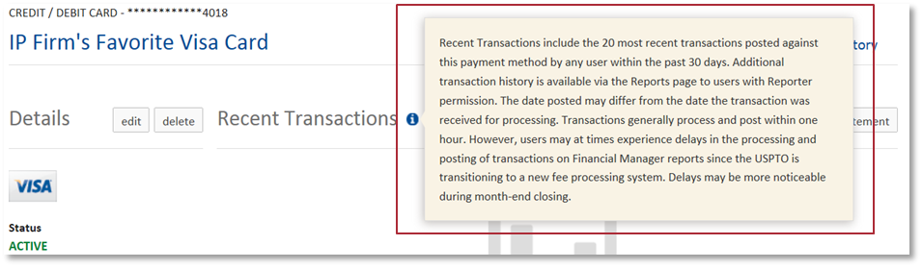

Forms

Field/Button Activation
In Financial Manager, some forms are not eligible for submission unless all of the required fields are filled out. Required fields are denoted with a red asterisk symbol (*). Some elements of a form are also dependent on previous entries. Subsequent and/or dependent fields or buttons are grayed and deactivated out until you've entered enough information to proceed.
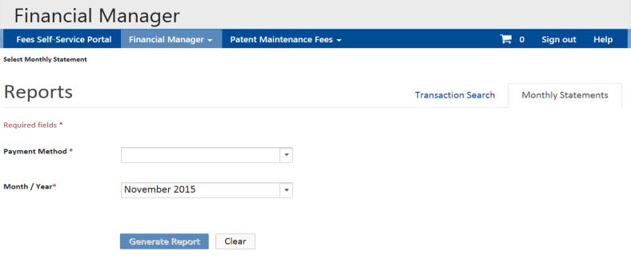
This form is missing information so some fields are not activated. The button at the bottom of the screen is also deactivated, preventing you from submitting the form.
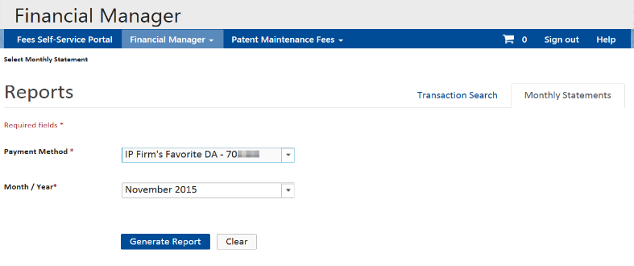
All of the required information has been entered in this form. Therefore, dependent fields and the button at the bottom of the screen are activated, allowing you to submit the form.

Success Messages
Financial Manager will display green success messages at the top of the screen after each successful action, as in the examples below. Success messages indicate that you’ve successfully completed the desired action and include important information about the process completed. These messages are only visible to the user initiating the action and will disappear when you navigate to a different page or manually close the message.
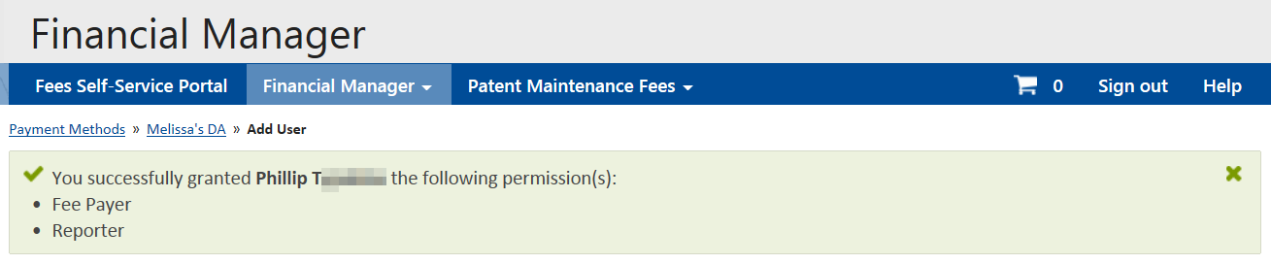

Alert Messages
Yellow warning messages display important information about your stored payment methods. These warning messages will be visible to all users who have access to the page.
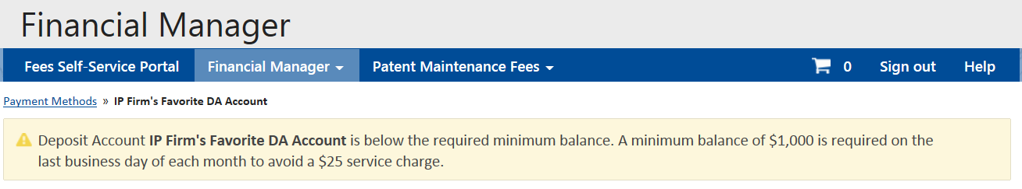
Red warning or error messages display urgent information about your stored payment methods or about the action you are attempting to complete. Red messages generally indicate that the user needs to take a specific action in order to continue conducting business with the USPTO.
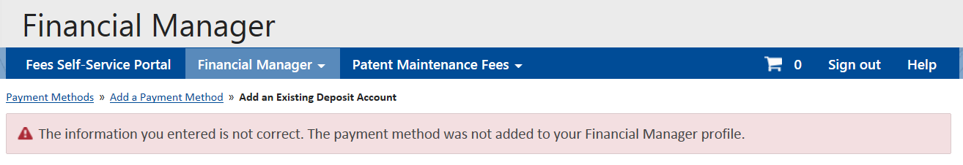

Tables
Several lists display as tables in Financial Manager. These include:
- Recent Transactions
- Administrative History
- User Permissions
- Transaction Reports
- Monthly Statements

Sorting Tables
In Financial Manager, you can sort tables to help you quickly find the information you need. This will rearrange the table so that the column you’ve selected displays in alphabetical or numerical order.
- Navigate to the header of the column you’d like to sort. When you hover over one of the sortable headers, a double headed carat symbol () will display, as in the example below. A gray message will also appear, indicating that the column is sortable.
When you select a sortable header, a small black triangle will appear, indicating the ascending or descending direction of the sorted information. A right side up triangle ( ) means the information is ascending; a downward pointing triangle ( ) means the information is descending.
- You can select the bold header again to reverse the sort. The small triangle will change direction to indicate whether the information is ascending or descending.
- You can select a different bold header to sort by another category in the table.

Filtering Tables
You can filter tables to only display items that are relevant to your search. Filter options are located in the left column of the page.
For checkbox filters, select the types of items you want to view, as in the example below. Selecting all of the checkboxes will restore the table’s original view.
For date filters, you can manually enter the date in MM/DD/YY format or use the dropdown menu to select the date on the calendar.
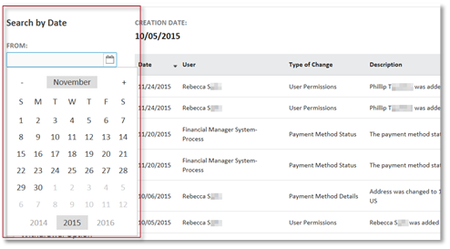
FROM: Enter the start date for the transaction search. You can manually enter the date in MM/DD/YY format or use the drop down to select the date on the calendar.
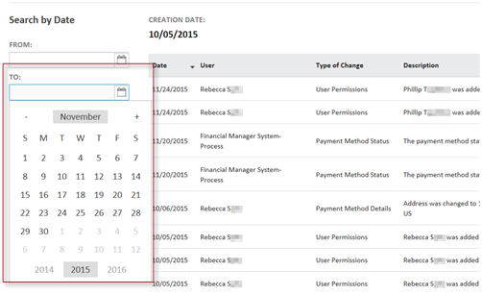
TO: Enter the end date for the transaction search. You can manually enter the date in MM/DD/YY format or use the drop down to select the date on the calendar.
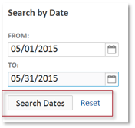
Select the 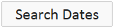 button to update the table to display items that fall within the selected date range.
To reset the table, select “Reset.” This will restore the table’s original view.

Expanding Items within Tables
By default, transaction reports and monthly statements display a summary view of each transaction that meets the report’s criteria. The expand feature () allows you to expand each summary to display details for the transaction.
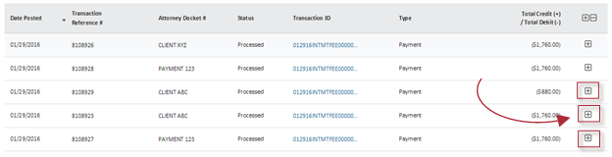
By default, this report displays a summary of each transaction. Click the icon to view details.
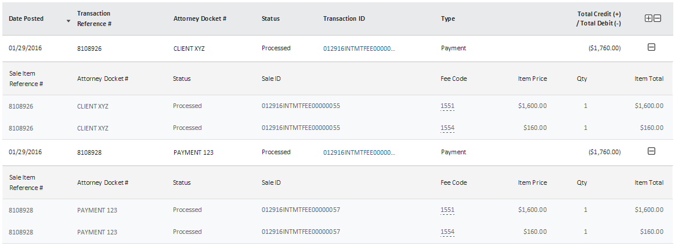
When a transaction is expanded to its detailed view, the icon displays. You can select the icon to collapse the detailed view, and return to the summary view of the transaction. A transaction in detailed view will also display with a lightly shaded background.

The detailed view includes its own sub-headers that apply to the fees paid within the transaction.

Filtering Monthly Statement Tables
Financial Manager offers advanced options for filtering monthly statements. When viewing a monthly statement, you can select filters that apply to the summary view and/or the detailed view. You can also layer multiple filters at once to help narrow down your search.
- While viewing your monthly statement, use the “Select a filter” dropdown menu to choose a filter to apply. Summary Filters will apply to the summary information of the transaction. Sale Item Details Filters will apply to the sale item details of the transactions. All others are displayed in both views.

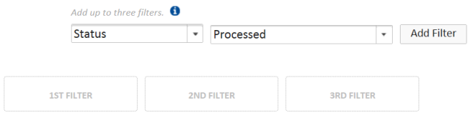
- Use the adjacent field to describe the filter rule you’d like to apply. This will activate the 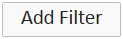 button.
- Select the button. The filter rule will appear in the 1st filter box. The table will also be updated to only display transactions that meet this criterion.

- Repeat steps 1-3 to add more filters. You may layer up to three filters.

Paginated Tables
Tables in Financial Manager will only display a limited number of items on each page. The navigation bar at the bottom of the page will become active if the table spans multiple pages.
Use the button to navigate to the following page. You can also use the “Go to page:” field to navigate to a specific page.

Stored Payment Methods

Introduction to Stored Payment Methods
At the USPTO, a stored payment method is an electronic payment method that is saved in Financial Manager. Financial Manager will allow you to save information for three types of electronic payment methods:
- Credit/debit cards
- Deposit accounts
- Electronic funds transfers
There is no limit to the number of payment methods you can store in Financial Manager. Storing your payment method information will allow you to quickly pay fees to the USPTO without having to enter detailed information for each transaction. You can also use Financial Manager to research transactions you’ve completed with the USPTO using one of your stored payment methods.

Credit/Debit Cards
The USPTO accepts American Express, Discover Network, MasterCard, and Visa branded credit/debit cards that do not require a PIN.
The U.S. Department of the Treasury limits the amount that any federal agency, including the USPTO, can charge to a given credit card in one day. The current daily limit is $24,999.99. There is no daily limit on debit cards.

Deposit Accounts
Deposit accounts are pre-paid fund reserves that customers can establish with the USPTO to pay fees. Deposit accounts are the only type of stored payment method that may be used for providing a general authorization to charge any deficiency in the payment of required fee(s), thus preserving the original payment or filing date.
Charges to deposit accounts with insufficient funds will not be accepted. A minimum balance of $1,000.00 is required on the last business day of each month to avoid a $25.00 service charge.

Electronic Funds Transfer
An Electronic funds transfer (EFT) provides a means of transferring funds from your bank or other financial institution to the USPTO. A U.S. bank account is required and your banking information must be verified before you can use the EFT to submit a payment to the USPTO. The verification process takes up to 8 business days.
Payments will not be processed if there is an ACH/EFT block or filter on your bank account. You may need to provide your bank with the USPTO’s ACH company ID number (1310000101) to properly establish the EFT payment method.

My Payment Methods Page
The My Payment Methods page is your personalized home page in Financial Manager. It lists all of the payment methods you have permission(s) to access.
          - Your stored payment methods will display in alphabetical order based on nickname by default. The nickname displays in large blue font on your My Payment Methods page. If you did not create a nickname for your stored payment method, an automated description of the payment method will display.
          - You can change the order in which your stored payment methods are sorted using the  dropdown menu in the upper right corner. You may choose to sort by nickname (A to Z); sort by nickname (Z to A); or sort by payment method status.
          - The My Payment Methods page also displays the status for your payment method. A list of possible statuses for each payment method is located in the Appendix.
          - Deposit account holders can also view their account balance on the My Payment Methods page. Balance changes are usually reflected in Financial Manager within one hour.
          - The filters located in the left column can help you display the type(s) of payment method(s) you want to access. Use the checkboxes to select the payment type(s) you want to see.
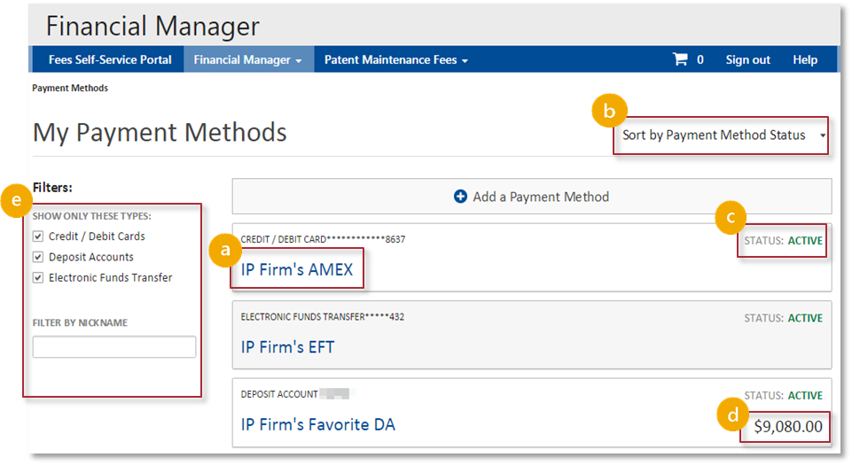

The first time you log in to Financial Manager, your My Payment Methods page will indicate that you do not have any stored payment methods. This will also display if you have deleted all of your payment methods or if all of your permissions to access stored payment methods have been removed.
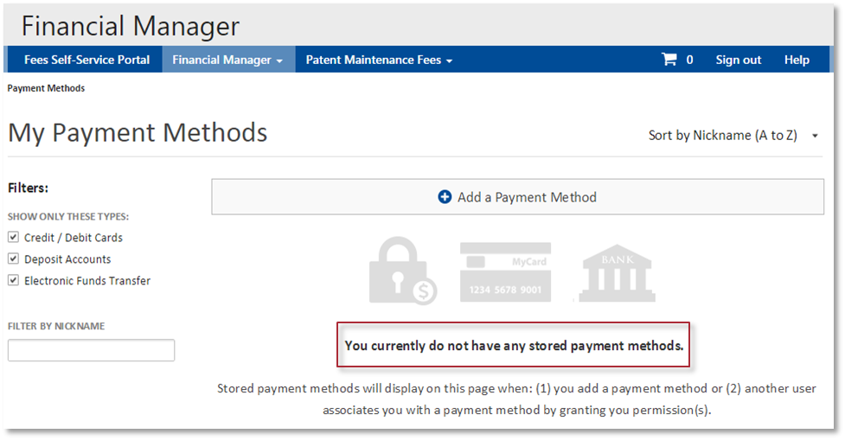

PART TWO

I’m a New User.
What do I need to know?

Stored Payment Methods

Add a Payment Method Page
The Add a Payment Method page allows you to store payment methods in Financial Manager.
- To access the Add a Payment Method page, select the “Add a Payment Method” button at the top of the My Payment Methods page.
- On the Add a Payment Method page, you may choose to add a new credit/debit card, deposit account, or EFT.
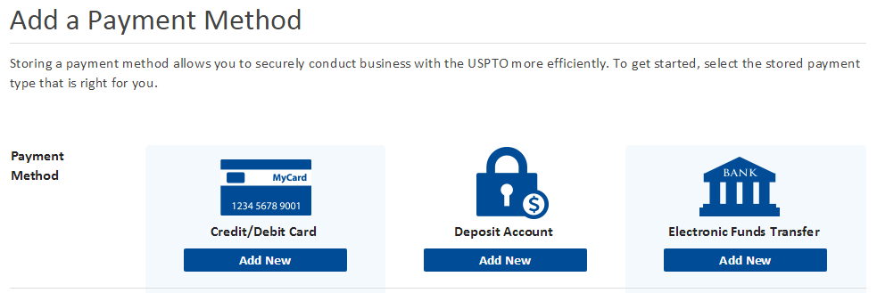
When you add a new payment method in Financial Manager, you are automatically assigned all user permissions for the payment method, including Administrator. As an Administrator, you can edit user permissions for the payment method after it is stored in Financial Manager.

Add a Payment Method

Add a New Credit/Debit Card
- On the Add a Payment Method page, select the button in the credit card column. This will take you to the Add a Credit/Debit Card form.
- Complete the Add a Credit/Debit Card form, entering card details and billing address information. A red asterisk (*) indicates that a field is required. When you have entered all of the required information, the button will become active.
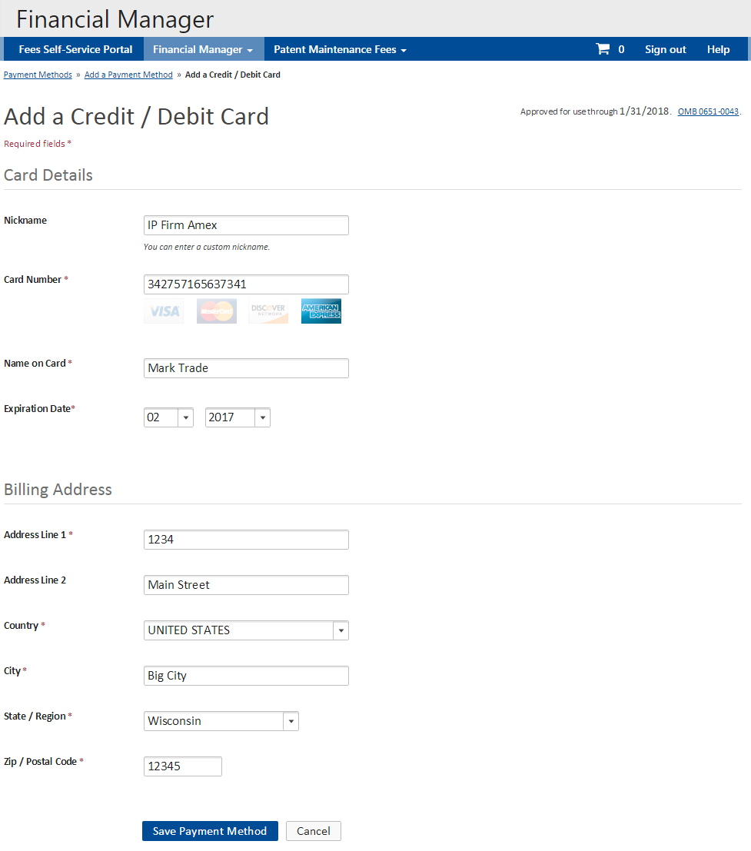
Financial Manager will recognize the type of credit card you are using and highlight its logo.
To complete the Add a Credit/Debit Card form, the following information is required (*):
- Card Number
- Name on Card
- Expiration Date
- Billing Address
(including country, city, state, and zip)
- Select the button to store your credit/debit card in Financial Manager. This will take you back to the My Payment Methods page, where your new credit/debit card will be listed as one of your stored payment methods. A success message will display, indicating that you’ve successfully added a new credit/debit card.

Add/Create a New Deposit Account
- On the Add a Payment Method page, select the button in the deposit account column. This will take you to the Add a Deposit Account form.
- Complete the Add a New Deposit Account form, entering deposit account details and correspondence address. A red asterisk (*) indicates that a field is required. When you have entered all of the required information, the button will become active.
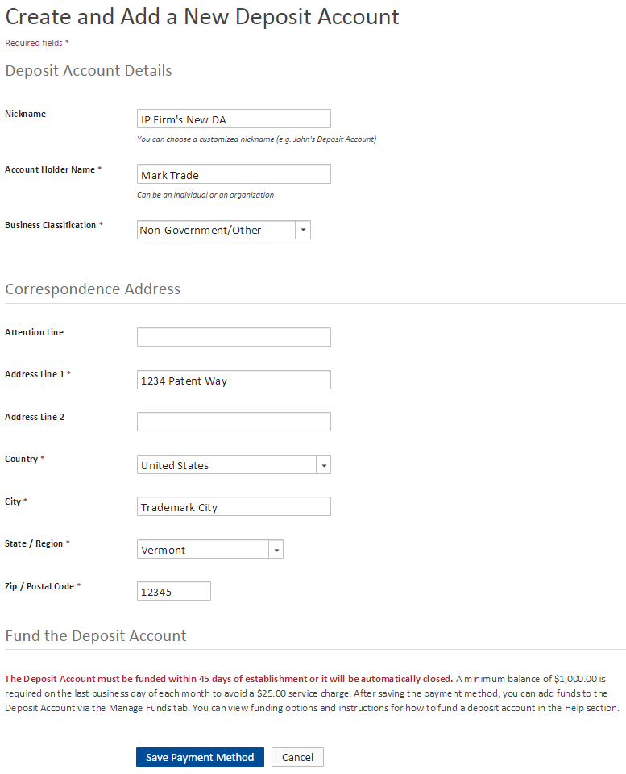
To complete the Add a New Deposit Account form, the following information is required (*):
- Account Holder Name
- Business Classification
(indicates affiliation with a government organization)
- Correspondence Address
(including country, city, state, and zip)
- Select the button at the bottom of the screen to submit the form. This will take you back to the My Payment Methods page, where your new deposit account will be listed as one of your stored payment methods. A green success message will also display at the top of the page.
Immediately after the deposit account is created, it will display on your My Payment Methods page with a status of Active – Unfunded, as in the example below.
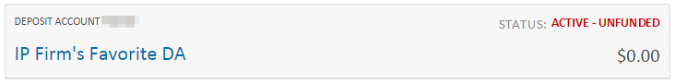
A deposit account can remain Active – Unfunded for 45 days before it is automatically closed. Learn more about stored payment method statuses.
On the deposit account’s Summary page, a yellow alert box will indicate the date the deposit account will close if it remains unfunded.
Only a Funds Manager can add funds to a new deposit account. The process for adding funds to a new deposit account is described in the Replenish a Deposit Account section.

Add a New EFT
If you believe that someone in your organization has already stored this electronic funds transfer account in Financial Manager, consider asking that user to grant you permission(s) to access the account. This will eliminate the 8 business day authentication period for you and give you immediate access to the EFT.
- On the Add a Payment Method page, select the button in the electronic funds transfer column. This will take you to the Add an Electronic Funds Transfer form.
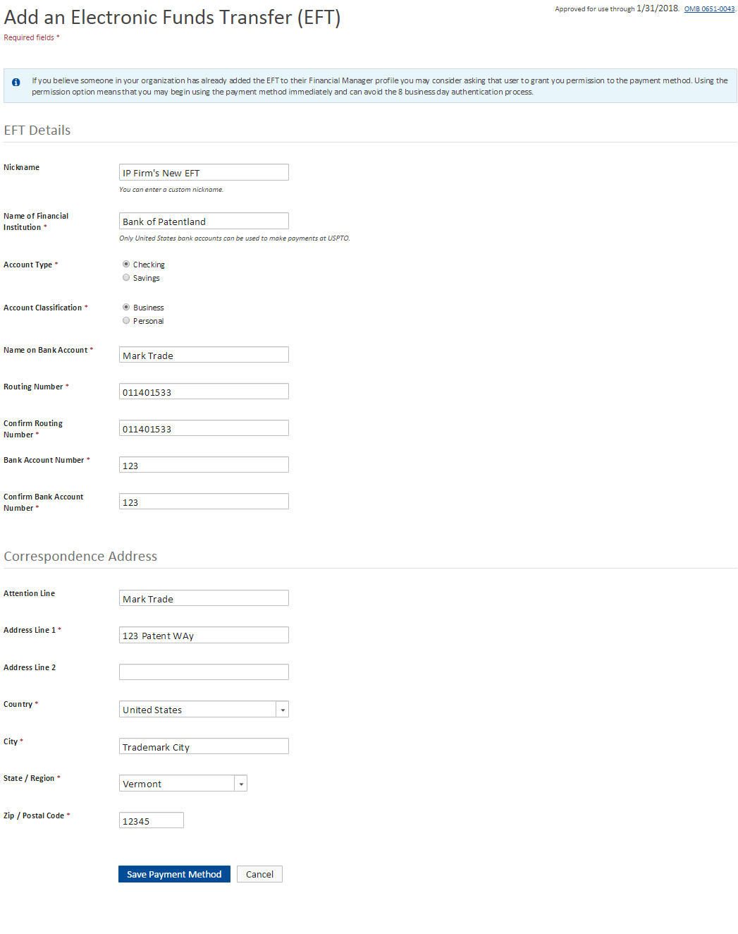
- Complete the Add an Electronic Funds Transfer form. A red asterisk (*) indicates that a field is required. When you have entered all of the required information, the Save Payment Method button will become active.
To complete the Add an Electronic Funds Transfer form, the following information is required (*):
- Name of Financial Institution
- Account Type
(checking or savings)
- Account Classification
(business or personal)
- Name on Bank Account
- Routing Number
- Bank Account Number
- Correspondence Address
(including country, city, state, and zip)

- Select the button at the bottom of the screen to submit the form. This will take you back to the My Payment Methods page, where your new EFT will be listed as one of your stored payment methods. A green success message will also display.
Immediately after the EFT is stored, it will display on your My Payment Methods page with a status of Pending Authentication, as in the example below.
On the payment method’s Summary page, a yellow alert box will indicate EFT Profile cannot be modified when an EFT is not in Active status.

Stored Payment Method Summary Page
The Summary pages for each of your stored payment methods includes administrative and transaction information about the payment method.
- To access the Summary page for a stored payment method, select the stored payment method on the My Payment Methods page.
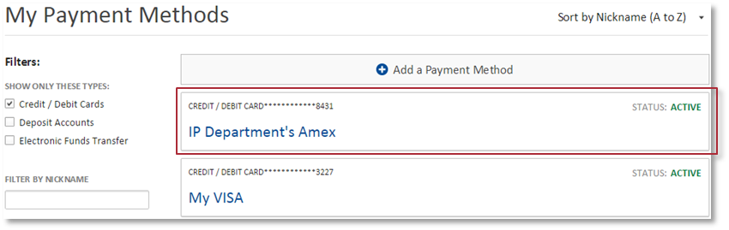
- While the details displayed on the Summary page will vary based on the level of access you have for the stored payment method, key components will be the same.
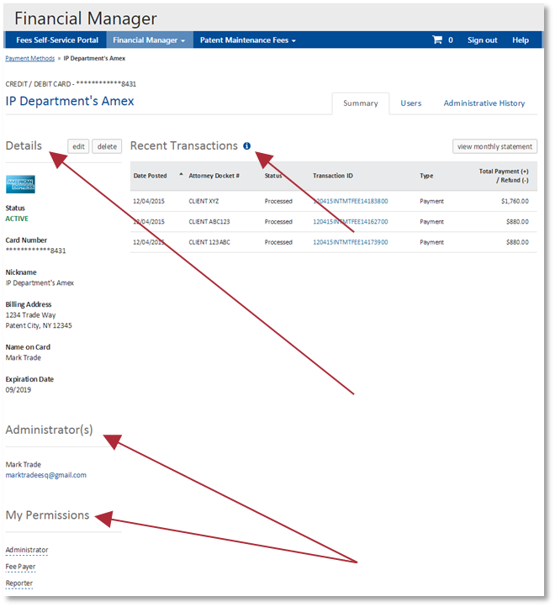
The center of the Summary page will display recent transactions completed with the stored payment method. Recent transactions are only visible to users with Reporter or Administrator permissions for the stored payment method.
Details for the stored payment method will display in the left column.
You will also be able to view contact information for Administrator(s) and your permissions for the stored payment method.
The Summary page will always display as the first tab.

Payment Method Details
Payment method details includes identifying information for the stored payment method (e.g. last four numbers of your credit card) and contact information associated with the stored payment method.
Under Details, you will also find your stored payment method’s:
- Status
- Nickname
- Administrators
Additional information displayed varies based on the stored payment method type. For example, deposit accounts list a deposit account number and EFTs list a routing number.

Payment Method Status
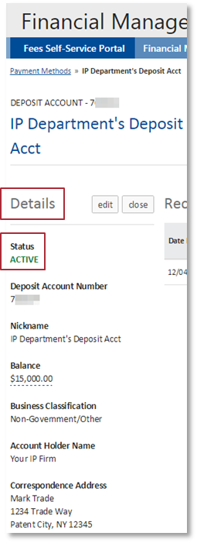
Your payment method status indicates your current and future ability to use the payment method to pay fees at the USPTO. Information about possible statuses for each payment method type is included in the Appendix.
In Financial Manager, you can find your payment method status on the My Payment Methods page or on the stored payment method Summary page.

User Permissions

Introduction to User Permissions
There are three standard permissions across all stored payment methods:
- An Administrator can:
  - View and modify the administrative details of the stored payment method
  - Delete or close a stored payment method
  - Grant and remove other users' permission and access to the stored payment method
- A Fee Payer can:
  - View the basic administrative details of the stored payment method
  - Make payments to the USPTO using the stored payment method
- A Reporter can:
  - View the basic administrative details of the stored payment method
  - Develop, view, and share reports about the transactions associated with the stored payment method
For deposit accounts and EFTs, there is a fourth permission:
- A Funds Manager can:
  - View the basic administrative details of the stored payment method
  - Add funds to a deposit account using an EFT (must also have Funds Manager permission on the EFT)
  - Transfer funds between two deposit accounts (must have Funds Manager permission on both deposit accounts)
  - Withdraw funds from a deposit account via mailed check or EFT (must also have Funds Manager permission on the EFT)
We suggest that you assign user permissions in a manner that aligns with your business processes. For example, if someone from your billing department handles most of your account reconciliation, consider granting them Reporter permissions.

Receiving Access to Existing Stored Payment Method
Anyone who has created a uspto.gov account can be granted access to an existing stored payment method in Financial Manager. To do this, an Administrator for the payment method must assign permission to the individual, using the user name (i.e. primary email address) associated with the user’s uspto.gov account.
Users that have been assigned permissions to a stored payment method will receive an automated email notification from Financial Manager explaining the change. The stored payment method will also become available on your My Payment Methods page.

View Your User Permissions
Each payment method stored in Financial Manager has its own set of customized user permissions. If you’ve been assigned any of the four user permissions for a given payment method, it will automatically display on your stored payment method Summary page in Financial Manager.

Email Notifications
Financial Manager sends auto-generated email notifications to help you manage your stored payment methods. Email notifications communicate an administrative action or payment method status change.
You will receive notifications that align with your permissions for each stored payment method. You will also receive an email notification when you receive new or updated permissions for a stored payment method.
There are two main types of email notifications:
- Standard Notification
Standard notifications are courtesy alerts or confirmation of a completed action. They do not call for any action from the recipient.
For example, deposit account Administrators and Funds Managers will receive an email notification when a deposit account replenishment has been successfully submitted for processing. No action is required; the email is just a courtesy notification.
- Notification and Action Required
Notifications requiring action are indications of an action or status change that inhibits your ability to use the stored payment method.
For example, credit/debit card Administrators and Fee Payers will receive an email notification when the credit/debit card has expired. An Administrator must update the credit/debit card details in order for payment functionality to resume at the USPTO.
At this time, email notifications can only be sent to the primary email address associated with a user’s uspto.gov account. Currently, customers cannot set preferences for or opt-out of receiving email notifications in Financial Manager.

PART THREE

I’m an Administrator.
What do I need to know?

The Administrator Role
In Financial Manager, an Administrator for a given stored payment method can:
- View and modify the administrative details of the stored payment method
- Delete or close a stored payment method
- Grant and remove other users' permission and access to the stored payment method

View and Modify Administrative Details

Payment Method Administrative Details
Payment method details are displayed in the left column of the Summary page for each of your stored payment methods. Learn more about payment method details.

Edit Payment Method Details
- On the payment method’s Summary page, select the button, located to the right of the Details header. This will take you to the form to update payment method details.
Only Administrators can access the edit button.
You can edit/update the following details for each stored payment method:
Credit/Debit Card | Deposit Account | Electronic Funds Transfer
- Nickname  - Name on Card  - Expiration Date  - Billing Address | - Nickname  - Account Holder Name  - Correspondence Address | - Nickname  - Name of Financial Institution  - Name on Bank Account  - Correspondence Address
- Edit the form fields to update details for your stored payment method.
- Select the button at the bottom of the screen to submit the form. This will take you to the payment method’s Summary page, where a green success message will indicate that you’ve successfully updated the stored payment method’s details. Your updated payment method details will be listed in the left column.

Recent Transactions

View Recent Transactions
Recent transactions for your stored payment method are displayed in a table on the payment method Summary page. It displays the 20 most recent transactions completed within the past 30 days. You can sort and apply filters to this table to help you find specific transactions.
The Recent Transactions table includes the following information for each transaction:
- Date Posted  - Status | - Transaction Reference #  - Total Credit / Total Debit  (deposit accounts only) | - Attorney Docket #  - Total Payment / Total Refund  (credit/debit cards and EFTs only) | - Transaction ID  - Type  (e.g. payment, refund, etc.)

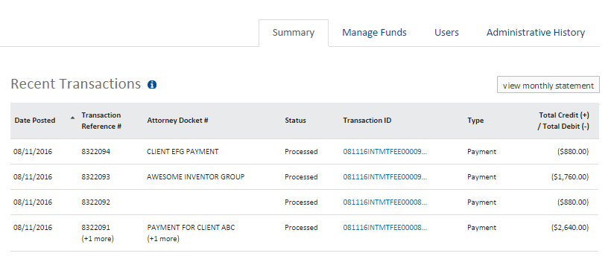

Administrative History Page
The administrative history for your stored payment method lists administrative changes that have been made to your stored payment method. These include changes to the payment method details, payment method status, and user permissions for the payment method. In addition, deposit accounts show changes to auto-replenishment and withdrawal options.
Access to the Administrative History page is limited to those with Administrator permission on the stored payment method.

View Administrative History
- From the stored payment method’s Summary page, select the 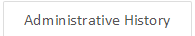 tab. This will open the stored payment method’s Administrative History page.
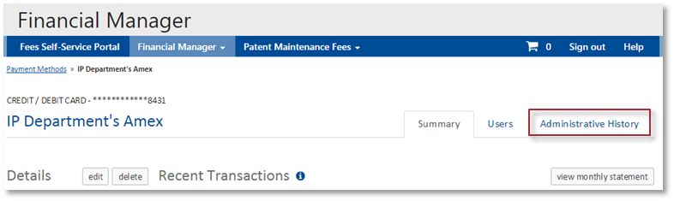
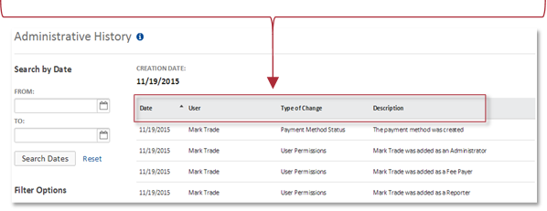
The Administrative History page includes details for each of the administrative actions or updates that have been made to the stored payment method. This includes:
Date | User | Type of Change | Description
Date the action was performed | Name of the user that performed the action – this can be someone from your organization or someone from the USPTO who completed the action on your behalf | Type of change that was made to the account. There are five types:  - Payment Method Details  - Payment Method Status  - User Permissions  - Auto Replenishment*  - Withdrawal Options*  *deposit accounts only | Details about the administrative action

Sort and Filter the Administrative History Table
To quickly find the information you need, you can sort the administrative history table by date, user, and type of change. This will rearrange the administrative actions so that the column you’ve selected displays in alphabetical or numerical order.
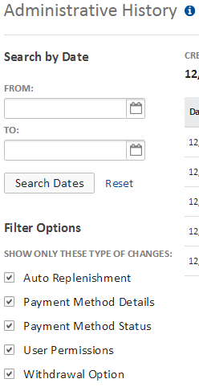
The Search by Date feature allows you to filter the Administrative History to only display items within a given range of dates.
You can also filter your Administrative History table so that it only displays items that are relevant to your search. You can filter your report to display items related to these types of changes:
- Auto Replenishment (deposit accounts only)
- Payment Method Details
- Payment Method Status
- User Permissions
- Withdrawal Options (deposit accounts only)
Learn more about sorting and filtering tables in Financial Manager.

Delete and Close Stored Payment Methods

Delete a Stored Payment Method
Deleting a stored payment method permanently removes it from your Financial Manager account and the accounts of all other users associated with the payment method. You will not be able to view transaction reports or view administrative history for the payment method. Deleting the payment method will not impact previously submitted payments.
To delete a deposit account, it must first be closed.
- On the stored payment method’s Summary page, select the button. A red and white confirmation message will display asking, “Are sure you want to delete this payment method?”
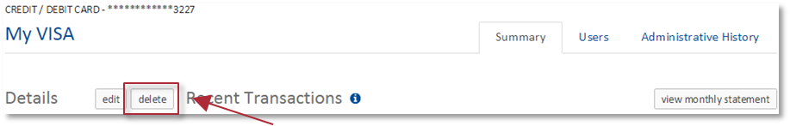
The delete button will only appear after a deposit account is closed. Only Administrators can access the delete button.
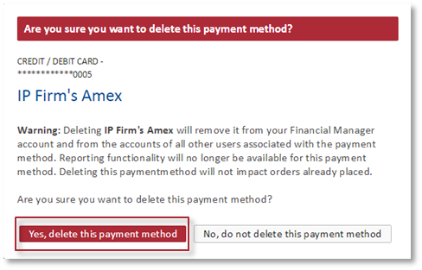
- Select the button. This will take you to the My Payment Methods page, where the deleted credit/debit card, EFT, or deposit account will no longer appear in your list of payment methods. At the top of the screen, a green success message will also indicate that you’ve successfully deleted the payment method.

Close a Deposit Account
When you close a deposit account, you will be asked to select a refund option, which is how you will receive the balance of funds in your deposit account. You may choose to transfer the funds to another deposit account or EFT you have Funds Manager permission for, or request a mailed check.
- On the deposit account’s Summary page, select the button. A red and white confirmation message will display asking, “Are sure you want to close this deposit account?”
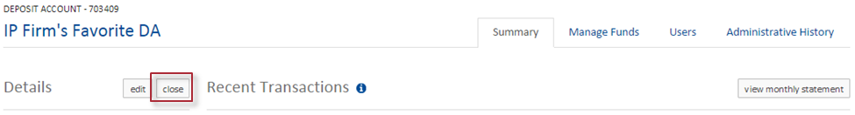
Only Administrators can access the close button.
- Select the button. This will take you to the Close Deposit Account page.
- Use the drop down box to select your refund method. If you select “Mailed Check,” a check will be mailed to the correspondence address associated with the deposit account.
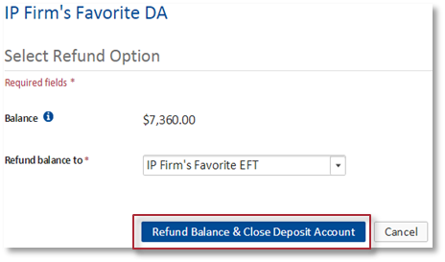
- Select the button at the bottom of the screen to submit the form. This will take you to the deposit account’s Summary page, where a success message will indicate you’ve successfully initiated the deposit account closure.

Once you initiate closure of your deposit account, you can no longer use it to make payments. It will close within 30 days – there is a 30 day waiting period from the date of the last posted transaction. If it has already been at least 30 days since your last transaction, your account will close the next business day. After closure, any remaining funds will be returned to you. On the deposit account’s Summary page, a yellow alert will display the date the account will close. An Administrator for the deposit account can reactivate a deposit account at any time during the pending closure period.

Reactivate a Deposit Account
After an Administrator submits a request to close a deposit account, the deposit account will transition to a status of Pending Closure – Customer Request. An Administrator can quickly reactivate a deposit account that is pending closure, if needed.
An Administrator can also reactivate a deposit account with a status of Active – No Recent Activity.
- On the deposit account’s Summary page, select the 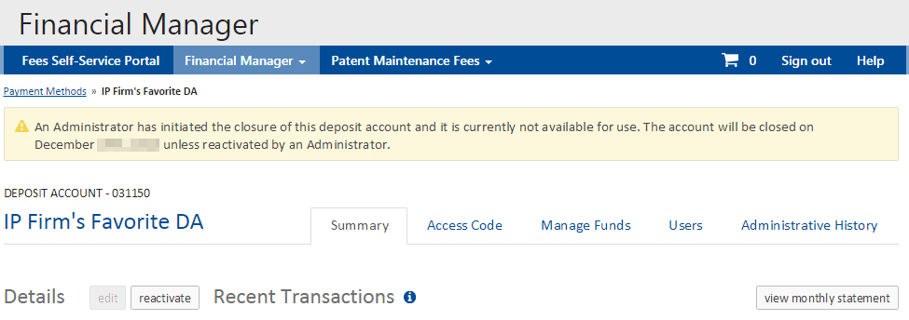 button. A red and white alert box will appear, asking if you are sure you want to reactivate this deposit account. 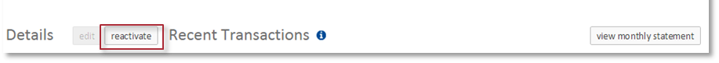
- Select the button. This will refresh the deposit account Summary page, where a green success message will indicate that you’ve successfully reactivated the deposit account. The status of the deposit account will also be updated to Active.
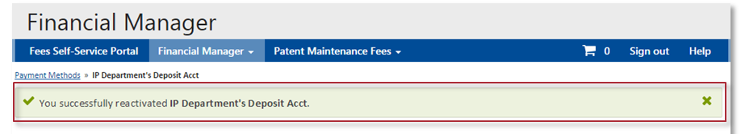

Grant and Remove User Permissions

User Permissions Page
The User Permissions page for your stored payment method allows Administrators to view, edit, and remove user permissions for the stored payment method. Additional information on user permissions is located in the Introduction to user permissions.

View User Permissions
Access to the User Permissions page is limited to those with Administrator permission on the stored payment method.

- Select the  tab on the stored payment method’s Summary page. The tab is always left of the Administrative History tab.
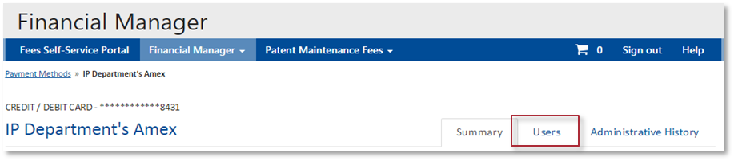
This will open the User Permissions page, where all of the users associated with your stored payment method are listed.
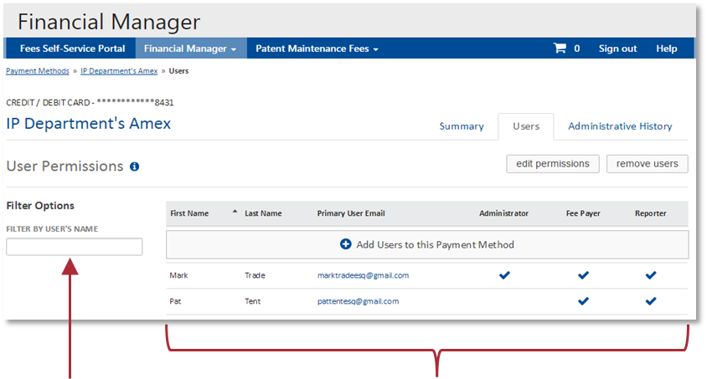
On the User Permissions page, a table lists all user information, including each user’s first name, last name, primary user email, and their assigned permissions indicated by check marks.
The filter allows you to refine your search by entering part of the user’s name.

Assign User Permissions
- On the User Permissions page, select the 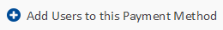button. This will take you to the Add User(s) to this Payment Method page.

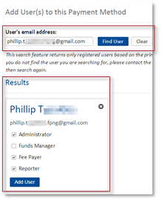
- Enter the user’s email address in the text field then select the button. The search will generate a “Results” box that lists the matching user’s email address, full name, and available permissions.
You must enter the email address associated with the user’s uspto.gov account.
- Select the checkboxes to assign permissions for the user. Hover your mouse over the permissions to view details about each.
As you select permissions for the user, Financial Manager will add additional permissions that pair well with the one(s) you’ve chosen, as described in the table below. You can deselect any permission(s) you do not want the user to have.
Permission Selected | Administrator | Funds Manager | Fee Payer
Auto-added Permission(s) | Fee Payer; Reporter | Reporter | Reporter
- Select the button. This will take you back to the Add User(s) page for the payment method. At the top of the screen, a green success message will indicate that you’ve successfully assigned the user permission(s).
There is no limit to the number of users you can add to a stored payment method.

Edit User Permissions
As an Administrator, you can also make updates to existing user permissions on your stored payment method. If you are an Administrator with multiple permissions, you can change all of your own permissions except “Administrator.”
- On the stored payment method’s User Permissions page, select the button.
This will reveal checkboxes that allow you to edit user permissions for one or more than one user. Each user associated with the stored payment method is listed, followed by a row of checkboxes that correspond to each permission.
- Select the checkboxes to assign or remove permissions for each user as desired. The button will become active only if you’ve made changes to the user permissions.
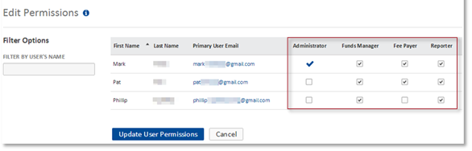
- After updating the Edit Permissions page, select the button to submit the form. This will take you to the User Permissions page. At the top of the screen, a green success message will indicate that you’ve successfully edited the user permission(s).
Each user associated with the stored payment method must have at least one permission. If you want to remove all permissions for a user, you must remove the user.

Remove Users from a Stored Payment Method
If you’d like to remove all of a user’s permissions to a stored payment method, you will need to remove the user from the stored payment method. This will completely eliminate the user’s access to your stored payment method.
An Administrator cannot remove him/herself from a stored payment method; this must be completed by another Administrator.
- On the stored payment method’s User Permissions page, select the button. This will take you to the Remove Users page.
- Select the checkbox(es) left of the user(s) you’d like to remove. You can perform this action for multiple users at once. You cannot remove yourself from the stored payment method.
- Select the button at the bottom of the page. A red and white confirmation message will display asking, “Are sure you want to remove the selected user(s)?”
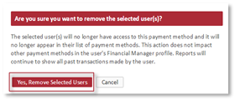
- Select the button. This will refresh the Users page, where a green success message will indicate that you’ve successfully removed the user(s).

Manage Deposit Accounts

Manage Deposit Account Withdrawal Options
In order for funds to be withdrawn from a deposit account, an Administrator must first select which option(s) will be available to the Funds Manager(s). This separation of duties helps protect our customers from unauthorized withdrawals. Both options are turned off by default.
- On the deposit account Summary page, select the Manage Funds tab. Then select the Manage Withdrawal Options tab.
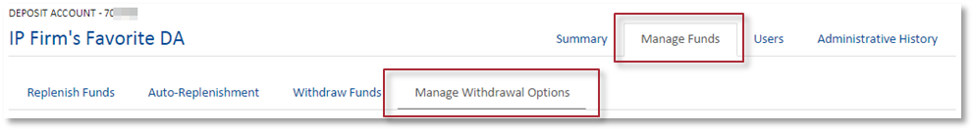
- On the deposit account Manage Withdrawal Options page, select the button. This will activate dropdown menus, allowing you to update the withdrawal options.
- Use the dropdown menus to indicate whether you wish to “Allow” or “Not Allow” funds to be returned via EFT and mailed check. For deposit accounts belonging to government entities, funds may only be returned via mailed check.
Allowing an EFT withdrawal permits Funds Managers to withdraw funds to any EFT for which they have Funds Manager permissions. Mailed Check withdrawals will only be sent to the correspondence address associated with the deposit account.
- Select the button to save your withdrawal options. This will refresh the Manage Withdrawal Options page, where your new withdrawal options will display for each option. A green success message will also display, indicating that you’ve successfully updated the deposit account’s withdrawal options.

PART FOUR

I’m a Fee Payer.
What do I need to know?

The Fee Payer Role
In Financial Manager, a Fee Payer for a given stored payment method can:
- View the basic administrative details of the stored payment method and
- Submit payments to the USPTO using the stored payment method.

View Administrative Details

Payment Method Administrative Details
Payment method details are displayed in the left column of the Summary page for each of your stored payment methods. Learn more about payment method details.

Submit Payments to the USPTO
With Financial Manager, uspto.gov account holders can quickly submit payments to the USPTO using a stored payment method. This means that you no longer have to enter detailed payment information for each transaction you make. Only Fee Payers for the stored payment method can use it to check out while logged in to uspto.gov.

Checking Out
Online payment of USPTO fees is initiated in the storefront that collects the fee. Some examples of USPTO storefronts include the Patent Maintenance Fees Storefront, EFS-Web, and TEAS.
The fee payment process will vary between storefronts. The Fee Payment examples included in this guide are from the Patent Maintenance Fees Storefront. Not all USPTO storefronts offer the option to use a shopping cart and pay with a stored payment method. A list of storefronts that offer these options is included in the Appendix.
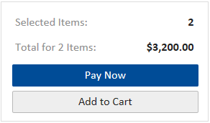
In the storefront, Fee Payers who are logged in to uspto.gov will have the option to select or before checking out.
Selecting “Add to Cart” will add the fee payment to your uspto.gov shopping cart.
Selecting “Pay Now” will take you to the uspto.gov Payment page.

Shopping Cart
Some USPTO storefronts allow logged in uspto.gov users to add items to a shopping cart before checking out. You can add items to your shopping cart and check out once you have compiled all of the fees you wish to pay. You can also review and delete items in your cart or pay some of the fees, leaving others in the cart to pay later. The cart will display an expiration date for each item. Items not paid for by the posted expiration date will be removed from your cart.
To access your shopping cart, select the  icon in the storefront navigation menu.
A list of storefronts that offer shopping cart services is included in the Appendix.

Review Items in your Shopping Cart
The details for each item in your cart are displayed in a table. The type of details displayed will vary between storefronts.
The checkboxes on the left of the table allow you to select fees you’d like to pay or delete. If you have multiple items in your cart, you can use the checkbox in the header to select or deselect all of the items in your cart.
The shopping cart will calculate the sum of all fees selected for payment.

Delete Items in Your Shopping Cart
- Use the checkboxes to indicate which item(s) you’d like to remove from your shopping cart. By default, all of the items in your cart will be selected, so you will need to make sure that the items you want to keep are unchecked.
- Select the 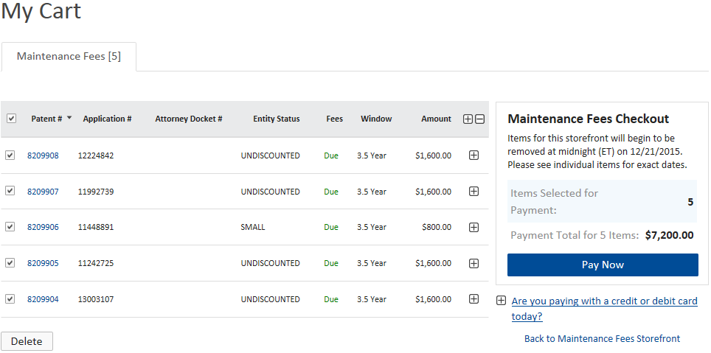 button to remove the selected items from your shopping cart. A red and white confirmation message will display asking, “Are sure you want to delete these items?”
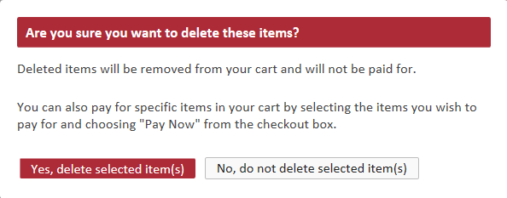
- Select the button. This will refresh your cart and a green success message will indicate that you’ve deleted the item(s) from your cart.

Pay for Items in Your Shopping Cart
- Use the checkboxes to indicate which item(s) you’d like to pay for. By default, all of the items in your cart will be selected, so you will need to make sure that the items you don’t want to pay for are unchecked.
- Select the button under Payment Total. This will take you to the Payment page, where you will enter payment information.

USPTO Payment Page
After you’ve selected in the storefront or shopping cart, you will be directed to the uspto.gov Payment page. The Payment page outlines the fees you are paying, collects your payment information, and accepts your payment.

Submit Payment Using a Stored Payment Method
- In the Payment Information section, select the Stored Payment Method radio button to activate the stored payment dropdown menu. The dropdown menu lists all stored payment methods for which you have Fee Payer permission.
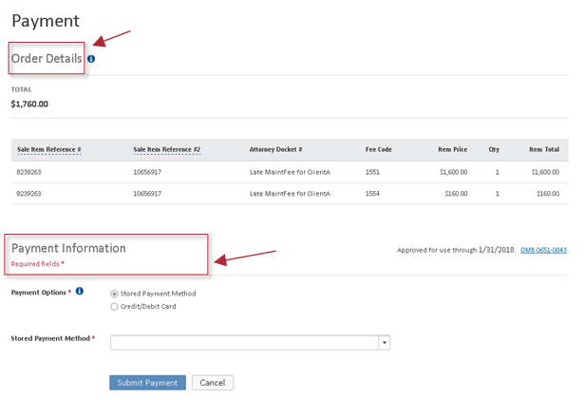
The Payment Information section of the payment page allows you to select a payment option and choose a stored payment method to check out with.
The Order Details section of the payment page includes the total amount for all of the fees you’re paying. It also lists details about each fee.
- Use the dropdown menu to select the stored payment method you’d like to use to pay your fees. If you are paying with a credit/debit card, you will be asked to enter the card security code (CVV). Data security best practices require us to collect credit card security codes for each credit/debit card transaction. The button will only become active if this information is provided.
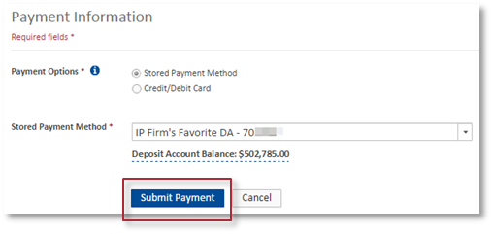
- Select the button. This will submit your payment information and take you back to the storefront, where you will receive your receipt.

Establish a General Authorization / Fee Preauthorization
A general authorization, also known as a fee preauthorization, authorizes the Director of the USPTO to charge any deficiency in the payment of required fee(s) and/or to credit any overpayments associated with a filing. The subsequent debits/credits will post against a deposit account designated by the customer at the time the fee preauthorization is established.
General Authorizations are currently available to customers submitting payments to the USPTO via the EFS-Web storefront only. In the future, general authorizations will be available in additional USPTO storefronts.
- On the USPTO Payment page, complete the Payment Information section of the form.
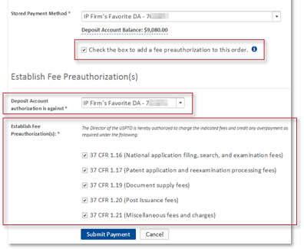
- Select the checkbox to add a fee preauthorization to your order. This will enable the Establish Fee Preauthorization(s) form to display.
- Use the dropdown menu to select the deposit account you’d like to use for this pre-authorization.
- Use the checkboxes to select the fees you’d like to authorize charges/credits for.
- Select the 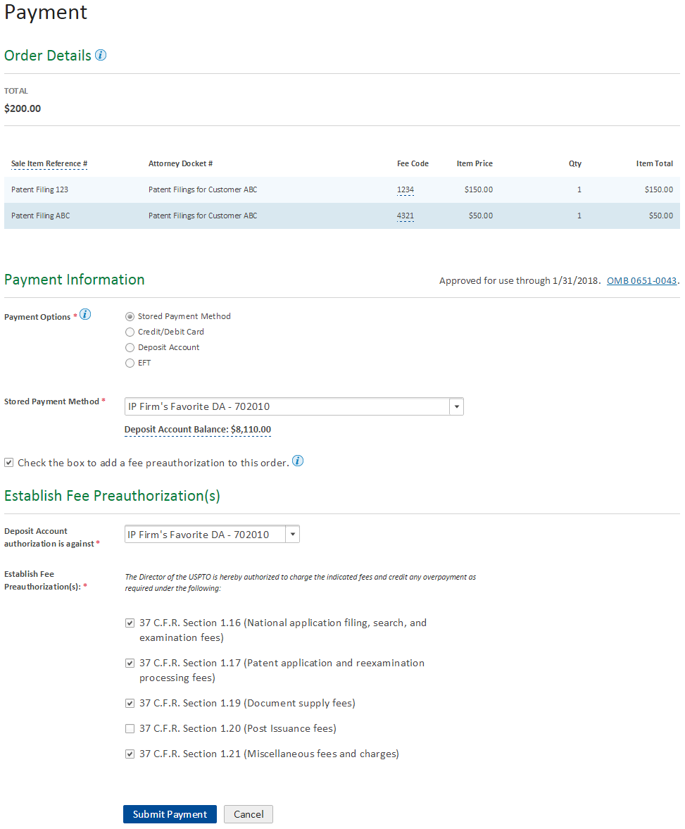 button.

PART FIVE

I’m a Reporter.
What do I need to know?

The Reporter Role
In Financial Manager, a Reporter for a given stored payment method can:
- View the basic administrative details of the stored payment method and
- Develop, view, and download reports about transactions associated with the stored payment method.

View Administrative Details

Payment Method Administrative Details
Payment method details are displayed in the left column of the Summary page for each of your stored payment methods. Learn more about payment method details. The Summary page is the only page/tab available to users with Reporter only access to the stored payment method in Financial Manager.

Develop, View, and Download Transaction Reports

Recent Transactions, Transaction Reports, and Monthly Statements

View Recent Transactions
Recent transactions for your stored payment method are displayed in a table on the payment method Summary page. It displays the 20 most recent transactions completed within the past 30 days. You can sort and apply filters to this table to help you find specific transactions.
The Recent Transactions table includes the following information for each transaction:
- Date Posted  - Status | - Transaction Reference #  - Total Credit / Total Debit  (deposit accounts only) | - Attorney Docket #  - Total Payment / Total Refund  (credit/debit cards and EFTs only) | - Transaction ID  - Type  (e.g. payment, refund, etc.)
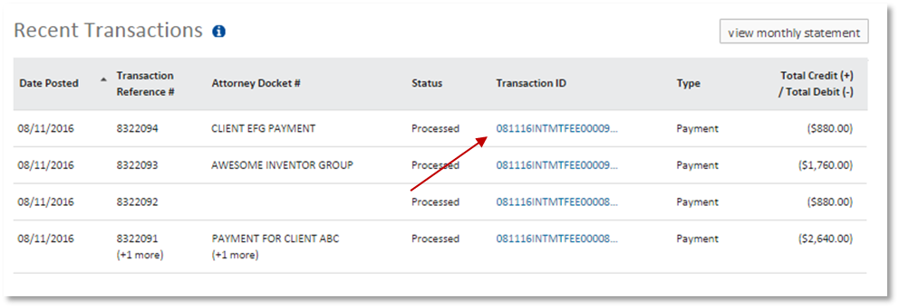
For more information about a specific transaction, you may select a hyperlink in the Transaction ID column to view transaction details.

Search for a Transaction / View Transaction Report
- From any page in Financial Manager, select “Transaction Search,” located in Financial Manager drop down of the menu main navigation menu. This will take you the Transaction Search form.
- Complete the Transaction Search form, indicating what payment method you’d like to run a report for, the date range you’d like to view, and additional identifying details to help narrow your search.
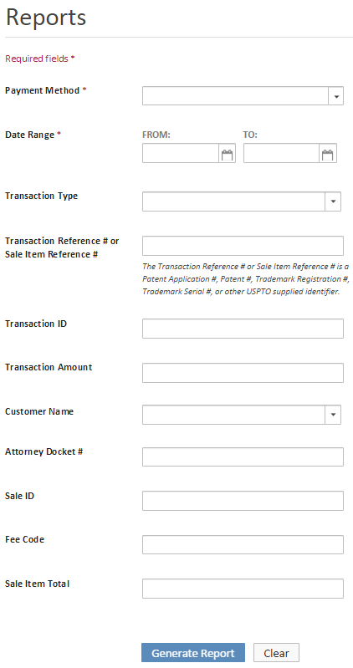
Payment Method
Optional search fields can help you narrow your search even further.
Payment Method and Date Range are required fields for all transaction searches.
Use the dropdown menu to select the stored payment method. You can only generate transaction reports on payment methods for which you are a Reporter. Reports are not available for deleted stored payment methods. You may choose to search for transactions within one payment method or all payment methods of the same type.
Date Range
Manually enter the date in MM/DD/YY format or use the dropdown menu to select the earliest and most recent dates you’d like to view. You can run reports on transactions conducted within the last eight years.
Transaction Type
Use the drop down menu to select which types of transactions you’d like to view. Details about transaction types available for each stored payment method type are available in the Appendix.
Transaction Reference # or Sale Item Reference #
Enter the patent application number, patent number, trademark registration number, trademark serial number, or other USPTO supplied identifier.
Transaction ID
If you are looking for a specific transaction, you can enter the Transaction ID provided on the transaction receipt.
Transaction Amount
Enter the dollar amount of the transaction you are looking for, if you know the exact amount.
Attorney Docket #
Enter the Attorney Docket Number you created to tag the transaction. An Attorney Docket Number is a reference text of up to 25 alphanumeric characters that many organizations use to label transactions and reconcile accounts. It can be any combination of numbers, letters, and spaces.
The following fields only become active if you are a searching for a “Payment” transaction type. This information can be found in the receipt you received after completing the transaction.
Sale ID
Enter the sale ID number for the fee paid in the transaction.
Fee Code
Enter the fee code for the fee paid in the transaction. If you paid multiple fees in the same transaction, you may enter the fee code for any one of the fees paid.
Sale Item Total
Enter the exact amount paid for one of the fees paid within the transaction.
Customer Name
Use the dropdown menu to select the customer that completed the transaction. The dropdown menu will display the names of all Fee Payers who completed payment transactions while signed in during the specified date range.
- Select the button. This will take you to the Transaction Search Results page, where all transactions meeting your criteria will display as expandable items within the table. You can sort this table and select the transaction ID to and view transaction details.

View Monthly Statements
Monthly statements outline all USPTO transactions completed with your stored payment within a given month. There are two ways to access your monthly statement:
From any Financial Manager Screen:
- From any page in Financial Manager, select “Monthly Statements,” located in the Financial Manager menu. This will take you to the Monthly Statements form.
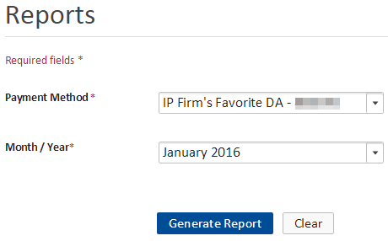
- Complete the Monthly Statements form to indicate the payment method and month/year you’d like to view.
Payment Method
Use the dropdown menu to select the payment method. You will be able to select any stored payment method for which you are a Reporter.
Month/Year
Use the dropdown menu to select the month/year you’d like to view. You can retrieve statements for any month within the past eight years.
- Select the button. This will take you to the monthly statement for the payment method and month/year you requested. All transactions completed within that period will display as expandable items within the table.
You can sort and apply filters to the monthly statement to help you find specific transactions.
From the stored payment method’s Summary page:
- Select the 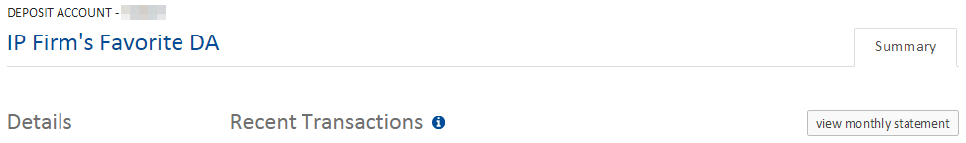 button in the upper right corner of the screen. This will take you to the the stored payment method’s monthy statement for the previous month.
Understanding Your Monthly Statement
- The statement month dropdown menu allows you to change which month’s statement you are viewing. | - The Date Range explains which dates are included in the report you are viewing.
- The Total Credits/Refunds and Total Debits/Payments fields indicate how much money has been added (credits/refunds) or deducted from (debits/payments) the account during the monthly period. For EFTs and credit/debit cards, this will display as total payments and refunds. | - The Opening Balance and Closing Balance (deposit accounts only) indicate the account balance at the beginning of the month (opening) and the end of the month (closing). The opening balance is available on the fourth business day of the same month. The closing balance is available on the fourth business day of the next month.
- The Select a filter dropdown menu allows you to apply up to three filters to the monthly statements. | - If you apply filters to your monthly statement, they will display in the filter boxes.

Download Transaction Reports and Monthly Statements
In Financial Manager, you can download transaction reports or monthly statements as a PDF, Excel, or CSV file. Three buttons at the top right of the transaction report or monthly statement provide these options.
- To download the transaction report or monthly statement, select the button that corresponds with the type of file you’d like to download. The download will begin automatically.
Details about the format of your downloaded Transaction Reports and Monthly Statements are available in the Financial Manager Reports Handbook.

View Transaction Details Page
Transaction detail pages provide detailed information about items paid for within a single transaction.
- From your stored payment method’s recent transactions, transaction report, or monthly statement, select the Transaction ID hyperlink that corresponds with the transaction you’d like to view. This will take you to the Transaction Details page.
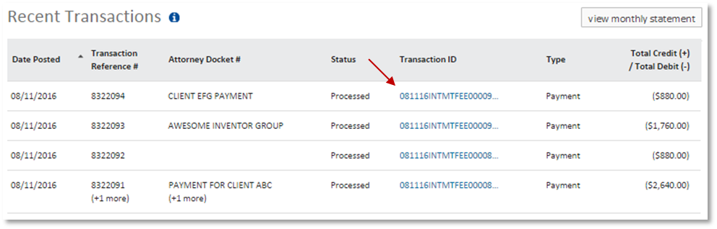
To view the transaction details page for a given transaction, select the Transaction ID hyperlink.

Understanding the Transaction Details Page
- The Transactions Details page includes the following information for each payment:
- Date Posted  - Total Payment  (credit/debit cards and EFTs only) | - Transaction ID  - Total Debit  (deposit accounts only) | - Status  - Type (payment)
- The Transactions Details page includes the following information for each fee paid:
- Sale Item Reference #  - Fee Code  - Customer Name | - Attorney Docket #  - Quantity | - Status  - Item Price | - Sale ID  - Item Total
- The Transactions Details page includes the following information for each refund:
- Type (refund)  - Transaction Reference # | - Date Posted  - Total Refund  (credit/debit cards and EFTs only) | - Status  - Total Credit  (deposit accounts only) | - Transaction ID
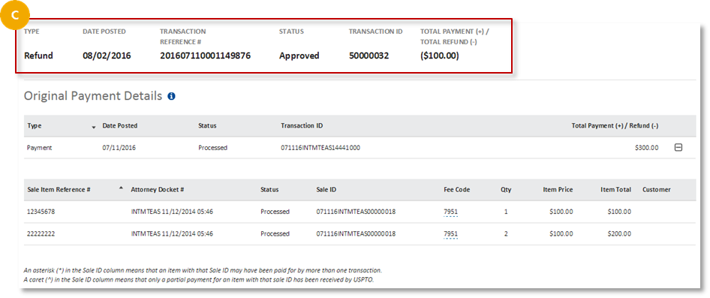
Refunds are tied to the original payment transaction, not a specific fee within the transaction. Therefore, in cases of overpayments or when funds from the original payment are reapplied to a new sale transaction, the refunded amount may not match the Item Total listed in the original transaction.

PART SIX

I’m a Funds Manager.
What do I need to know?

The Funds Manager Role
The Funds Manager role is available for deposit accounts and EFTs only. In Financial Manager, a Funds Manager can:
- View the basic administrative details of the stored payment method,
- Add funds to a deposit account using an EFT (must also have Funds Manager permission on the EFT),
- Transfer funds between two deposit accounts (must have Funds Manager permission on both deposit accounts), and
- Withdraw funds from a deposit account via mailed check or EFT (must also have Funds Manager permission on the EFT).

View Administrative Details

Payment Method Administrative Details
Payment method details are displayed in the left column of the Summary page for each of your stored payment methods. Learn more about payment method details.

Add Funds to a Deposit Account

Replenish a Deposit Account
The Replenish Funds feature allows you to transfer funds to your deposit account from an EFT or another deposit account. If you wish to process a deposit account transfer, you must initiate a replenishment for the deposit account you are transferring funds to.
- On the deposit account’s Summary page, select the 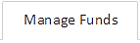 tab. This will open the Replenish Funds page.
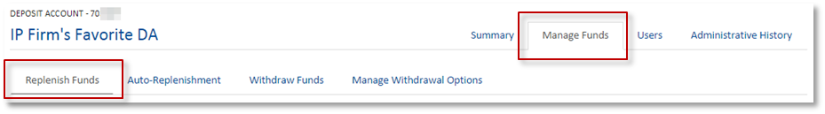
- Select the “Replenish Funds” tab if you were not automatically directed there.
- Complete the Replenish Funds form to indicate how much you’d like to add to the deposit account and what source you’d like to use to replenish the funds.
Replenish funds from
Use the dropdown menu to select the funding source you’d like to use to replenish your deposit account. Your choices will be listed by nickname.
You must have Funds Manager permission on the EFT or other deposit account in order to select it as a source of funds for your replenishment.
Amount to replenish
Enter the amount of money (USD) you’d like to add to the deposit account.
Attorney Docket Number
You may choose to enter an Attorney Docket Number. This is a reference text of up to 25 alphanumeric characters that many organizations use to label transactions and reconcile accounts. It can be any combination of numbers, letters, and spaces.
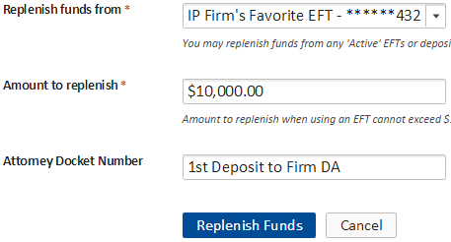
- Select the button to complete the transaction. This will take you to the deposit account’s Summary page, where a success message will indicate that your replenishment was successfully submitted. You will also receive an email notification from Financial Manager.
The amount of time it takes for the replenishment to post to your deposit account depends on the funding source you use to add funds to your deposit account. Please visit the Appendix to learn more about deposit account replenishment processing time.

Set Up and Modify Deposit Account Auto-Replenishment
The Auto-Replenishment feature allows you to set up automatic transfer of funds from an EFT to your deposit account. Financial Manager will check deposit account balances once per day and replenish deposit accounts using this feature when the balance is below the customer defined threshold.
- On the deposit account’s Summary page, select the “Manage Funds” tab. This will open the Replenish Funds page.
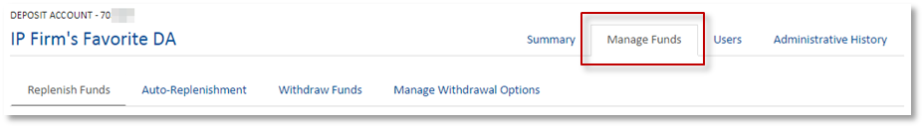

- Select the 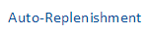 sub header. This will open the Auto-Replenishment form.
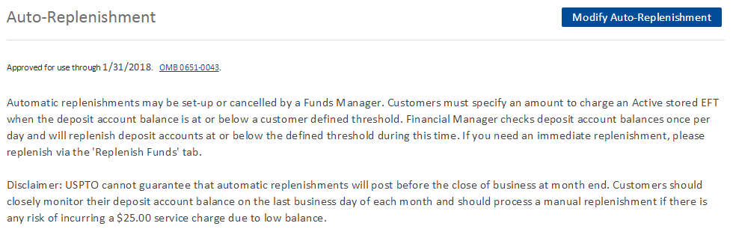
- Select the button. This will activate the Auto-replenishment toggle button.

- Select the button to toggle on the Auto-Replenishment option. Once the button is in the “ON” position, subsequent form fields will become active.
- Complete the Auto-Replenishment form, indicating your desired replenishment threshold, replenishment amount, and source.
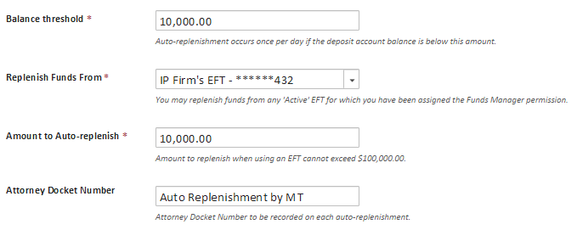
- Read and check the box to authorize the USPTO to debit your EFT as instructed and agree to the USPTO’s Auto-Replenishment policy.
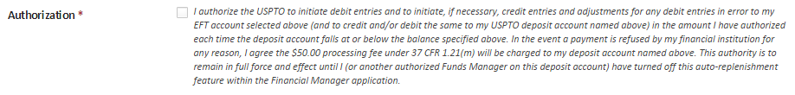
- Select the button.

Withdraw Funds From Deposit Accounts
The Withdraw Funds feature allows you to withdraw funds from a deposit account when this feature is enabled by an Administrator. The funds may be returned via an EFT or mailed check depending on the options selected by the Administrator.
Funds may not be immediately available for withdrawal. There is a holding period of 14 business days for EFT replenishments and 30 business days for check replenishments before those funds are available for withdrawal.
- From the deposit account Summary page, select the Manage Funds tab. Then select the Withdraw Funds tab. 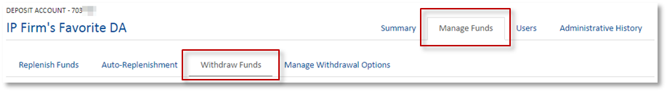
- On the Withdraw Funds page, complete the form to indicate how much you’d like to withdraw and how you want to receive the funds. 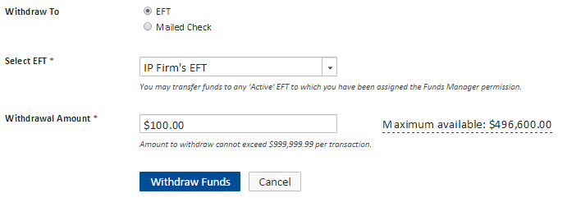
Withdraw To
If you chose to withdraw funds to an EFT account stored in Financial Manager, you will be able to select the EFT you’d like the funds to be delivered to. If you’d like the funds to be returned via mailed check, it will be sent to the Correspondence Address on file. Administrators for the deposit account can turn on/off the option to withdraw funds from the deposit account via electronic funds transfer (EFT) and/or Mailed Check. If you do not have these options available and need to make a withdrawal, you will need to contact an Administrator of the Deposit Account to update the withdrawal options.
Select EFT
Use the dropdown menu to select the EFT you’d like your withdrawal delivered to. You can only send funds to an EFT for which you are a Funds Manager. This field only displays if an Administrator has enabled withdrawals via EFT.
Withdrawal Amount
Enter the amount you’d like to withdraw from the deposit account.
Maximum Available
The maximum available to withdraw from the selected deposit account is the available balance of the deposit account less $25.00 and less any EFT replenishment received within the past 14 business days and/or any check replenishment received within the past 30 business days. You cannot withdraw your account down to zero without going through the closure process.
- Select the 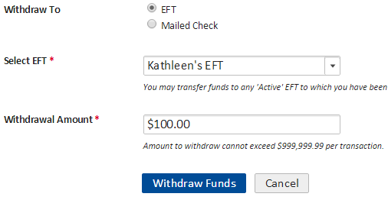 button. This will refresh the Withdraw Funds page, where a success message will indicate you’ve successfully submitted the withdrawal request.

PART SEVEN

Appendix

Stored Payment Method Status Definitions
Status | Applicable Payment Methods | Definition
Active | All | Your stored payment method is in good standing and can be used to make payments.
Active –  Low Balance | Deposit Account  Only | Your deposit account has fallen below the required minimum balance, $1000.00 for unrestricted deposit accounts and $300.00 for restricted deposit accounts. If the deposit account is below the required minimum balance on the last day of the month, the deposit account will incur a $25.00 service charge. The deposit account will continue to incur a $25 service charge each month until the balance is drawn down to $0 or until the account is replenished with enough funds to reach the minimum required balance at month end.
Active –  No Recent Activity | Deposit Account  Only | Your deposit account has not been used in the past year. It will be closed in 60 days unless a transaction is posted against the Deposit Account within 30 days of entering Active – No Recent Activity status or the Deposit Account is reactivated by an Administrator within 60 days. If your deposit account is closed automatically, a check for the remaining balance will be mailed to your correspondence address.
Active –  Unfunded | Deposit Account  Only | Your deposit account has a balance of $0. This may be because your deposit account was recently created, but not funded or because your funds have been depleted. You have 45 days from entering Active – Unfunded status to replenish your deposit account or it will close automatically.
Closed –  Customer Request | Deposit Account  Only | Your deposit account has been closed by an Administrator of the deposit account.
Closed –  No Recent Activity | Deposit Account  Only | Your deposit account has not been used in the past year. No action was taken to retain it during the 60 day grace period and it was closed automatically. A check for the remaining balance has been mailed to your correspondence address.
Closed –  Unfunded | Deposit Account  Only | Your deposit account was not funded within 45 days of the balance falling to $0, so it was closed automatically.
Expired | Credit/Debit Card  Only | Your credit/debit card has expired. One of your Administrators will need to update the expiration date for the card.
Failed  Authentication | EFT Accounts  Only | Your EFT failed authentication with the Department of the Treasury. Delete the failed EFT from your profile, contact your bank to confirm your account information and initiate the process to add a new EFT with corrected information.
Finance  Inactivated | All | Your stored payment method has been inactivated by USPTO’s Finance Group.
Pending Authentication | EFT Accounts  Only | Your EFT has been submitted to the Department of the Treasury for authentication. The authentication process takes 8 business days. When the authentication process is complete, you will receive an email notification and the status of the EFT will be updated in Financial Manager.
Pending Closure – Customer Request | Deposit Account  Only | An Administrator for this deposit account requested to have it closed. It can no longer be used to make payments unless an Administrator reactivates it. The pending closure period is 30 days from the date that the last transaction posted against the account. During this time, an Administrator may reactivate the deposit account.
Pending Closure –  No Recent Activity | Deposit Account  Only | The deposit account has been inactive for one year and 30 days. The deposit account will automatically close after 30 days of entering status Pending Closure – No Recent Activity unless an Administrator chooses to reactivate the deposit account.
Returned Payment | EFT Accounts  Only | A payment associated with your EFT has been returned by your bank. This EFT cannot be used to make payments until this matter is resolved. Contact RADHelpdesk@uspto.gov for assistance with reactivating your EFT after a returned payment.

Transacation Types Available in Transaction Search Reports

Credit/Debit Card
- Payment
- Refund

Electronic Funds Tansfer (EFT)
- Payment
- Refund
- Credit To Deposit Account (Replenishment)
- Credit From Deposit Account (Withdrawal)

Deposit Account
- Payment
- Refund
- Replenishment
- Withdrawal

USPTO Shopping Cart Services
The following UPSTO storefronts offer shopping cart services:
- Patent Maintenance Fees Storefront

Deposit Account Replenishment Time
The processing time for deposit account replenishments varies depending on the replenishment method.

EFT Replenishment
EFT replenishments are posted near real-time when an active EFT is used. Check again in a few minutes.

Transfer from another Deposit Account
A transfer from another deposit account is posted near real-time when an active deposit account is used. Check again in a few minutes.

Wire Transfers
The USPTO must receive funds by noon Eastern Time to be credited on the same business day and available in your deposit account.

Mailed Check
After the USPTO receives your check, it generally takes 2-3 business days for the payment to be credited and available in your deposit account.

Intra-Governmental Payment and Collection (IPAC) system (Federal Agencies Only)
IPAC payments are generally credited and available in your Deposit Account within 2-3 business days.

Contact Us
We’d love to hear from you! Your questions and comments about Financial Manager help us make improvements that enhance your online fee payment experience.
- For more information on Financial Manager, visit us online at www.uspto.gov/financialmanager.
- For technical support or questions about Financial Manager, give us a call or send us an email.
  - Toll Free: 800-786-9199
  - Local: 571-272-1000
  - TTY: 800-877-8339
  - Email: FeesHelp@uspto.gov
- To share comments or feedback about Financial Manager, send us an email at FeesHelp@uspto.gov.

