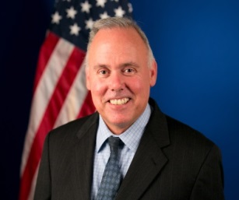
Anthony Caputa

Anthony (Tony) Caputa is the Director of the Office of Patent Quality Assurance (OPQA). As the Director of OPQA, Tony Caputa is responsible for assessment and measurement of patent examination quality at the USPTO as well as providing support to the patent examining Corps in developing and implementing data-driven quality improvement initiatives.

Mr. Caputa received his Bachelor of Science degree from the University of Wisconsin in Bacteriology and a Doctor of Philosophy (PhD) degree from the University of Minnesota in Veterinary Microbiology.

