DEPARTMENT OF COMMERCE
2018 FINANCIAL MANAGEMENT TRAINING
US Patent & Trademark Office, Alexandria, VA
May 29 – 31, 2018
- Directions and parking
Addresses for GPS or Google Maps:
Madison Building North Entrance - 600 Dulany Street, Alexandria, VA
USPTO West Parking Garage - 550 Elizabeth Ln, Alexandria, VA 22314
USPTO East Parking Garage - 598 John Carlyle St, Alexandria, VA 22314

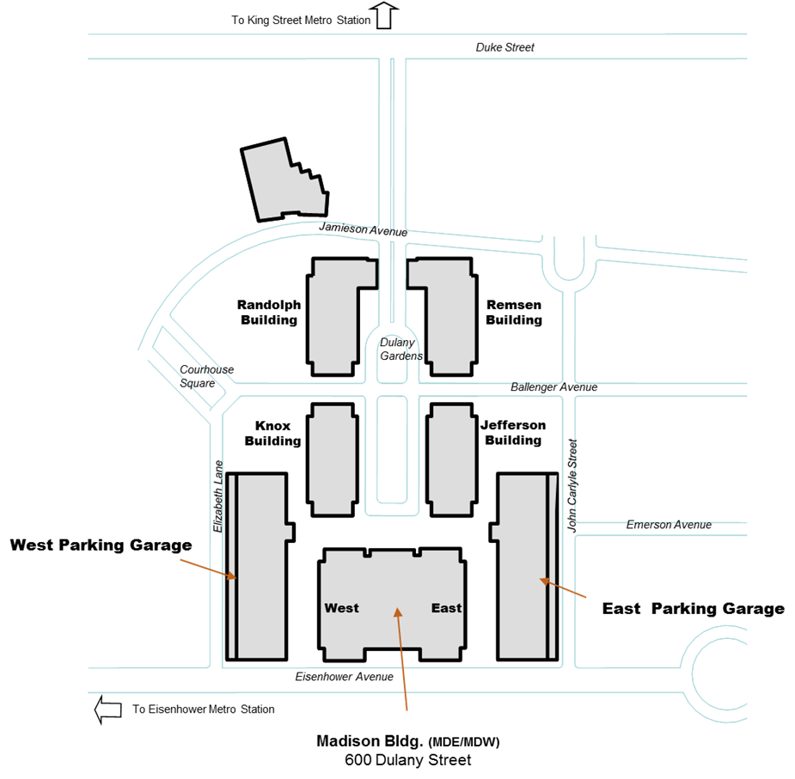

By car/van:
Addresses for GPS or Google Maps:
Madison Building North Entrance - 600 Dulany Street, Alexandria, VA
USPTO West Parking Garage - 550 Elizabeth Ln, Alexandria, VA 22314
USPTO East Parking Garage - 598 John Carlyle St, Alexandria, VA 22314
Parking:
Use Level 2 exit from the EAST garage for Concourse level/Madison Auditorium. Use Level 1 exit from the WEST garage for Concourse level/Madison Auditorium. Pay on your way out using a pay station in the garage elevator lobby or in the garage. Parking is $10, but a $2 discount can be applied for Federal employees at any security station.
By Metro:
- Take yellow or blue line to the King Street station, or yellow line to Eisenhower station.
- Follow the maps below for the King Street or Eisenhower stations.
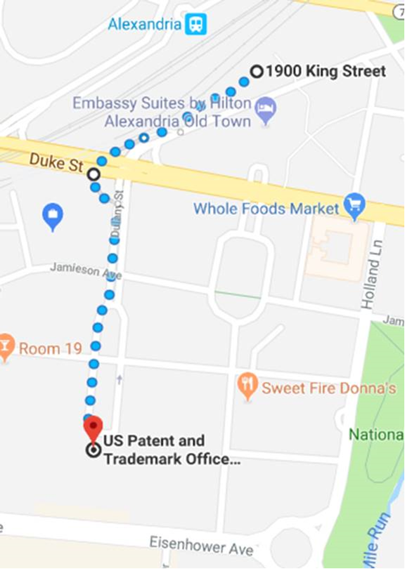

PLEASE USE THE TUNNEL UNDER DUKE STREET FOR OWN YOUR SAFETY!

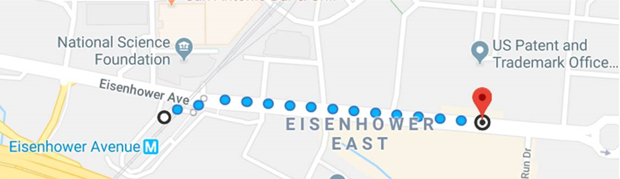

- USPTO Cafeteria
USPTO Roundhouse Café

Menu Link

Online ordering - Convenience at your fingertips! Place orders for a personal meal or arrange a catered event from your desktop, tablet or mobile device. With your personal login you can create, manage and pay for events from anywhere, anytime. And you can keep track of your orders using a personal event calendar where you can review past orders, repeat favorite orders and make change requests.

https://uspto.catertrax.com/shopportal.asp?pageid=21&pageref=Order&intOrderID=&intCustomerID=

- WiFi
Guest Wi-Fi SSID, Username and Password will be provided.

