MyUSPTO Patent Docket Widget status change notification instructions

- First do a search for the patent(s) you are interested in at this site –
https://ppubs.uspto.gov/pubwebapp/static/pages/ppubsbasic.html
- Log into https://my.uspto.gov
- On your Dashboard page, if you haven’t already, add the “Patent Docket” widget
  - Click on “Home actions” drop down which is available on the right side of the page then select ‘’Add widgets”.
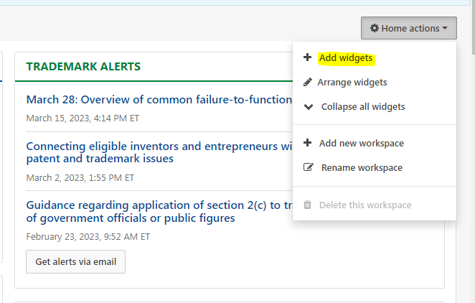
  - Now you will see “Widget library” - select “Patents” link on the left side then click on add button in “Patent docket” section and click on Save button.
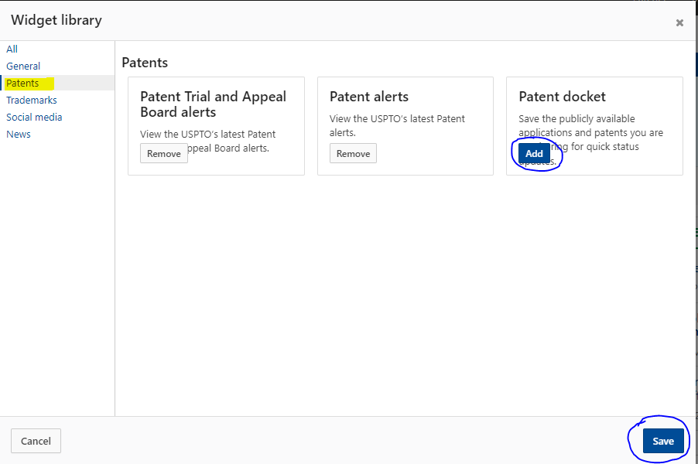

  - Now you can see “PATENT DOCKET” widget in the dashboard like below. To add patent applications to the collection click on “Create a new collection” button.
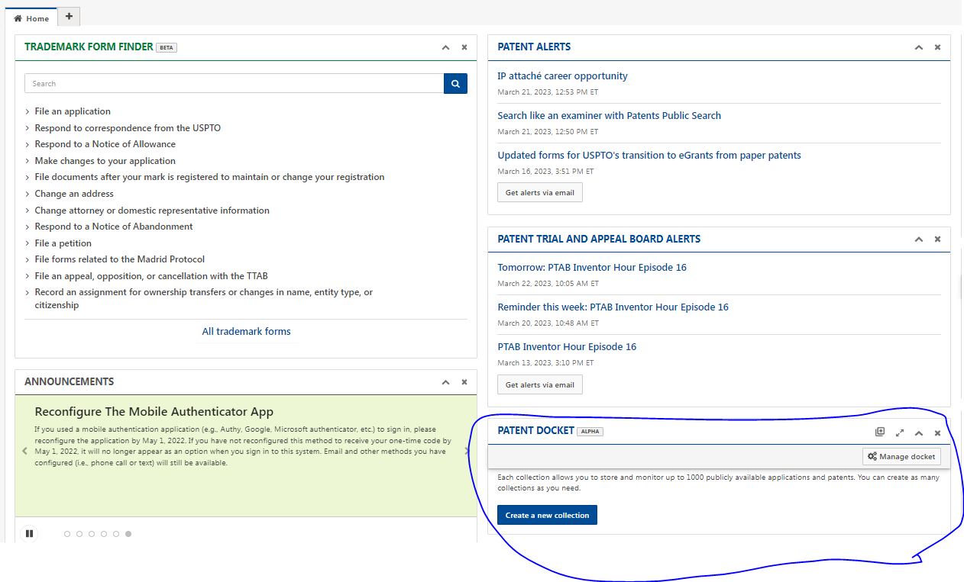
- The “Create a collection” window will appear – fill in the “Collection name” and “Notes” details and click on “Next” button.
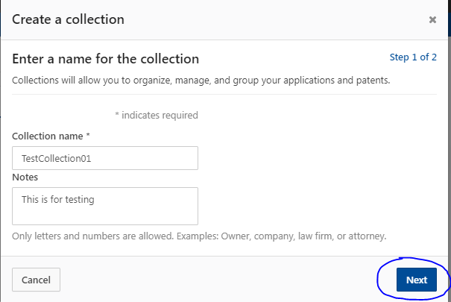
- In the next page you can search the patent application data by using patent application number, customer number, Patent Number, or PCT Number. After providing details in search box click on “Search” button.
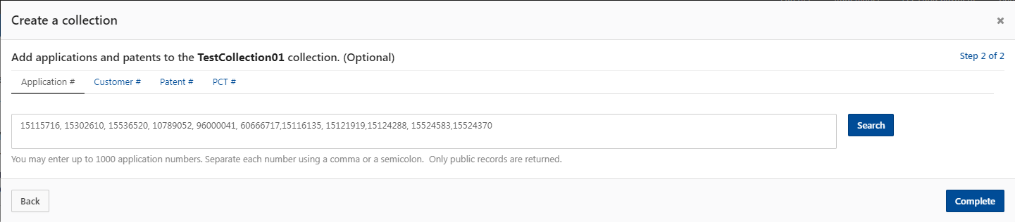
- The meta data details including Title, Application #, Patent #, Filing date, and Status date will appear. Select the check box next to the applications which you want to add to the collection and then click on the Complete button.
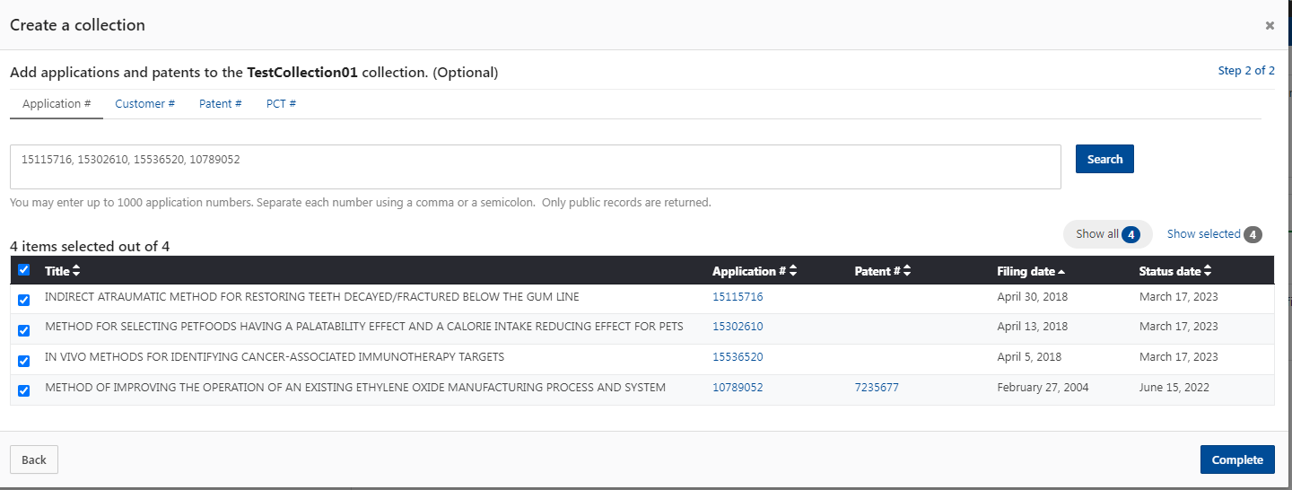

The collection with the added Patent applications will be listed. A green bell icon shows that the status has been changed in the last 14 days.
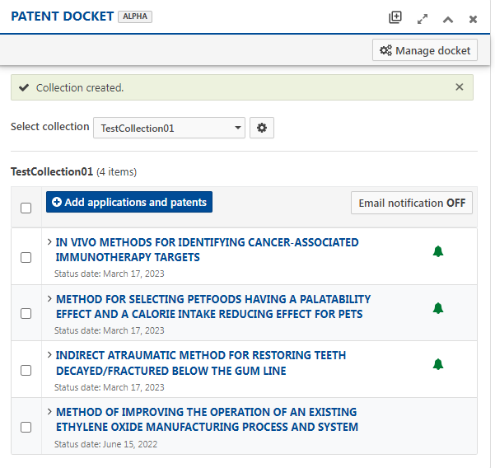
- To receive email notification when any status change happens to the patent application, click on “Email notification OFF” button (by default it is off) in order to turn it ON. You will see a pop-up. Click on “Accept” button.
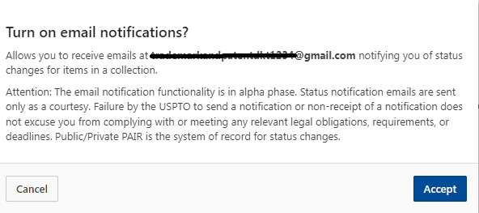

Now receiving email notifications is turned on and you will receive email when any status changes occur.
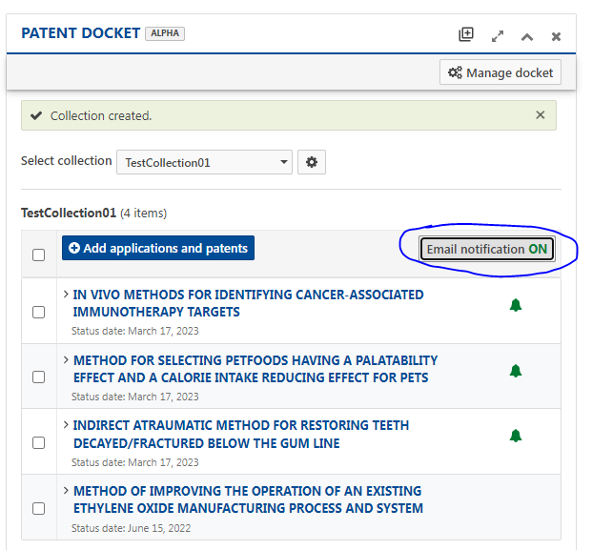

Sample status change email:

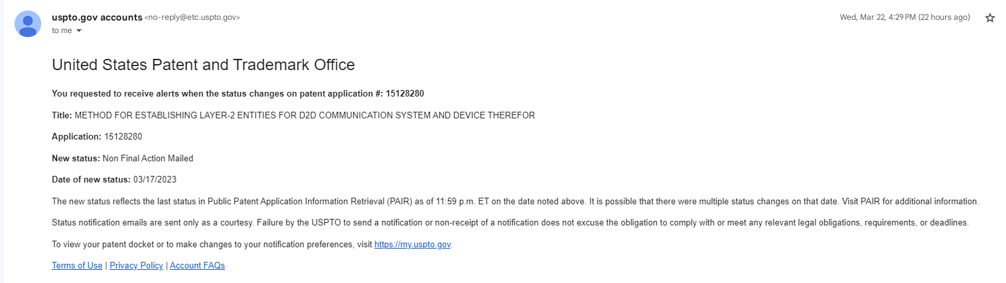

Note: The notification feature relies on the status date change in order to trigger a notification email. If someone enters a back-dated change into the database, our process will miss it. That happens infrequently but is possible.

