TSDR Release Highlights
On October 24, 2015, the USPTO released a new version of Trademark Status and Document Retrieval (TSDR) featuring several enhancements. Unfortunately, this released version of TSDR was rolled back to the earlier version in order to repair minor defects. The new version was re-released on November 20, 2015, and will include the following new features:

- A new consolidated search tab that automatically recognizes serial numbers, registration numbers, and reference numbers.

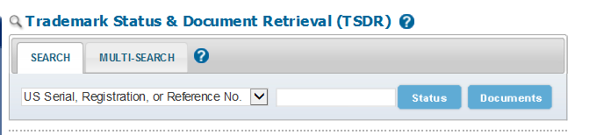

- A new “Maintenance” tab for post registration filings that will display the maintenance filing status and dates of the next required filing.

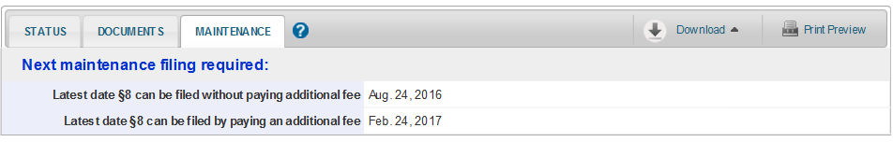

- Improvements to the ordering of documents and quality of images.

Please direct any questions about the release to TSDR@uspto.gov.

