Patent Center
Quick Reference Guide | March 2022

Patent Center Auxiliary PDF
Auxiliary PDF documents are an evidentiary copy for DOCX filings of Specification, Claims or Abstract in 35 U.S.C. 111(a) filings in Patent Center. Only one Auxiliary PDF document can be uploaded per submission and the Auxiliary PDF can only be uploaded if a DOCX document is uploaded in the submission.
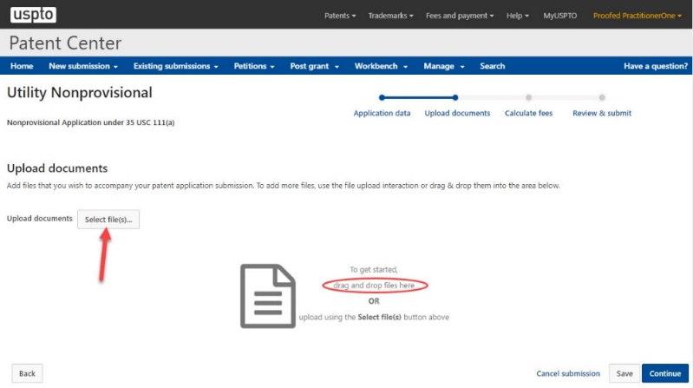

Uploading DOCX Document
After providing application data information and proceeding to the “Upload documents” screen, upload a DOCX document by either using the “Select file(s)…” button or by dragging and dropping the document on the screen.

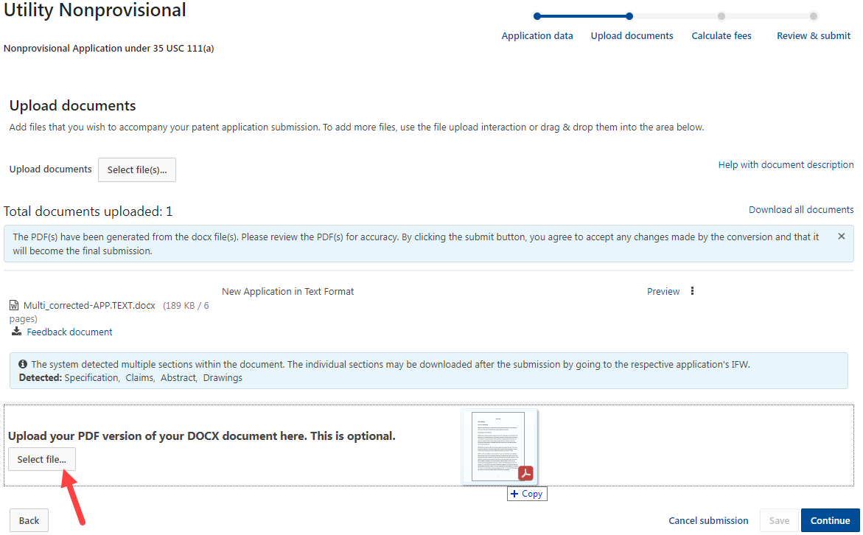

Uploading Auxiliary PDF
Once the DOCX document is uploaded, a new section where the Auxiliary PDF can be uploaded will become available. The Auxiliary PDF may be uploaded by either using the “Select file(s)…” button or by dragging and dropping the document on the screen. The Auxiliary PDF will automatically be assigned the “Aux.PDF” document code.

If all DOCX documents are removed from the submission after uploading the Auxiliary PDF, then the submission cannot be filed without deleting the Auxiliary PDF.

For More Information:
For questions regarding Patent Center, please contact the Electronic Business Center (EBC), Monday through Friday, 6 a.m. – Midnight (Eastern Time), via email at ebc@uspto.gov or phone at 866-217-9197.

