
User’s Manual/Quick Reference Guide
for
Checker 4.4.6
Approved by:
 | Program Manager  Robert Vanni |  | Date  12/3/2010
Prepared for:
United States Patent and Trademark Office
Prepared by:
Computer Sciences Corporation
2051 Jamieson Avenue - Suite 500
Alexandria, Virginia 22314


Table of Contents
SECTION 1 Tell me about checker 1-1
1.1 Overview 1-1
1.2 Features 1-1
1.3 Conventions for this User’s Manual 1-1
SECTION 2 getting started 2-1
2.1 Software Version 2-1
2.1.1 Getting the Software 2-1
2.1.2 Checking the Version 2-1
2.2 Checker System Requirements 2-1
2.3 Access Information 2-2
SECTION 3 How do i …? 3-1
3.1 Start Process 3-1
3.2 Work Process 3-2
3.2.1 Checker Edit File Button 3-3
3.2.2 Checker Process File Button 3-4
3.2.3 Checker View Errors Button 3-6
3.2.4 Checker View Report Button 3-7
3.2.5 Checker Help Button 3-7
3.2.6 Checker Properties Dialog Box 3-8
3.3 Shut Down Process 3-10
SECTION 4 Getting Help 4-1
4.1 Solutions to Common Problems 4-1
4.2 Getting More Help 4-1
4.3 Help Desk 4-1
APPENDIX A List of acronyms A-1
APPENDIX B error messages B-1

List of Figures
Figure 3-1 Checker Welcome Window 3-1
Figure 3-2 Checker Main Menu Window 3-2
Figure 3-3 Checker Edit File Open Dialog Box 3-3
Figure 3-4 Checker Edit File Opened in Wordpad 3-4
Figure 3-5 Checker Process File Open Dialog Box 3-4
Figure 3-6 Checker Progress Bar Dialog Box 3-5
Figure 3-7 Checker There Are Errors in Your File Dialog Box 3-5
Figure 3-8 Checker There Are No Errors in Your File Dialog Box 3-5
Figure 3-9 Checker Errors Report Opened in Wordpad 3-6
Figure 3-10 Checker Verification Summary Report Opened in Wordpad 3-7
Figure 3-11 Checker Online Help Menu 3-8
Figure 3-12 Checker Administration Properties Dialog Box 3-9
Figure 3-13 Checker Caution Dialog Box 3-9
Figure 3-14 Checker Set Up Failed Caution Dialog Box 3-9

List of Tables
Table 1-1 Manual Conventions 1-1

Record of Changes
Revision | Date | Pages Affected | Type of Change
 | 6/20/02 | Throughout | Initial issue under Task Order  02-23.
A | 10/7/03 | Cover page, TOC, ROC, page 1-1 and page 2-1. | Updated software revision to 4.2.
B | 9/15/04 | Cover, ROC, and throughout. | Update for CRF/Checker 4.3.1.
 |  | Pages 3-1, 3-2, and 3-9. | Updated screen shots.
C | 5/11/05 | Cover and ROC | Updated revision reference from B to C.
 |  | B-2 | Updated message #310 content.  This LMCO release did not go through QA.
D | 5/18/05 | Cover, ROC, and throughout. | CRF/Checker 4.3.1 updated the error message. Delete reference to Windows 95, 98, and ME.
E | 5/27/05 | Cover, ROC, 1.1, 2.2, 3.1 & 3.2.8 | Updates from the SDM for 4.3.1
F | 10/18/05 | Cover, ROC, and throughout | Updated message #251 in Appendix B-2, Updated pictures for Figures: 2-1, 3-1, 3-2. Updated Version from 4.3.1 to 4.4.0 in the document.
G | 07/15/10 | 1-1, 1-2, B3 | Update of messages

Tell me about checker

Overview
The Checker Version 4.4.6 system is a state-of the-art Windows software program employing a logical and intuitive user interface to validate and convert patent applications to be compliant with 37 Code of Federal Regulations (CFR) 1.821 – 1.825 for both ‘old rules’ (October 1990) and ‘new rules’ (July 1998). Checker replaces the previous DOS-based versions of Checker.

Features
The key features of the Checker system are listed below:
- Edit File – Allows the user to edit the sequence listing file.
- Process File – Allows the user to validate the sequence listing file and check for errors.
- View Errors Report – Allows the user to view a list of all errors encountered during the file processing.
- View Verification Summary Report (VSR) – Allows the user to view a report summarizing the verification process.

Conventions for this User’s Manual
Consistent visual cues and standard keyboard operations are used throughout this manual. These conventions are listed in Table 1-1.
Table 1-1 Manual Conventions
Notation | Represents | Example
 | Process the command with a mouse action. |  Select Open from the file menu.
 | Process the command with the keyboard. |  Type changes into the Edit field.
Bold type | Name of a function, file, menu item, or programming construct. |  Click on Exit.

getting started

Software Version
The software version of Checker covered in this user manual is identified as follows:
- Checker 4.4.6

Getting the Software
To get the Checker software:
- Download Checker Version 4.4.6 software for Windows XP/Vista/Windows 7 Personal Computers (PCs) [file size 1.31 MB] from the USPTO Web site, or
Purchase a diskette from the Catalog of Patent & Trademark Products & Services section of the General Information Home Page.

Checking the Version
If you are currently running the Checker software, but do not know the version number of the software, follow these steps:
 Click Help or select Alt-H on the keyboard to view the Help Menu.  Click About Checker to view the About dialog box (Figure 2-1). The About Checker dialog displays the version number and release date of the installed Checker application, as well as copyright information. The USPTO will periodically update Checker and the current version and release date will be displayed on the USPTO Web site at the following Uniform Resource Locator (URL):
http://www.uspto.gov/patents/resources/tools/checker/index.jsp.

Checker System Requirements
Checker Version 4.4.6 is a state-of-the-art Windows-based software application used for checking biotechnology sequence listings for compliance with format and content rules. Checker validates sequence listings generated for the original version of 37 CFR 1.821 – 1.825 effective October 1, 1990 (old rules) or the revised version (new rules) effective July 1, 1998 as well as World Intellectual Property Organization (WIPO) Standard ST.25.
Checker Version 4.4.6 replaces the previous Microsoft Windows and DOS-based version of Checker. This version executes on the newest operating systems, Windows XP, Windows Vista and Windows 7. Checker allows public users to check sequence listings before submitting them to the USPTO. Use of Checker prior to filing the sequence listing is expected to result in sequence listings with fewer errors, thus saving time and money.
Checker can run on any personal computer that uses Windows XP, Windows Vista or Windows 7. The recommended memory requirement for the Checker workstation is a minimum of 64 megabyte (MB) Random Access Memory (RAM). Disk space provided should be a minimum of 10 MB for temporary storage of the unzipped setup and installation program files. In addition, disk space must be allowed for user input files and Checker output reports (a total of twice [2X] the input file size.) To save space, setup files (6MB) can be deleted after the installation of the Checker application.

Access Information
To access Checker,  click the Checker icon on your desktop.

How do i …?

Start Process
When you open the Checker application, the Welcome window, shown in Figure 3-1, displays. This window identifies the application and displays copyright information for the software.
 Click 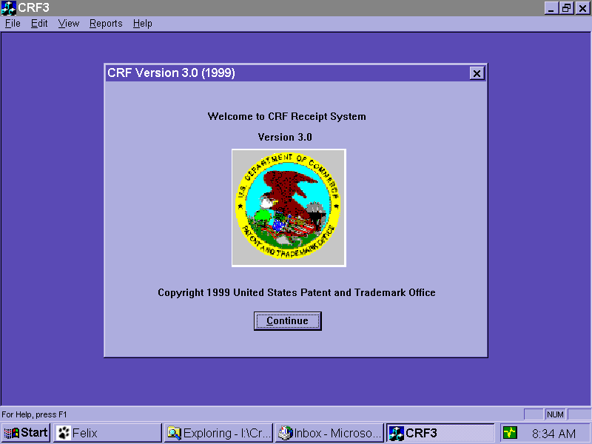 to work in the Checker application.

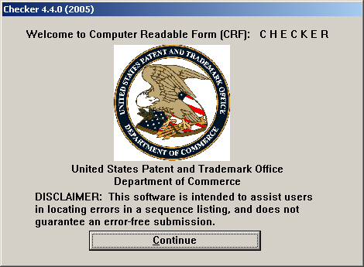
Figure 3-1 Checker Welcome Window

Work Process
When you open the Checker application, the Checker Main Menu window, shown in Figure 3-2, automatically displays.
The Checker Main Menu includes the following six buttons:
- Edit File
- Process File
- View Errors
- View Report
- Help Topics
- Exit
These buttons are discussed in more detail in Sections 3.2.1 through 3.2.6.
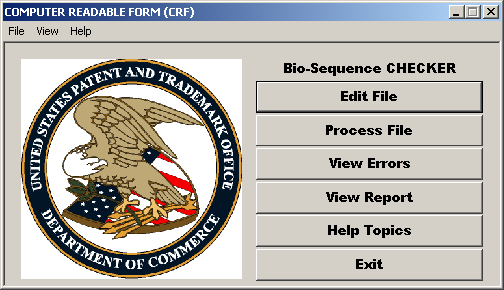
Figure 3-2 Checker Main Menu Window

Checker Edit File Button
To edit a file before running ‘Process File’:
-  Click on the Checker Main Menu.
- The WordPad document window displays. Select File and then Open from the Main Menu.
The Open dialog box displays (Figure 3-3).
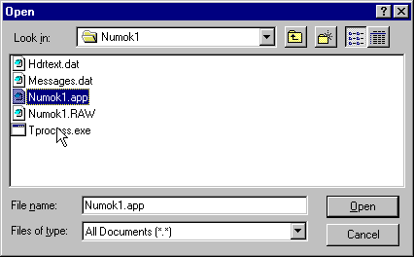
Figure 3-3 Checker Edit File Open Dialog Box
-  Click on the file to be edited.
-  Click 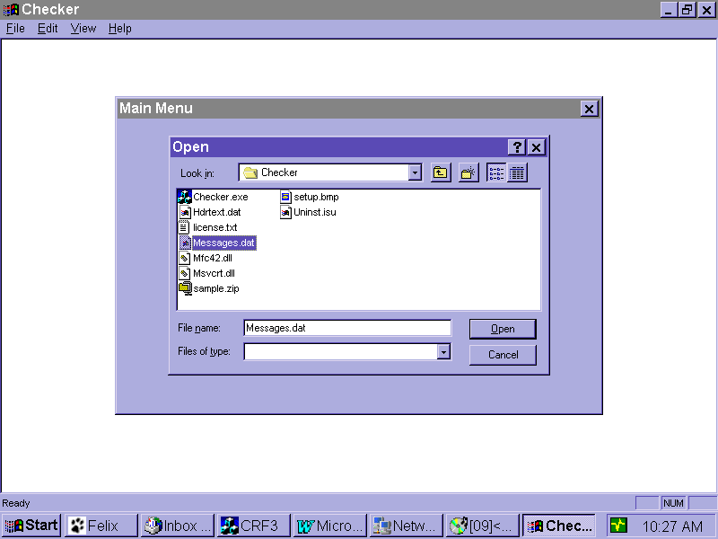.
The file is opened in either Wordpad or the user’s default editor.
To edit a file after running ‘Process File’:
- Click on the Checker Main Menu.
- The WordPad document window displays the input file that was last processed (Figure
3-4).
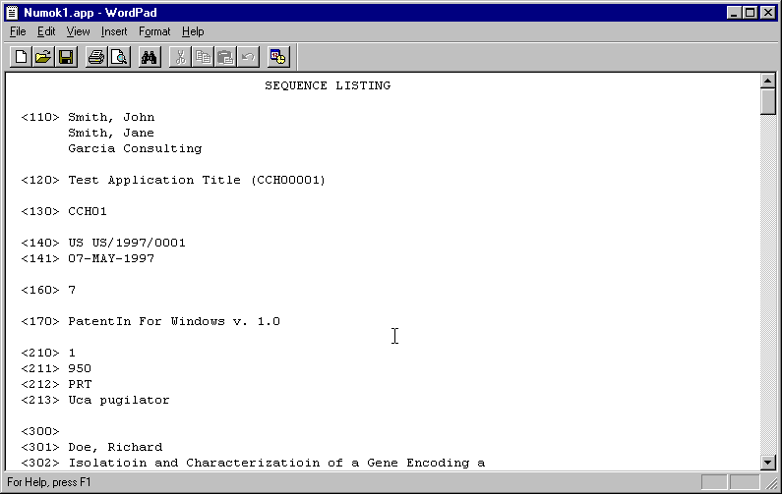
Figure 3-4 Checker Edit File Opened in Wordpad
-  Edit file and save.

Checker Process File Button
To process a file:
-  Click on the Checker Main Menu.
The Open dialog box displays (Figure 3-5).
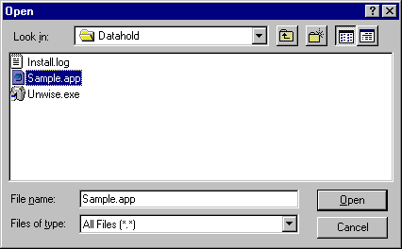
Figure 3-5 Checker Process File Open Dialog Box
-  Click on the file to be processed.
-  Click .
The Progress Bar dialog box displays (Figure 3-6).
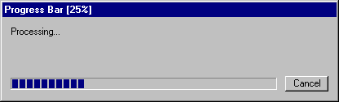
Figure 3-6 Checker Progress Bar Dialog Box
- The Progress Bar dialog box closes when validation is complete.
If there are errors in the file, the There Are Errors in Your File dialog box displays (Figure 3-7).
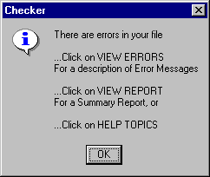
Figure 3-7 Checker There Are Errors in Your File Dialog Box
- If there are no errors in the file, the There Are No Errors in Your File dialog box displays (Figure 3-8).

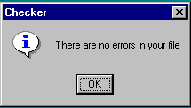
Figure 3-8 Checker There Are No Errors in Your File Dialog Box
-  Click 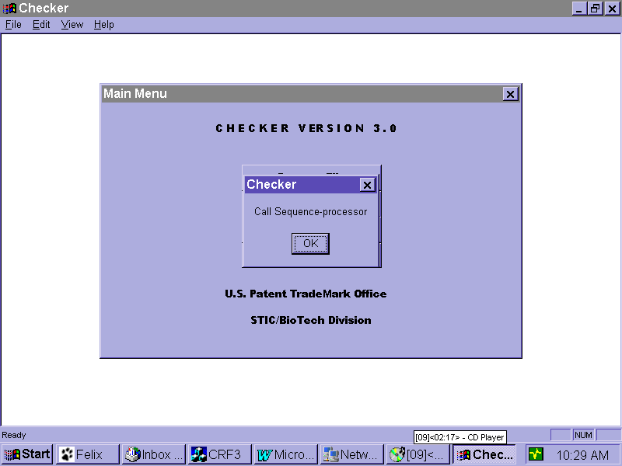 on either dialog box.
The Checker Main Menu displays.
- To view the file errors (if there are errors in your file),  click 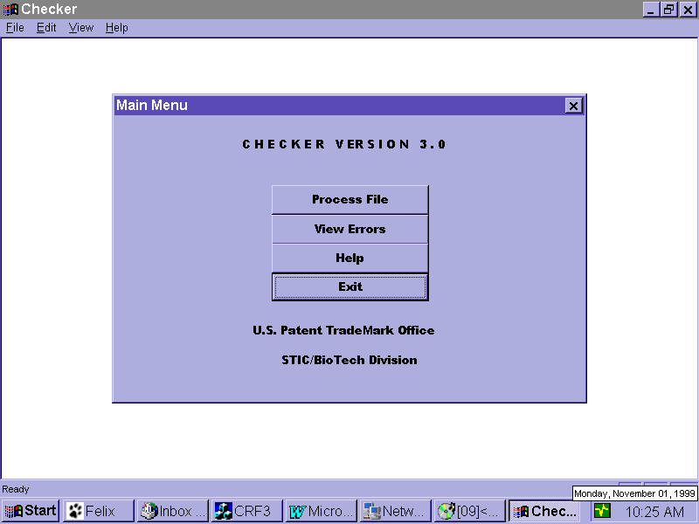 on the Checker Main Menu. Please see Section 3.2.3 for more information on viewing errors.

Checker View Errors Button
To view errors:
 Click on the Checker Main Menu.
The Errors Report, shown in Figure 3-9, is opened in Wordpad or the user’s default editor.
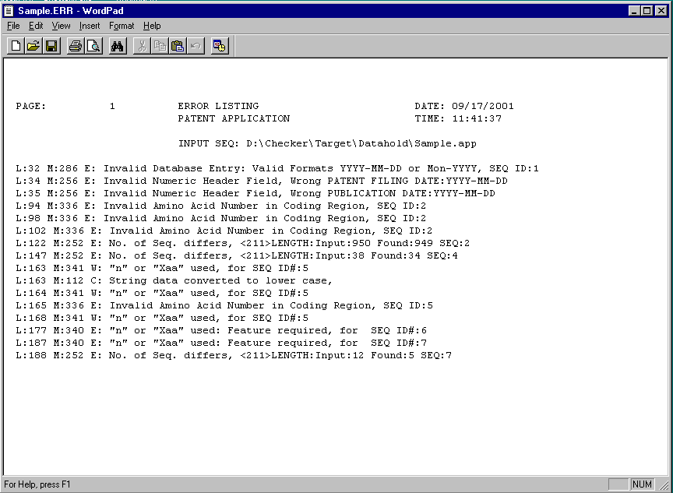
Figure 3-9 Checker Errors Report Opened in Wordpad

Checker View Report Button
To view the Verification Summary Report (VSR):
 Click on the Checker Main Menu.
The VSR, shown in Figure 3-10, is opened in Wordpad or the user’s default editor.
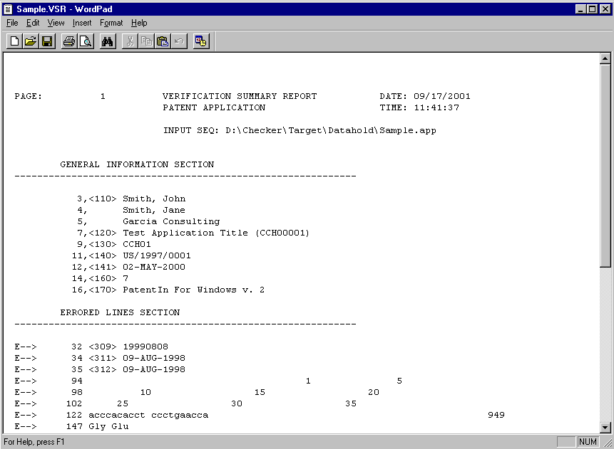
Figure 3-10 Checker Verification Summary Report Opened in Wordpad

Checker Help Button
To access the Checker online help menu:
 Click on the Checker Main Menu.
The Checker Online Help menu, shown in Figure 3-11, displays.
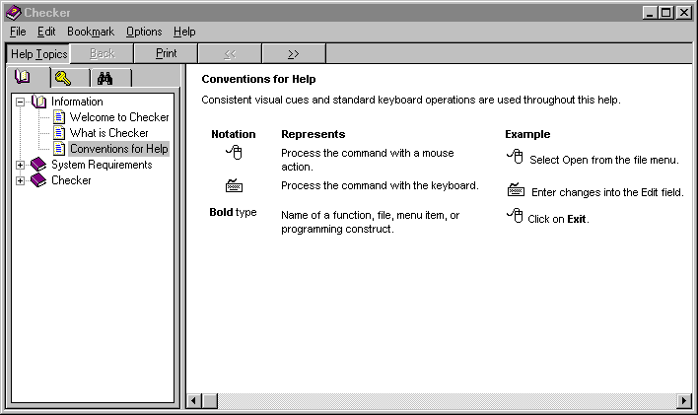
Figure 3-11 Checker Online Help Menu

Checker Properties Dialog Box
To view the Properties Dialog Box:
 Click File or select Alt-F on the keyboard to view the File Menu.  Click Administration and then Properties to view the Properties dialog box (Figure 3-12). The Properties dialog box allows the user to change the input and output directory paths as well as select an alternate ASCII file editor. To change file editor, the user must specify the path and executable file name of a suitable editor to replace WordPad. Note that the example in the figure is only an example and the actual paths may vary depending on the version of the Operating System running on the workstation.

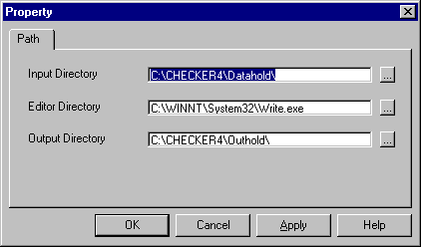
Figure 3-12 Checker Administration Properties Dialog Box

Should the user encounter the caution dialog box shown in Figure 3-13, it is an indication that the Input and Output directories are outside of Checker’s default path (a very likely occurrence if Checker was installed in other than the default location).  Click the [OK] button and the Property Dialog Box in Figure 3-12 will be presented. From there  Click the […] button and select the new path by navigating to Checker’s installed location. Should the [Cancel] button of Figure 3-12 be clicked the user will see the dialog in Figure 3-14 alerting the user that nothing was changed.
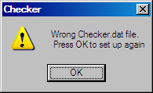
Figure 3-13 Checker Caution Dialog Box

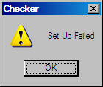
Figure 3-14 Checker Set Up Failed Caution Dialog Box

Shut Down Process
To exit Checker:
 Click 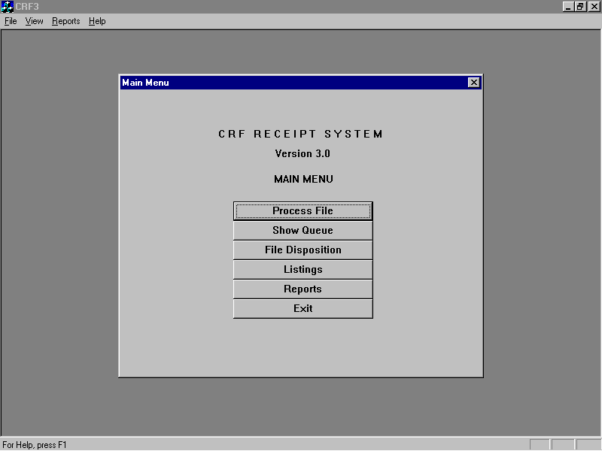 to exit the Main Menu and return to the main Checker application page. From here, you can use the Checker menu bar.

Getting Help

Solutions to Common Problems
N/A

Getting More Help
For Checker help, contact the Patent Electronic Business Center at 866-217-9197 or send an
e-mail to:
EBC@uspto.gov
Please provide a description of the problem or question.
NOTE: The procedure for activating MS Word line numbering (to view line numbers in a sequence listing) is included with the Checker distribution files and is automatically copied to the Checker installation folder. The name of the file is CrfMacros.doc.

Help Desk
N/A

List of acronyms
The following acronyms were used in this document.
Acronym | Definition
ABSS | Automated Biotechnology Sequence Search
CFR | Code of Federal Regulations
CRF | Computer Readable Form
MB | Megabytes
NT | New Technology
PC | Personal Computer
RAM | Random Access Memory
URL | Uniform Resource Locator
USPTO | United States Patent and Trademark Office
VSR | Verification Summary Report
WIPO | World Intellectual Property Organization

error messages
All possible error messages in the Checker software are included in the following table.
The legend for error messages is:
C: Corrected text string(s)
E: Error as defined in 32 C.F.R. 1.821 – 1.825 rules
S: System errors
W: Warning as defined in 32 C.F.R. 1.821 – 1.825 rules

System Errors  100 S: Failure opening input file  101 S: Failure reading input file  102 S: Failure writing output file  103 S: Failure allocating memory | General Messages  110 C: Removed Non-printable characters  111 C: String data converted to upper case  112 C: String data converted to lower case  113 C: Missing blank line  114 E: Unexpected end of input file
General Header Messages  200 E: Mandatory header field missing  201 E: Mandatory field data missing  202 E: Value must be an Integer  203 E: Calc# of Seq. differs from actual; <: Input (A), Counted (B)>  204 E: Calc# of Bases differs from actual; <: Input (A), Counted (B)>  205 E: Calc Length of Seq. Differs from actual; <: Input (A), Counted (B)>  210 E: Invalid Number of Sequences  212 E: Invalid or duplicate Sequence ID Number  General Header Messages (continued)  214 E: Seq.# missing; <: Seq.ID (A)>  216 E: Seq.#s missing; <: Seq.ID (A) thru (B)>  218 E: Input File vs. Calc Seq. Length differ; <: Input (A), Calc. (B)> | Alpha Header Messages  220 C: Keyword misspelled  222 E: Mandatory Keyword missing  230 E: Invalid or missing General Information  240 E: Invalid or missing Sequence Header field  241 E: Invalid Alpha Header field  242 E: Mandatory header field value missing  243 E: Alpha header field expected  244 E: Invalid beginning of sequence listing  Alpha Header Messages (continued)  245 E: Invalid value of Alpha General Header field  246 E: Invalid value of Alpha Sequence Header field  247 C: Inserted Optional Header Field  248 E: Inserted missing Mandatory Header Field  249 C: Inserted Mandatory Field
Numeric Header Messages  250 E: Invalid Numeric Identifier  251 E: Invalid Description for Numeric Identifier, <213> ORGANISM has both "Artificial" and "Unknown" for SEQ ID#:n  252 E: Calc# of Seq. differs from actual; <: Input (A), Counted (B)>  253 E: Calc# of Bases differs from actual; <: Input (A), Counted (B)>  254 E: Number of Bases conflicts Running Total; <:Input (A), Counted (B)>  256 E: Numeric Identifier expected  257 W: Sequence data Name/Key Feature Missing  258 E: Mandatory Feature Missing  259 E: Field exceeds allowed number of lines  270 C: Current Application Number differs  271 C: Current Filing Date differs  Numeric Header Messages (continued)  280 E: Numeric Identified already exists  281 E: Numeric fields not Ordered  282 E: Numeric Field Identifier Missing  283 E: Missing blank Line separator; <before this field identifier>  284 E: Blank Line not allowed; <before this field identifier>  285 E: Invalid Journal Date: Wrong YYY-MM-DD, MMM-YYYY or Season-YYYY  286 E: Invalid Database Entry Date: Wrong YYYY-MM-DD or MMMM-YYYY  287 E: Invalid Date; <Wrong YYY-MM-DD or MMMM-YYYY>  288 E: Application Number is Repeated; <PRIOR APPLICATION NUMBER:>  289 E: Numeric Identifier Mission or Out-of-Order; <PRIOR APPLICATION NUMBER> | Sequence Data Messages  300 W: Intentionally skipped Sequence: Sequence Id ()  301 E: No Sequence Data was Shown  302 E: Unknown or Misplaced Identifier  310 E: Wrong or Missing Sequence Type, numeric identifier<212>, for SEQ ID#: n  320 E: Wrong Nucleic Acid Designator  321 E: “t” not allowed in the RNA Sequence  322 E: Invalid Residue in Sequence  330 E: Wrong Amino Acid Designator  332 E: Invalid/Missing Amino Acid Numbering  333 E: Wrong Sequence grouping; <spacing>  334 E: Invalid Amino Acid in Coding Region  Sequence Data Messages (continued)  336 E: Invalid Amino Acid Number in Coding Region  340 E: “n” or “Xaa” used: Feature required  341 W: “n” or “Xaa” used  342 E: Invalid Stop Code On Error  344 W: Removed Stop Code On Error  351 E: Sequence data Name/Key Feature Out-of-Range  360 E: ”Line length error for SEQ ID#:%ld. Line was %d characters.” Maximum is %d Where the ‘%’ letter formatting tags are replaced with the sequence number, line length and maximum line length respectively.  361 E: Invalid Split Codon

