VENDOR PORTAL

User Guide

# Table of Contents

VENDOR PORTAL 1

User Guide 1

Table of Contents 2

Part ONE 3

Introduction 3

Welcome to Vendor Portal 4

What is Vendor Portal? 4

Getting Started with Vendor Portal 5

Request your Vendor Portal account 5

Sign in to Vendor Portal 7

Vendor Portal Profile 7

Password Policy and Password Reset Process 9

Key Terms 12

Navigating Vendor Portal 14

Navigation Tools 14

Forms 15

Tables 16

Searching 17

User Permissions 18

Introduction to User Permissions 18

PART TWO 19

I’m an Administrator 19

I’m an Vendor Admin 20

The Administrator Role 20

Create and Manage Users 20

Disable/Enable a User account 22

Delete a User account 23

View Award Information 24

View and Submit Invoices 24

View and Submit eDeliverables 25

PART THREE 26

I’m an eDeliverable Manager. 26

Submit an eDeliverable 27

Submit a Contract Actuals File 30

PART FOUR 33

I’m an Invoice Manager 33

Submit an Invoice 34

Submit a Contractor Actuals (CA) Invoice & Invoice Template 36

View & Search for previously Submitted Invoices 40

View Payment status 41

Contact Us 42

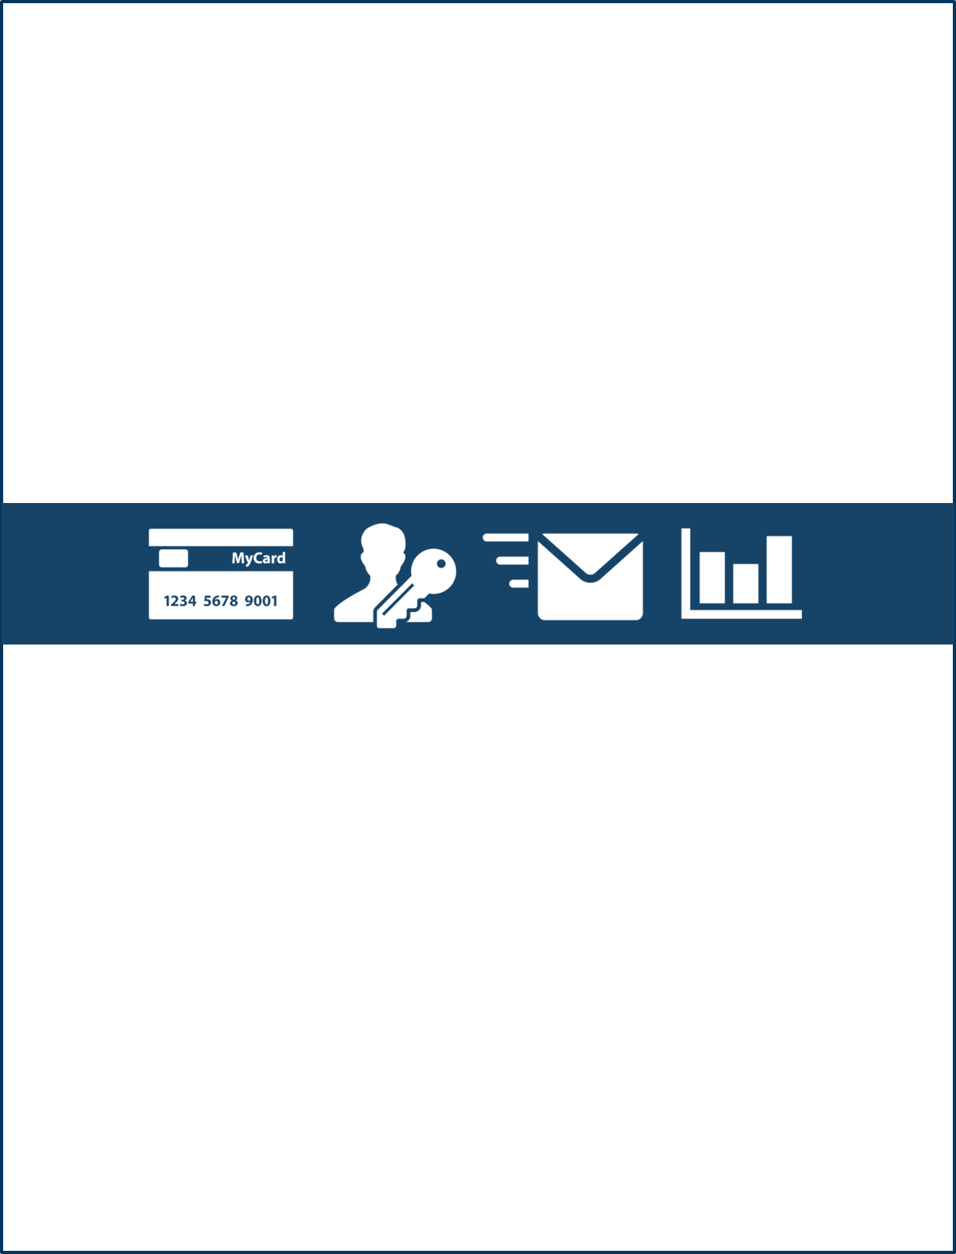Part ONE

Introduction

# gray backgroundWelcome to Vendor Portal

## What is Vendor Portal?

The USPTO Vendor Portal is a secure web-based service to provide more efficient information flow between the USPTO and our vendor community. The Vendor Portal provides vendors with the ability to manage invoice and deliverable submission electronically as well as obtain status of payments and other pertinent information on your awards.

With Vendor Portal access, you can:

* **Submit Invoices**: Submit your invoices electronically and receive confirmation and status of payments
* **Submit Contract Deliverable(s)**: Submit your contract deliverables electronically including contractor actuals deliverables and receive confirmation and status of receipt. For contractor actuals, there are additional system built in validations to ensure all errors are identified prior to submission
* **View Contract Information**: Provides vendor(s) access contract information with the USPTO

# Gray backgroundGetting Started with Vendor Portal

## Request your Vendor Portal account

To access the Vendor Portal, vendors will need to follow the registration instructions detailed on the USPTO Vendor Information site to request an account. Vendors will be required to coordinate an account request that must be submitted by the Electronic Business POC established for their organization in SAM.gov. Vendor users may request various account types based on their expected roles from the organization’s master admin if one has already been established in the system. A Vendor Portal account is established once a user confirms and activates their account via an email invitation.

1. Navigate to the uspto.gov ‘Vendor Information’ page: <https://www.uspto.gov/about-us/vendor-information>
2. On the [Vendor Information page](https://www.uspto.gov/about-us/vendor-information/vendor-portal-information), navigate to the ‘Vendor Invoices’ section and click the ‘Vendor Portal Information’.
3. There are two ways vendor users may request a Vendor Portal account:
4. *Vendors may coordinate establishing their first Vendor Portal account for the organization by following the registration instructions detailed on the USPTO Vendor Information Page <* [*https://www.uspto.gov/about-us/vendor-information/vendor-portal-information*](https://www.uspto.gov/about-us/vendor-information/vendor-portal-information)*>*

Once the Vendor’s registration details are submitted by the company’s Electronic Business POC registered in SAM, the help desk will review the request. Once the required details are validated, the Electronic Business POC will be administered the company’s first master admin account. They will receive an email invitation to register and confirm their Vendor Portal account. (Refer to step 4 on registering your account via email invitation)

1. *Vendor users may request a Vendor Portal account through their organization’s master admin established in the Vendor Portal*

If your organization has a master admin account established in the Vendor Portal and you have their contact, you may reach out to request an account to be provided. Once the master admin validates the user requesting an account, the master admin will login to the Vendor Portal to administer the account. The requesting user will receive an email invitation to register and confirm their Vendor Portal account. (Refer to step 4 on registering your account via email invitation)

If a vendor user is unsure whether their organization has a master admin established, they may follow the steps to have the organization’s Electronic Business POC register for a master admin account. If it turns out that your organization has an established master admin once the registration is submitted, the Vendor Portal registration helpdesk will forward your account request to the established master admin in the system. The master admin will reach out to the requesting user to establish a user account. Please note that the Vendor Portal help desk will not directly provide the master admin’s contact details to any requesting users due to security and privacy considerations. If the master admin is able to validate the user requesting an account, the master admin will administer the account through Vendor Portal. The requesting user will receive an email invitation to register and confirm their Vendor Portal account. (Refer to step 4 on registering your account via email invitation)

1. To complete the registration of a Vendor Portal user account, check your email for an account invitation. Click the ‘Confirm Account’ This button is used to confirm a users account button to complete the creation of your Vendor Portal account.  
     
   Below is a screenshot of the Vendor Portal welcome screen, displaying the ‘Confirm Account’ button.

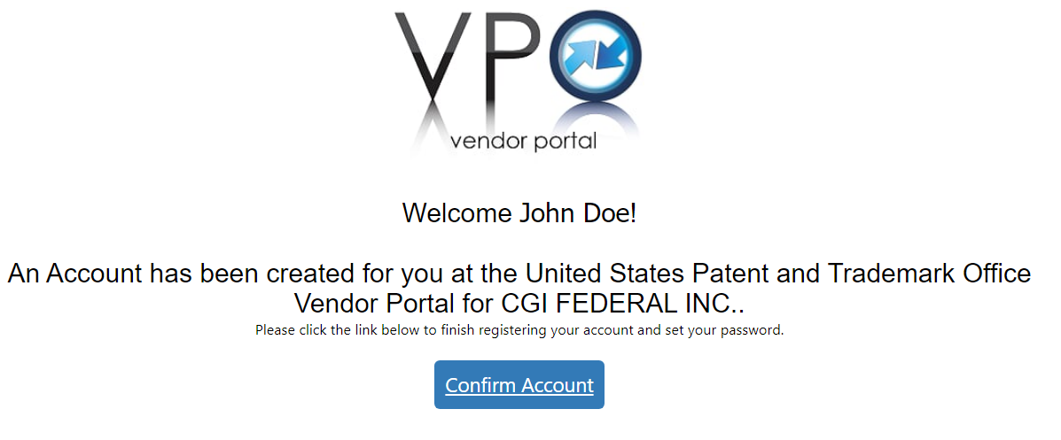

1. Complete the creation of your account by confirming a password and setting your security question and answer. Click the ‘Set’ button The set icon is used to finalize the account creation to finalize the account creation.

## Sign in to Vendor Portal

1. Navigate to the Vendor Portal homepage using this link: <https://vendors.uspto.gov/VendorPortal>

Below is an image of the USPTO Vendor Portal Homepage

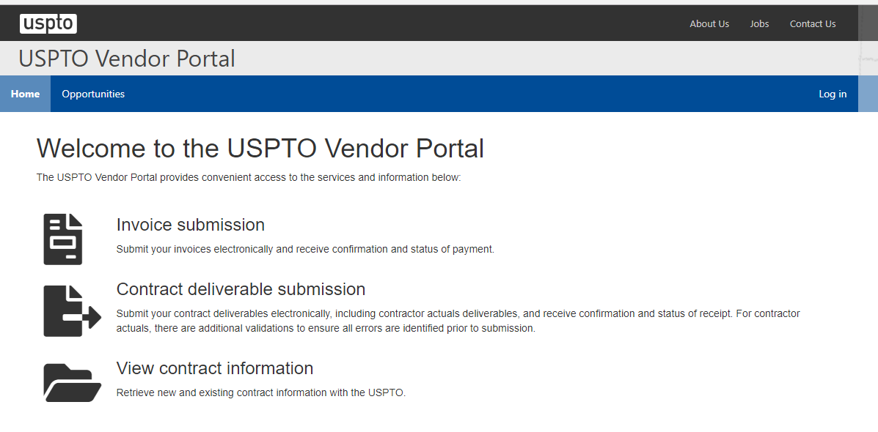

1. Click ‘Log in’ at the upper right hand corner, entering the email address and password associated with your Vendor account.
2. Select the ‘Log in’ use the Log In icon to log into Vendor Portal button at the upper right hand corner of the page. This will take you to the USPTO Vendor Portal, and default to ‘Awards’ that are owned by your vendor.

## Vendor Portal Profile

The following steps can be used to view and modify your user profile:

1. To view a user profile, click on the dropdown next to the user and vendor name and click on ‘My Profile’.

Below is an image displaying the drop down arrow next to a user’s name and all the options available under their account

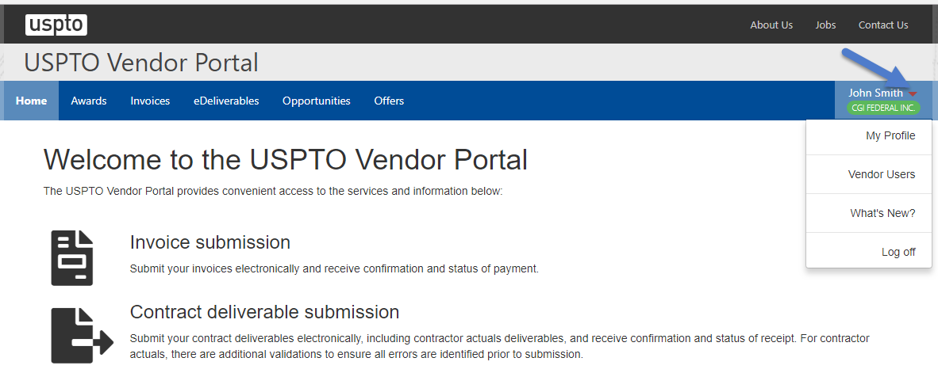

1. The vendor user’s contact information and system role will be displayed.   
     
   Below is an image displaying the user’s profile and contact information

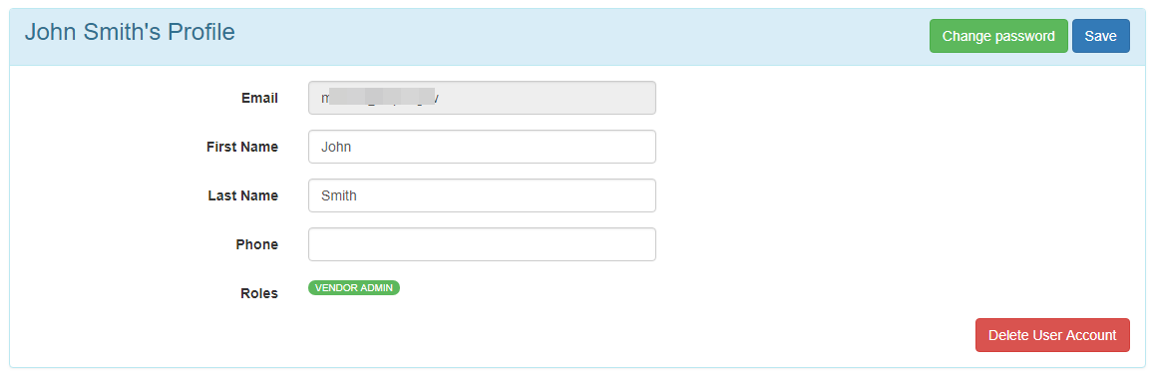

1. The ‘Vendor Information’ section will display information regarding the vendor organization (i.e. Business Name, DUNS, Address). The ‘Address’ fields listed will default to the vendor address as listed in SAM (System for Award Management). A user may edit this vendor information on their user profile, however it will not change the default vendor information.  
     
   Below is an image of the ‘Vendor Information’ screen that displays the address of the organization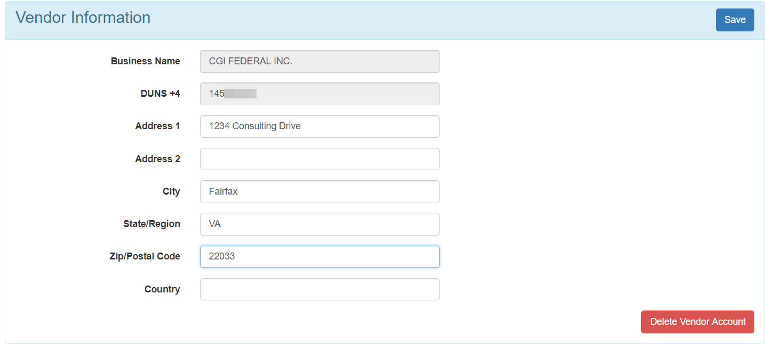

## Password Policy and Password Reset Process

### Password policy

The password for the Vendor Portal account will need to be changed every 60 days. The password for Vendor Portal accounts must be at least 12 characters long and include: one uppercase letter, one lower case letter, one number and one special characters. The following special characters are accepted to use in passwords:

~`!@#$%^&*()-_+={}[]|\;:<>,./’?"

### Changing your Password

To change the password for your account, you will need to log on to your account with the current password.

1. At the top of the navigation bar, you will see your name along with a carat icon next to it.
2. Select your name and you will be given a drop down list of options.
3. One of the options is ‘My Profile’, please select the link in order to proceed.

The image below displays the users name and shows the carat icon, the ‘My Profile’ option is displayed.

1. Once selected, you will be taken to a page to change information about your profile.  
     
   The image below illustrates the ‘Change Password’ button

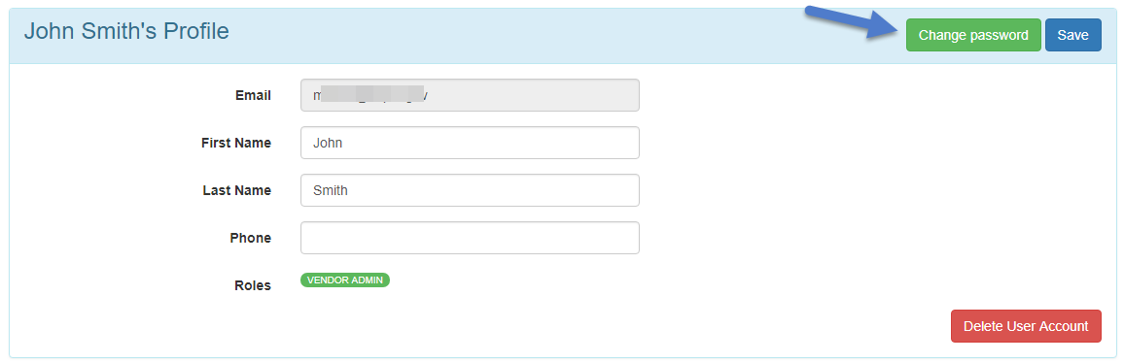

1. Click on the ‘Change password’ Change Password Button button to initiate the process to change your password.

**Forgot your Password?**

If you forgot the password, you can reset the password for your account

1. To start, click on the ‘[*Forgot password?*](https://vendorportal.uspto.gov/VendorPortal/Account/ForgotPassword)*’* link located on the ‘Log in’ page or visit the page: <https://vendorportal.uspto.gov/VendorPortal/Account/ForgotPassword>

The image below displays the ‘Forgot password?’ link on the ‘Log In’ screen

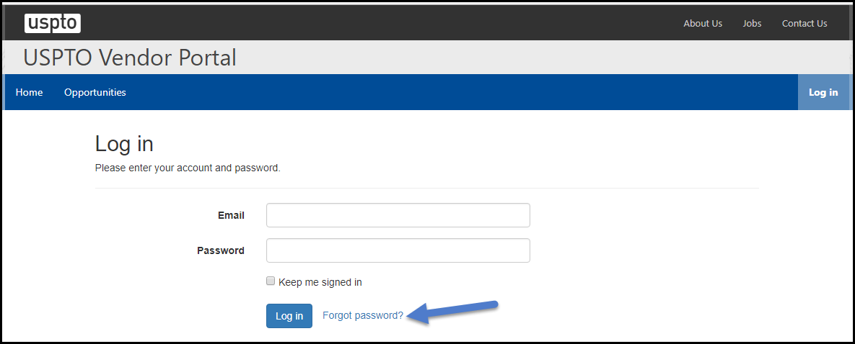

1. To keep your account secure, please enter your email address associated with your account and click on the ‘Reset Password’ Reset Password button
    button.

The image below displays the ‘Reset Password’ button on the ‘Forgot Password’ screen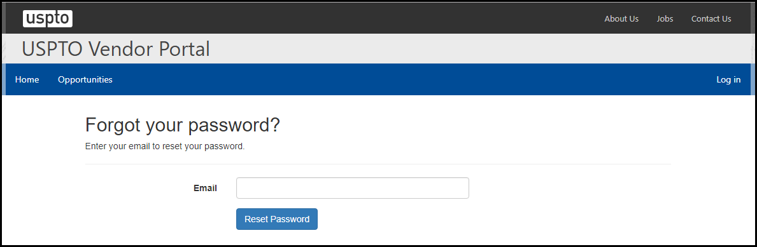

1. The page will then notify you that an email was sent to your registered email address. The email will provide you with a link to reset your password.

## Key Terms

### Award A contract, open market simplified acquisition, or BPA.

### Contractor Actuals Deliverables

Contractor Actuals are comprised of a number of different items. Templates are available for vendors that notate every FTE and how the resource is billed. Two deliverables are required for Contract Actuals, an A file and a B file, both of which are submitted each month to create a Receiver. The vendor will also submit an invoice that matches the A & B file submissions. The COR will validate and Finance will then be able to process the payments.

Other Contract Actual deliverables include acquisition plans, project deliverables, schedules, and other support documentation.

### Contracting Officer Representative (COR)

Contracting officers have authority to enter into, administer, or terminate contracts and make related determinations and findings. Contracting officers may bind the Government only to the extent of the authority delegated to them. Contracting officers shall receive from the appointing authority (as described in FAR subpart 1.6 Career Development, Contracting Authority, and Responsibilities) clear instructions in writing regarding the limits of their authority. Information on the limits of the contracting officers’ authority shall be readily available to the public and agency personnel. Contracting officers are responsible for ensuring performance of all necessary actions for effective contracting, ensuring compliance with the terms of the contract, and safeguarding the interests of the United States in its contractual relationships. In order to perform these responsibilities, contracting officers should be allowed wide latitude to exercise business judgment.

### eDeliverables

Electronic deliverables that are required by the terms of the contract and can be submitted for review using Vendor Portal.

### Invoice Template

An Excel file that is available to use an example that will help vendors format their invoices (a contractor’s bill or written request for payment under the contract for supplies delivered or services performed).

**Opportunities**  
The ‘Opportunities’ tab within Vendor Portal has not yet been operationalized, however once this functionality becomes available, this is where you will find opportunities within USPTO. Vendors can follow their individual opportunity link or public opportunity and respond directly to the request when logged in to Vendor Portal.

**PPA Codes**

PPA stands for ‘Program, Project, and Activity’. They are a government wide cost accounting practice. Vendors working with PTO should be given a PPA code by their CO/COR. This PPA code is required in our systems as well as on the invoices.

**Vendor Portal**

The USPTO Vendor Portal is a secure web-based service to provide more efficient information flow between the USPTO and our vendor community. The Vendor Portal provides vendors with the ability to manage invoice and deliverable submission electronically as well as obtain status of payments and other pertinent information on your awards. Vendor Portal access provides the capability to electronically submit invoices, contract deliverable(s) and view up to date contract information.

# Gray boxNavigating Vendor Portal

## Navigation Tools

**Navigating Vendor Portal**

After log-in, the main navigation menu will be displayed in a grey bar towards the top of the page.  
  
The below image illustrates the options available in the navigation menu as well as in the drop down carat for the user profiles

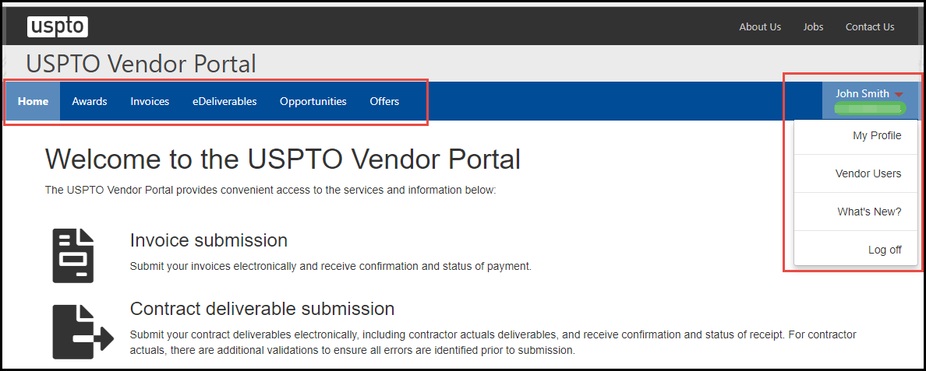

| There are six primary navigation options:   1. Home 2. Awards 3. Invoices 4. eDeliverables 5. Opportunities 6. Offers | To the right, are three additional options:   1. My Profile 2. Vendor users 3. What’s New? 4. Log off |
| --- | --- |

On some pages, sub tabs provide additional menu options, as in the example below.  
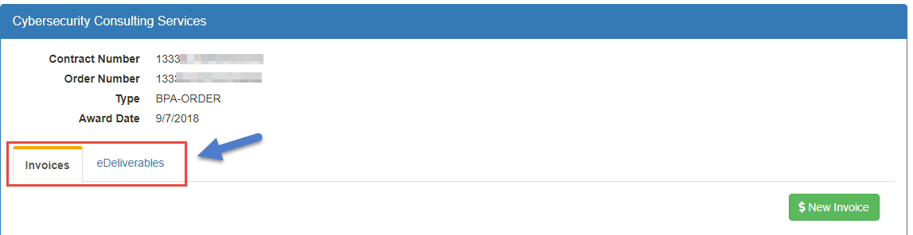

On the ‘Award’ page, expandable and collapsable arrows provide additional details related to the award, as in the example below.

Collapsable arrows provide additional details related 

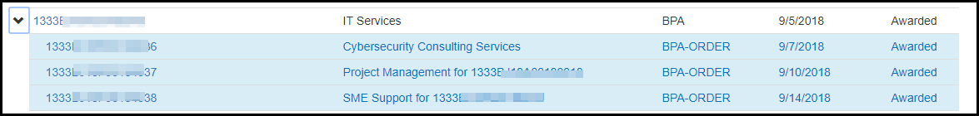

## Forms

### Field/Validations

In Vendor Portal, some forms are not eligible for submission unless all of the required fields or attachments are provided. If required fields are not completed, the system will indicate the missing required fields in an error message. The user will be unable to proceed until the required information is completed.

The image below illustrates the error messages that will display when required fields are missing.

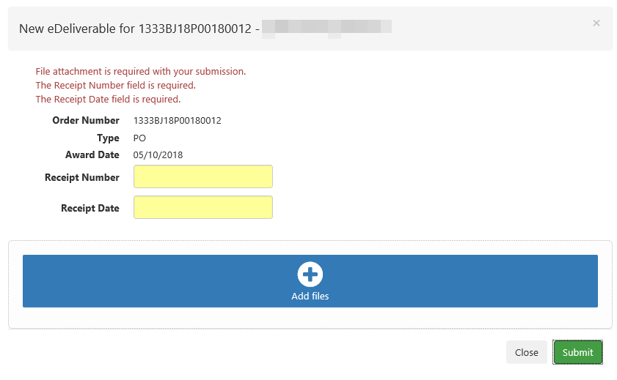

This form is missing information so the system will notify the user which required fields are needed before allowing submission

### Success Messages

Vendor Portal will display a green success message at the top of the screen after each successful action, as in the example below. Success messages indicate that you’ve successfully completed the desired action; it may include important information such as the date and time that the process was completed. These messages are only visible to the user initiating the action and will disappear when you navigate to a different page or manually close the message.

Please note that a successful submission does not necessarily indicate that the submitted deliverable or invoice has passed system validations. For more information regarding eDeliverable for CA Deliverable Templates refer to section: Submit a Contract Actuals File. For more information regarding Invoice Validation for CA Invoice Templates refer to section: Submit a Contractor Actuals (CA) Invoice & Invoice Template.

The image below illustrates a successful eDeliverable submission message.

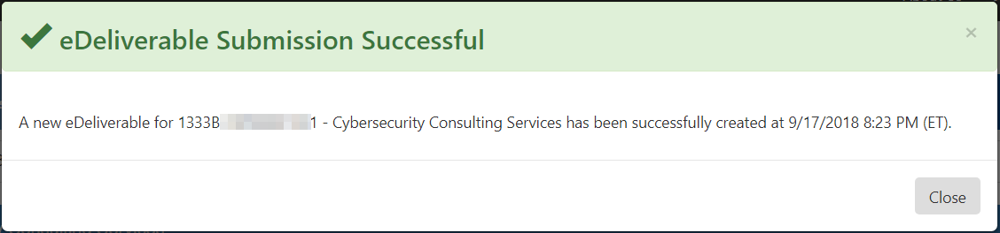

## Tables

Vendor Portal displays information in table format. Each tab has several columns of relevant information that are capable of being sorted for user preference. Several lists display as tables in Vendor Portal.

### Sorting Tables

In Vendor Portal, you can sort tables to help you quickly find the information you need. This will rearrange the table so that the column you’ve selected displays in alphabetical or numerical order.

1. Navigate to the header of the column you’d like to sort. Click on the header column to sort results by that column. An arrow pointing up or down will indicate whether results are sorted in ascending or descending order.

The image below illustrates a standard table in Vendor Portal

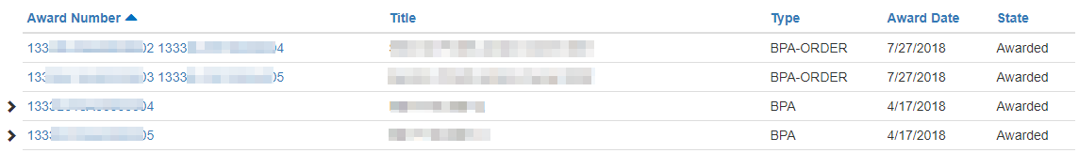

When you select a sortable header, a small blue triangle will appear, indicating the ascending or descending direction of the sorted information. A right side up triangle ( ) means the information is ascending; a downward pointing triangle ( ) means the information is descending.

1. You can click the header column again to reverse the way the information has been sorted. The small triangle will change direction to indicate whether the information is ascending or descending.
2. You can select a header column to sort by another category in the table.   
     
   The image below illustrates the header column, in this case ‘Title’

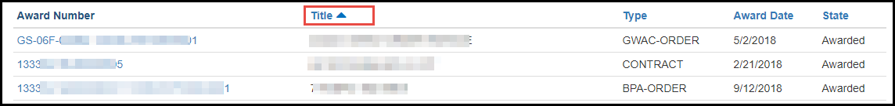

### Paginated Tables

Tables in Vendor Portal will only display a limited number of items on each page. The navigation bar at the bottom of the page will become active if the table spans multiple pages. The results will indicate what page you are currently on and by highlighting the current page number out of a total number of pages.

The image below illustrates the numbered pages of information available in Vendor Portal



Use the arrow icon Use the arrow icon button to navigate to the subsequent page button to navigate to the subsequent page. You can click on a page number to navigate to a specific page.

## Searching

The main Vendor Portal header pages (ex. Awards) are searchable in order to reduce the results. In order to search for a specific result, enter a full or partial alphanumeric text in the upper right hand corner ‘Search’ box. If matching result(s) exists within the page, the page will be filtered down. Search results are not case sensitive.

The image below illustrates an example of ‘Search’ results in Vendor Portal

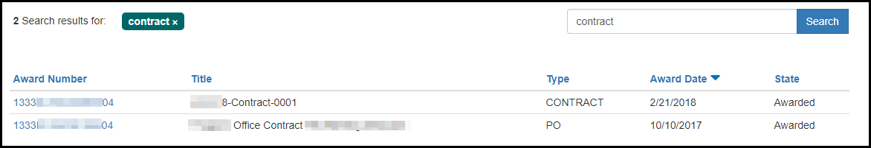

# Gray boxUser Permissions

## Introduction to User Permissions

The following roles are available to vendors when they request access to the system:

* **Vendor Administrator**: This is the Master Admin account for a vendor. This is the only account that USPTO will assist in creating when an organization is new to the agency. All subsequent roles (including additional Vendor Admin accounts for the vendor) will be assigned by this Vendor Admin account. This role has the ability to invite, manage, and delete users’ within the vendor organization.
* **eDeliverable Manager**: This role has the ability to view, maintain, and submit eDeliverable actions on behalf of the vendor organization. It is assigned by the Vendor Admin role.
* **Invoice Manager**: This role has the ability to view, maintain, and submit Invoice actions on behalf of the vendor organization. Vendor Admin role.
* **Offer Manager**: This role has the ability to view posted opportunities and submit offers on behalf of the vendor organization. Vendor Admin role.

We suggest that you assign user permissions in a manner that aligns with your business processes. For example, if someone from your Finance department handles most of your invoice submission, consider granting them ‘Invoice Manager’ role. Your Vendor Administrators should routinely review the roles for all users within your organization and make updates as needed to ensure the security of the information shared within the Vendor Portal for your organization.

PART TWO

I’m an Administrator

**What do I need to know?**

# I’m an Vendor Admin

## The Administrator Role

In Vendor Portal, a user with the Vendor Admin role has the highest permission for a given vendor account and can perform the following:

* Create and manage users for the vendor account
* View award information for all awards for the vendor
* View and submit invoices
* View and submit eDeliverables

## Create and Manage Users

The ‘Vendor Users’ page allows the Vendor Admin to view, create, edit permissions and remove users for a vendor. Additional information on user permissions is located in the ‘User Permissions’ section.

1. To access the information, the Vendor Admin must log in to Vendor Portal.
2. At the top of the navigation bar, you will see your name along with a carat icon next to it.
3. Select your name and you will be given a drop down list of options.

The image below illustrates the ‘What’s New?’ option in the drop down menu



1. One of the options is ‘Vendor Users’, please select the link to display information for all users for the vendor account.

### View User Permissions

The ‘Vendor Users’ page provides a summary of all users under the vendor account, including: each user’s email address, full name, date the account was created, the date the account was last accessed, the roles for the user and the status of the user account.

The image below illustrates the summary screen for Vendor Users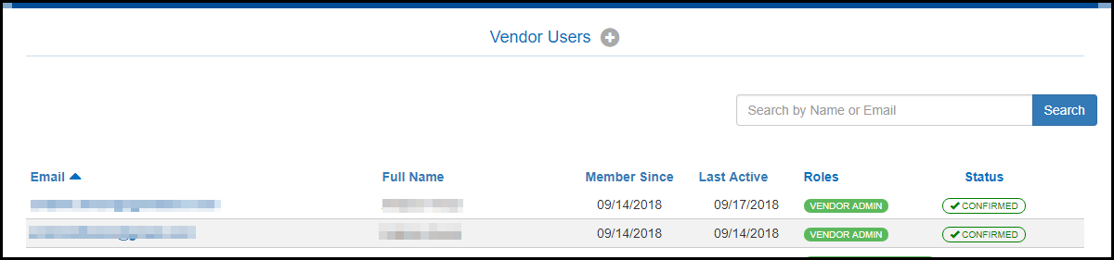

A user account may have the below status:

**Invited**: This user has been invited, but has not confirmed the account.

**Confirmed:** This user has been invited and has confirmed the account.

**Disabled:** This user account has been disabled, due to inactivity or by an administrator.

### Create a User account

1. On the ‘Vendor Users’ page, click ‘Vendor Users+’ Vendor Users icon to access a form to create a new user account button to access a form to create a new user account  
     
   The image below illustrates the ‘Vendors Users +’ button

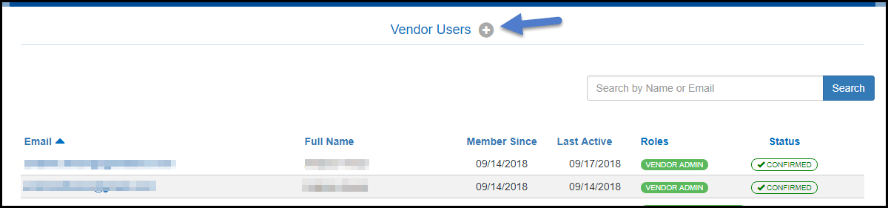

1. Enter the information in the field for ‘First Name’, ‘Last Name’, ‘Email’ and ‘Confirm Email’.
2. Select the appropriate ‘User Roles’ for the account.
3. Click the ‘Create’ button.

Once the account is created, the user will receive the invite email to confirm the account. There are no limits to the number of users you can create for a vendor account.

### Modify a User account

1. On the ‘Vendor Users’ page, double click on a user account to modify.
2. The administrator can modify the information in the ‘First Name’, ‘Last Name’ and ‘Phone’ fields as well as changing the ‘User Roles’ for the user.

The image below illustrates how to add user roles to an account

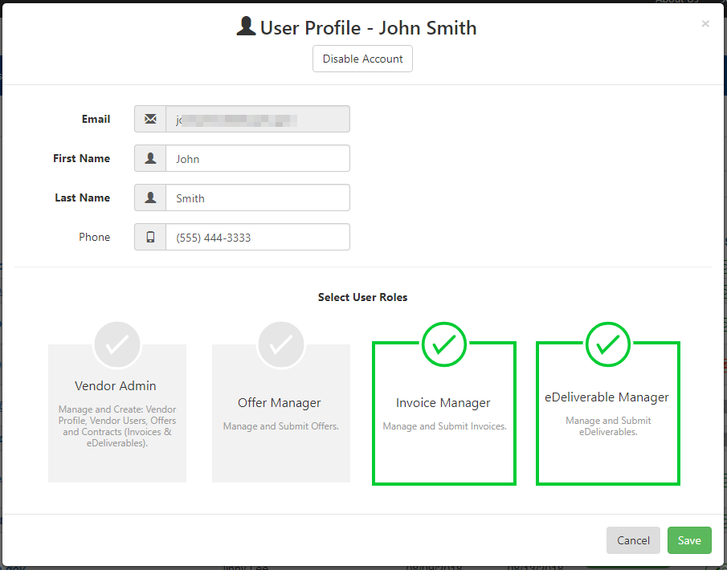

1. Click the ‘Save’ button to save changes.

## Disable/Enable a User account

1. On the ‘Vendor Users’ page, double click on a user account to modify.
2. At the top of the ‘User Profile’ window, the administrator can click the ‘Disable Account’ button to disable a user account if the account is currently active. Alternately, the administrator can click the ‘Enable Account’ button to enable a user account if the account is disabled.  
     
   The image below illustrates the location of the ‘Disable Account’ button

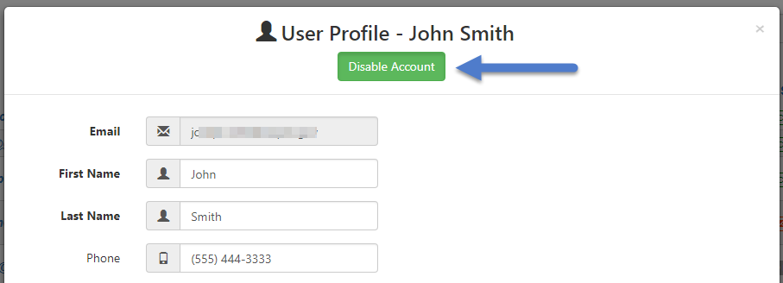

The image below illustrates the ‘Enable Account’ button

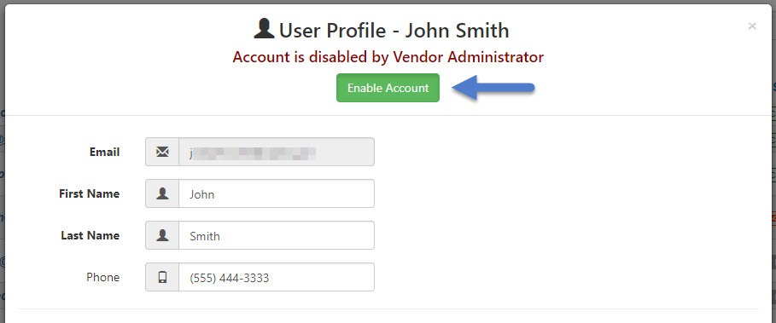

1. Click the ‘Save’ button to save changes.

## Delete a User account

1. On the ‘Vendor Users’ page, locate the user account that needs to be removed
2. Hover to the right of the status to the user, the ‘X’ button will be presented to delete the account.  
     
   The image below illustrates the red ‘X’ icon needed to delete the account



1. A warning message will display to confirm the action to delete the user.  
     
   The image below illustrates the warning message that will display when you attempt to delete a user

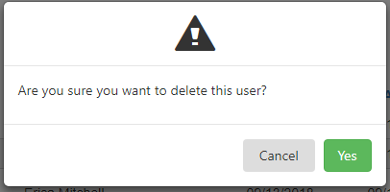

1. Click ‘Yes’ to delete the user from the vendor account. Click ‘Cancel’to abort the action.

## View Award Information

1. Click on the ‘Awards’ tab on the navigation bar to access the award information. The ‘Award’ tab lists a table of all awards for the vendor account, including ‘Award Number’, ‘Title’, ‘Award Type’, ‘Award Date’ and ‘State’.
2. Double click an award number of interest to access the information.  
     
   The image below illustrates the award information screen

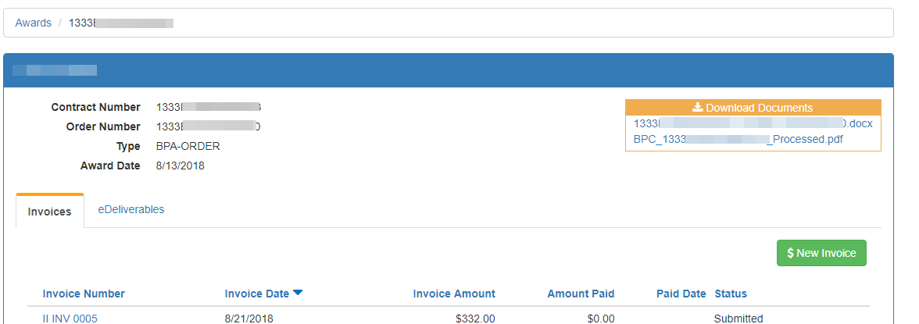

## View and Submit Invoices

1. Click on the ‘Awards’ tab on the navigation bar to access the award information.   
     
   The image below illustrates the ‘Awards’ tab

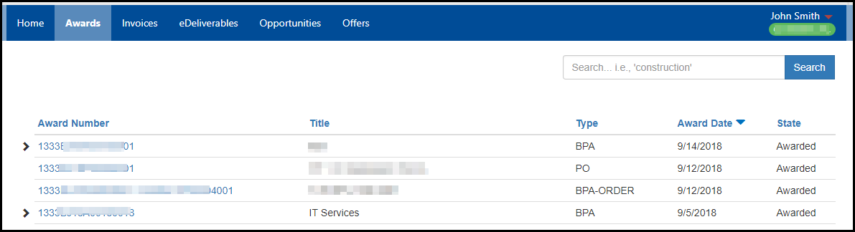

1. Double click an award number of interest to access the information. The ‘Invoices’ tab displays a table of all the invoices submitted for the award, including ‘Invoice Number’, ‘Invoice Date’, ‘Invoice Amount’, ‘Amount Paid’, ‘Paid Date’ and the ‘Status’.

The image below illustrates the ‘Invoices’ tab and the ‘$ New Invoice’ button

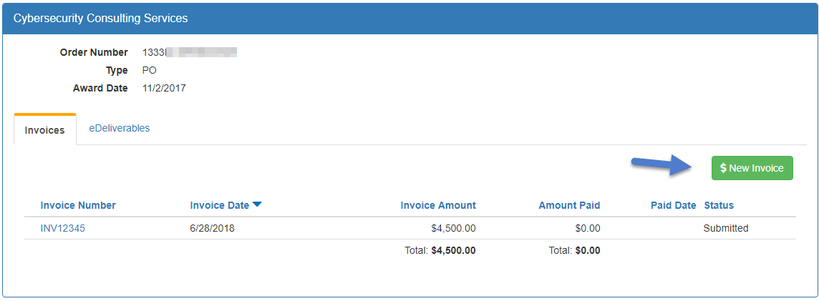

1. To submit a new invoice, click the ‘$ New Invoice’Use the $ New Invoice button to submit a new invoicebutton.

For more information about submitting invoices, visit Submit an Invoice

## View and Submit eDeliverables

1. Click on the ‘Awards’ tab on the navigation bar to access the award information.
2. Double click an award number of interest to access the information. The ‘eDeliverables’ tab displays a table of all the invoices submitted for the award, including eDeliverable Number, eDeliverable Date and Status.

The image below illustrates the ‘New eDeliverable’ button

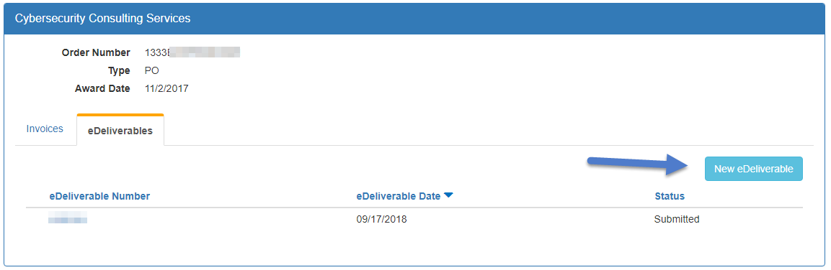

1. To submit a new eDeliverable, click the ‘New eDeliverable’ Use the 'New eDeliverable' button to submit a new eDeliverable button.

For more information about submitting eDeliverables, visit Submit an eDeliverable

PART THREE

I’m an eDeliverable Manager.

**What do I need to know?**

# Gray barSubmit an eDeliverable

To submit an eDeliverable through the Vendor Portal, the role of ‘Vendor Admin’ or ‘eDeliverable Manager’ must be associated to your profile (see ‘User Profile’ section).

1. Before submitting an eDeliverable action, it is important to locate the appropriate award or order to submit the eDeliverable for. These actions can be located by navigating to the ‘Awards’ tab.

The image below illustrates the ‘Awards’ tab location

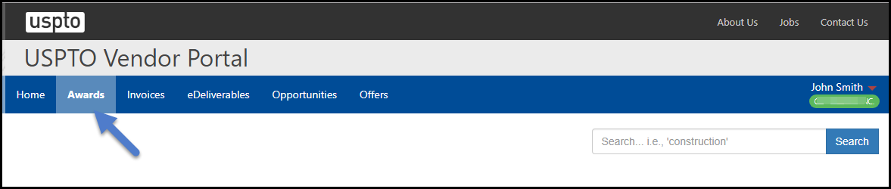

1. All modification and order actions associated with an award (i.e. BPA or IDV) can be located by using the arrow next to the action to drill down.   
     
   The image below shows the descending arrow button

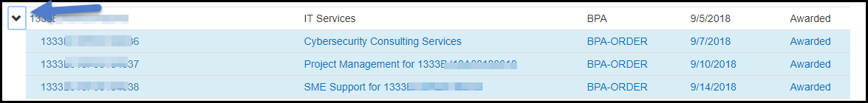

1. To proceed with submitting an eDeliverable action, click into the award or order action and navigate to the ‘eDeliverables’ tab.
2. Click on the ‘New eDeliverable’ button.  
     
   The image below illustrates the location of the ‘New eDeliverable’ button



1. In the eDeliverable creation screen, the vendor must enter a ‘Receipt Number’ and a ‘Receipt Date’. The ‘Receipt Number’ is a free from text field that accepts alpha numeric values and is a reference identification that the vendor organization can use to communicate with USPTO.   
     
   The image below illustrates the calendar available in the ‘Receipt Date’ section

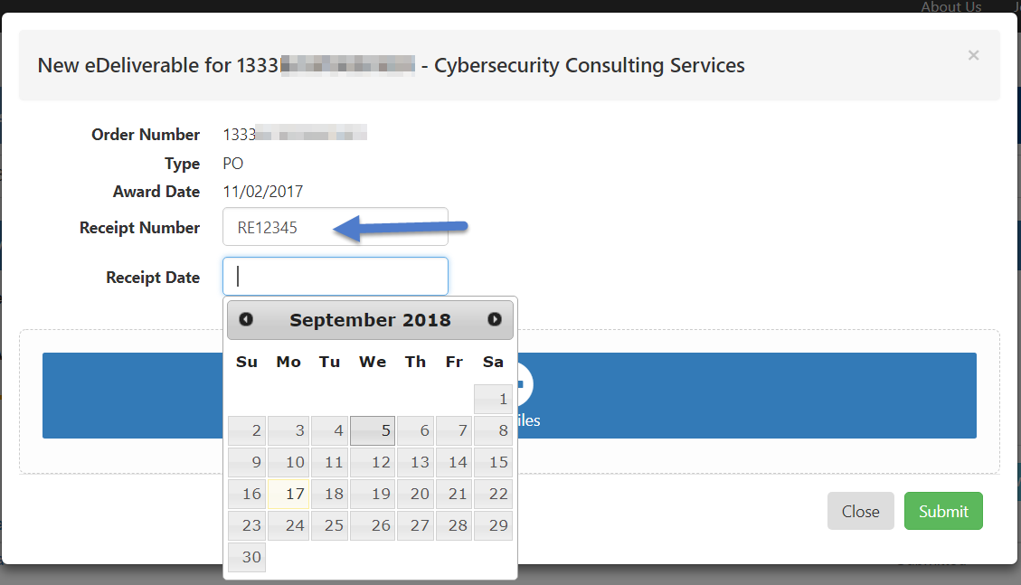

1. Click the ‘Add Files’ icon 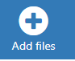 to upload any attachments. Select the appropriate file for upload from your computer. Once the file has been uploaded, click the ‘add tag’link to open thedropdown containing a list of meta data tags.  
     
   The image below illustrates the ‘add tag’ option

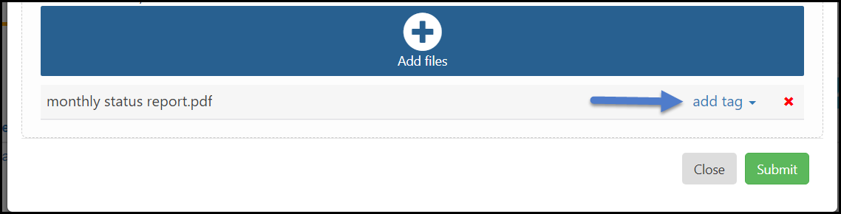

1. The appropriate tag should be selected from the dropdown list. **Note**: The ‘Contract Actual Deliverable’, ‘Detailed Plan’, ‘High Level Plan’ and ‘Schedule Template’ tags should only be used for files that will go through the USPTO Contractor Actuals validation process (see ‘Contract Actual Deliverable’ section for more information). The image below has an example of a monthly status report being delivered to USPTO. The attachment is tagged with the ‘Project Deliverable’tag.  
     
   The image below illustrates the tag options, in this case ‘Project Deliverable’ is selected

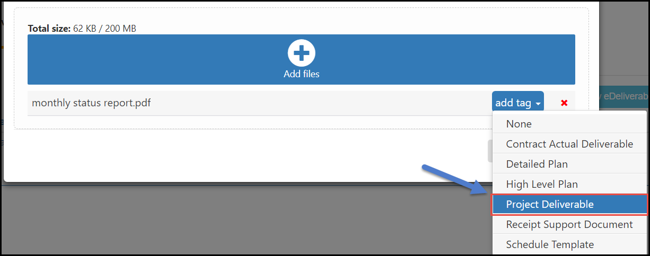

1. When the appropriate tag has been selected, click the ‘Submit’ button.  
     
   The image below illustrates the ‘Submit’ button location

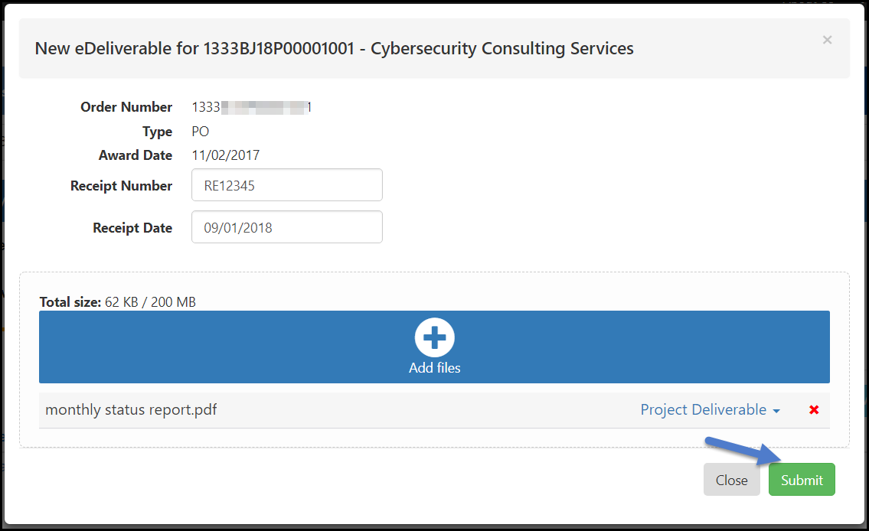

1. The below message will be returned upon successful submission.  
     
     
     
   The image below illustrates the ‘eDeliverable Submission Successful’ message



1. The ‘eDeliverables’ tab under the contract/order action will display all eDeliverable actions submitted for that contract/order.

Gray bar

# Submit a Contract Actuals File

To submit a Contractor Actuals (CA) deliverable through the Vendor Portal, follow the below steps.

**Note**: It is important to locate the **correct order** in which the Contract Actuals file should be submitted against. The existing USPTO Contractor Actuals (CA) template should be used to populate the appropriate data.

1. Complete the Contractor Actuals (CA) Template.
2. Locate the correct order in which the CA file(s) should be submitted against.
3. Navigate to the ‘eDeliverables’ tab within the order action.
4. Click the ‘New eDeliverable’ button.
5. Enter a ‘Receipt Number’ and select a ‘Receipt Date’.
6. Click the ‘Add Files’  button.
7. Upload the Contractor Actuals (CA) Template file.
8. Select the ‘Contract Actual Deliverable’ tag as show in the image below. **Note**: If this tag is not selected the file will not be routed through the validation process.

Below is an image of the ‘Contract Actual Deliverable’ tag

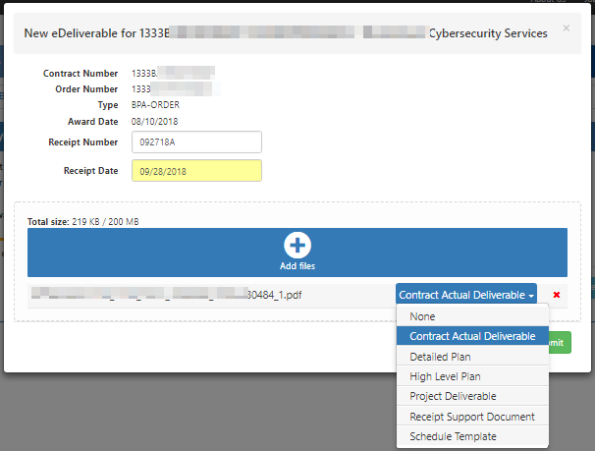

1. Click the ‘Submit’ button.
2. Upon submission, the vendor user will be routed to the ‘eDeliverable’ tab of the order action.
3. The validation status of ‘Passed’ or ‘Failed’ will be visible after submission.   
     
   The image below illustrates the validation status, in this case it was ‘Failed’

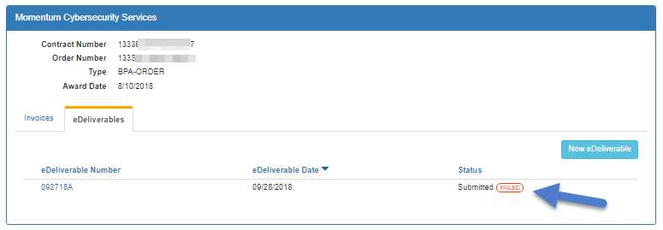

1. Click into the eDeliverable action to view the ‘Contract Actual Validation .pdf’  
     
   The image below illustrates the ‘Contract Actual Validation.pdf’ file

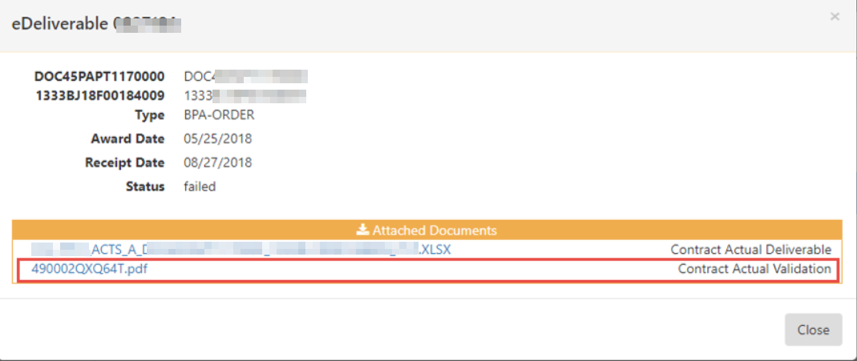

1. If the validation status is ‘Failed’, open the ‘Contract Actual Validation’ file to review the errors.

The image below illustrates the PDF file with the errors described

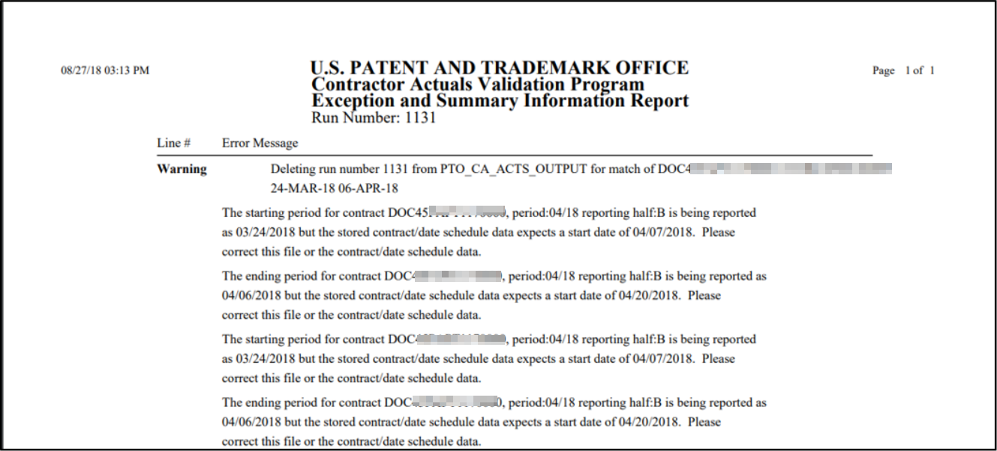

1. If the validation status is ‘Failed’, the Contract Actuals (CA) file will need to be corrected and resubmitted (repeat steps 1-10).

**Note:** The Contract Actuals A and B files must be submitted monthly and pass validation upon submission. Please reach out to the [MomentumHelpdesk@uspto.gov](mailto:MomentumHelpdesk@uspto.gov) for validation or submission errors.

PART FOUR

I’m an Invoice Manager

**What do I need to know?**

# Gray barSubmit an Invoice

To initiate the invoicing process, it is important to locate the order (task order, deliver order, or BPA Call) that the invoice should be submitted against. **Note**: An invoice should not be submitted against a base award or modification action.

The image below illustrates the difference between a Base Award and an Order

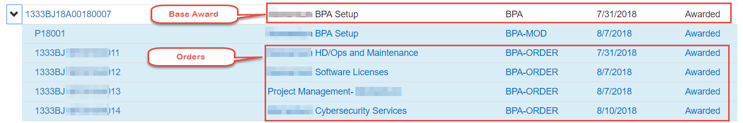

1. To access the order, click into the action. Once accessed, the ‘Invoices’ tab will be displayed.   
     
   The image below illustrates the ‘Invoices’ tab and the ‘$ New Invoice’ button

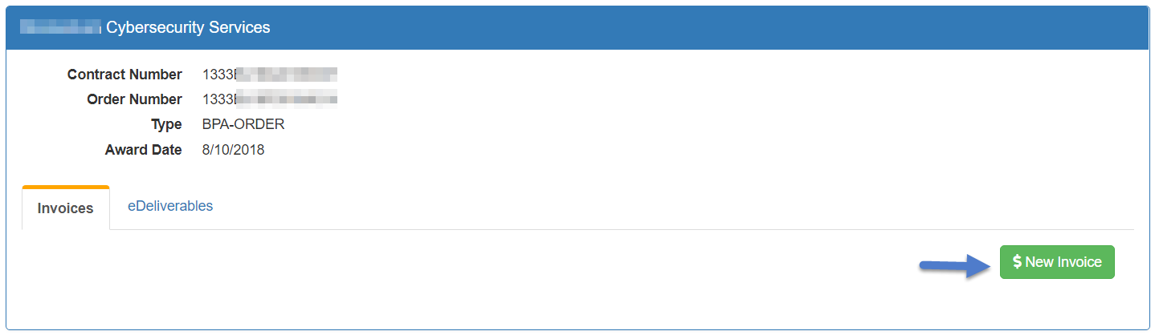

1. Click the ‘New Invoice’ button to initiate the invoice creation.
2. On the ‘Invoice Creation’ screen, enter an ‘Invoice Number’, ‘Invoice Date’, ‘Performance Start’, and ‘Performance End’. **Note**: Please enter the applicable ‘Performance Start’ and ‘Performance End’ dates as outlined by the contract.

The image below illustrates a ‘New Invoice’ screen

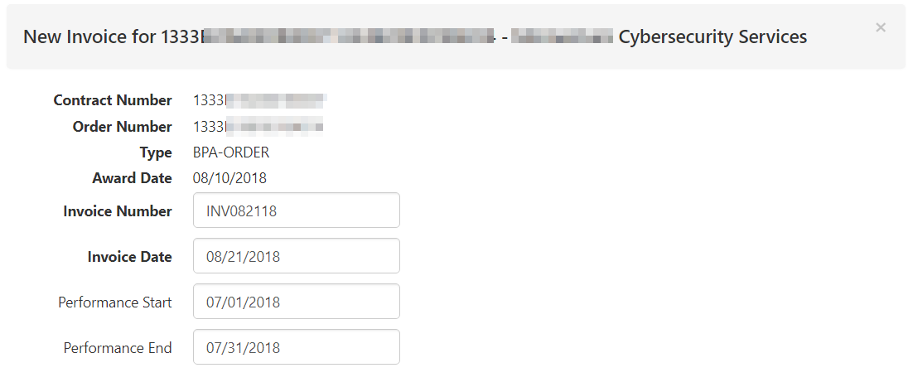

1. In the ‘Items’ section, the PPA data can be entered by clicking the ‘Plus’ button The image illustrates a 'New Invoice' screen next to the item number. **Note:** If submitting a Contractor Actuals (CA) Invoice template, PPA information should **not** be entered directly in the Vendor Portal.
2. The ‘PPA Description’, ‘PPA Code’, and ‘Amount’ should be populated. **Note**: Multiple PPA code entries can be entered under a single line item. For questions regarding PPA code information and what to use on the invoice, please reach out to the Contracting Officer’s Representative (COR).

The image below illustrates the ‘PPA Description’, ‘PPA Code’, and ‘Amount’ values

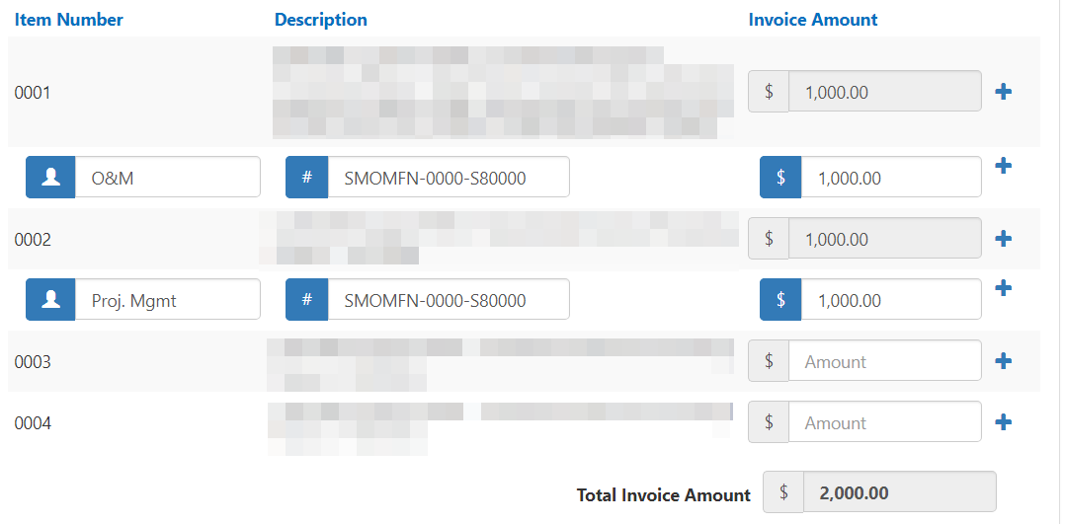

1. Click on the ‘Add Files’ button 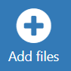 to upload the invoice document (.pdf, .xlsx, .docx) and select the file from your computer. When the file is uploaded, click the ‘add tag’ dropdown and select the ‘Invoice’ tag. Proper tagging will ensure that the invoice is transmitted to USPTO in a timely and efficient manner.   
     
   The image below illustrates the ‘add tag’ button

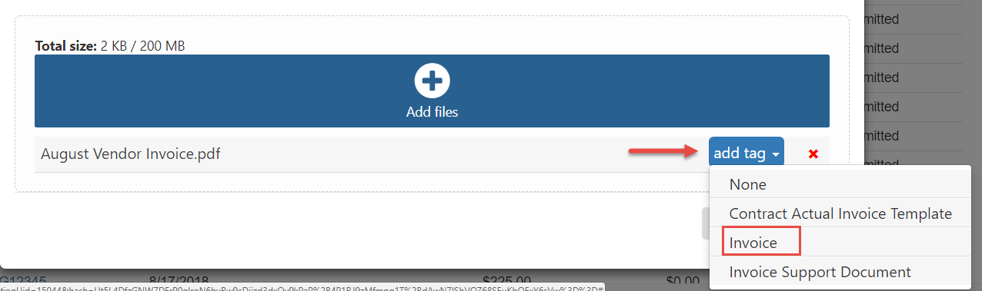

1. When all information has been entered accurately, click the ‘Submit’ button at the bottom right of the screen.

The image below illustrates the ‘Submit’ button at the bottom of the screen

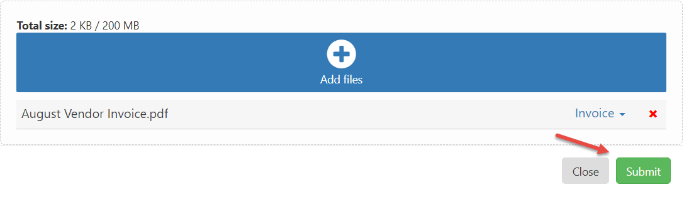

# Gray barSubmit a Contractor Actuals (CA) Invoice & Invoice Template

The Vendor Portal supports submission of the Contractor Actuals Invoice Template by any user with the ‘Invoice Manager’ role or the ‘Master Admin’ role. Once submitted, the template will be validated for accuracy and the results of the validation will be displayed for the vendor.

To submit a ‘Contractor Invoice Template’, please follow the below guidance.

1. Complete the ‘Contractor Actuals Invoice Template’ prior to submission in Vendor Portal.

The image below illustrates an example of the ‘Contractor Invoice Template’

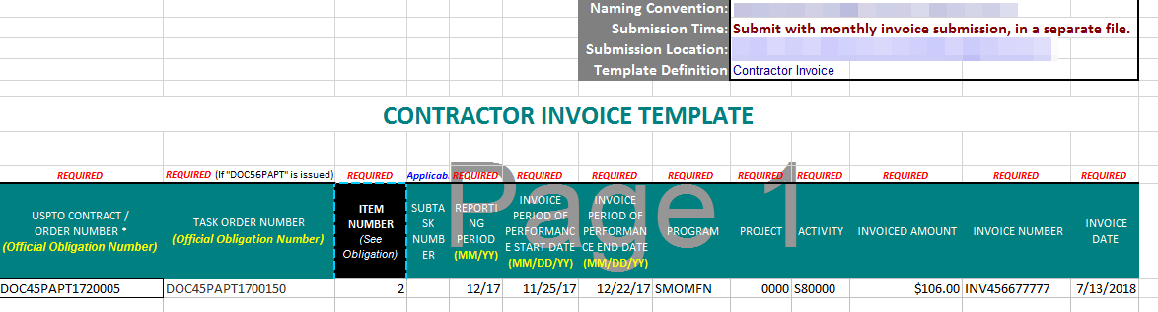

1. Locate the order action in Vendor Portal (task order, delivery order, BPA call) that the ‘Contractor Invoice Template’ should be submitted against. The PIID can be used as the identifier.
2. Click the ‘New Invoice’ button to create the new invoice action.
3. On the ‘Invoice Creation’ screen, enter the ‘Invoice Number’, ‘Invoice Date’, ‘Performance Start’, and ‘Performance End’ dates. **Note**: These values should match the information entered in the ‘Contractor Invoice Template’.   
     
   The image below illustrates the ‘New Invoice’ screen

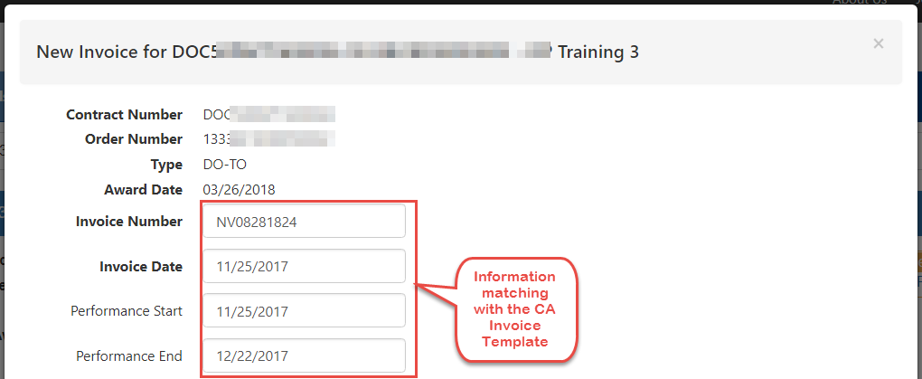

1. In the ‘Items’ section, enter the ‘Invoice Amount’ next to each applicable item number. **Note**: PPA code information should **not** be entered directly in Vendor Portal if the ‘Contractor Invoice Template’ is being submitted.

The image below illustrates the fields available for ‘Invoice Amount’

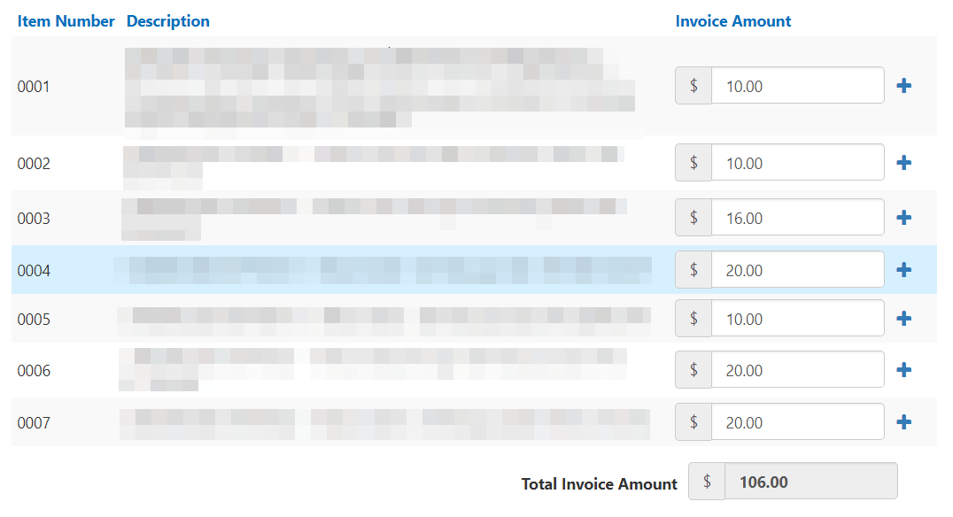

1. To upload the ‘Contractor Invoice Template’, click the ‘Add Files’  button. Once uploaded, click the ‘add tag’ dropdown and select ‘Contract Actual Invoice Template’. **Note**: The file will need to be tagged correctly to ensure it goes through the validation process.  
     
   The image below illustrates the ‘add tag’ button and the options available

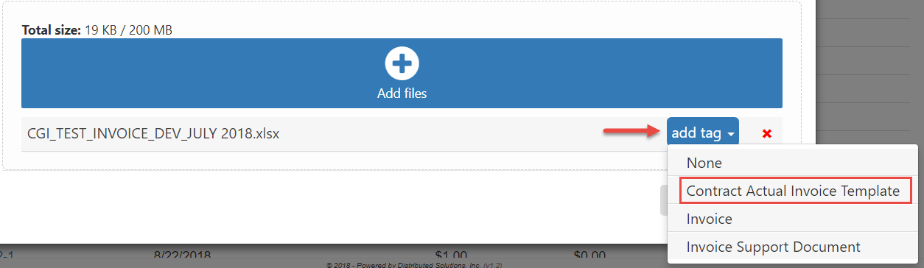

1. To upload an additional file(s), such as the ‘Invoice .pdf’, click the ‘Add Files’  button. Once uploaded, click the ‘add tag’ dropdown and select ‘Invoice’.

The image below illustrates the ‘add tag’ button and the options available

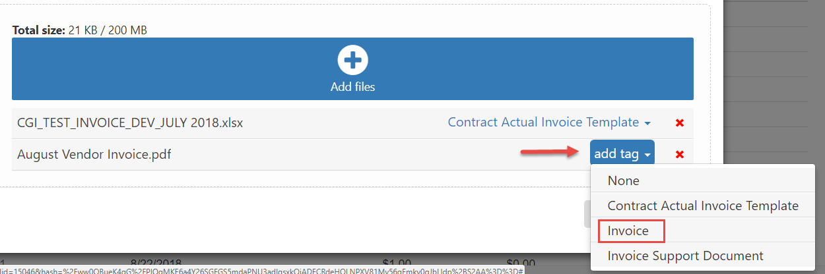

1. Click the ‘Submit’ Submit button button when all information has been entered and all files have been uploaded.
2. When the validation is complete, a status of ‘Passed’ or ‘Failed’ is returned.   
     
   The image below illustrates the validation status, in this example it has ‘PASSED’

The image illustrates the validation status, in this example it has 'PASSED'

1. To view a summary of the submission, click into the invoice action that was created (i.e. INV08281824) by clicking on the invoice number.

The ‘Contract Actual Validation’ file should be viewed to confirm results of the validation. If a status of ‘*Failed*’ is returned, the file will list all errors that caused the validation to fail. The errors will need to be corrected and the file will need to be resubmitted by repeating Steps 1-8.

The image below illustrates the ‘Contract Actual Validation .pdf’ file

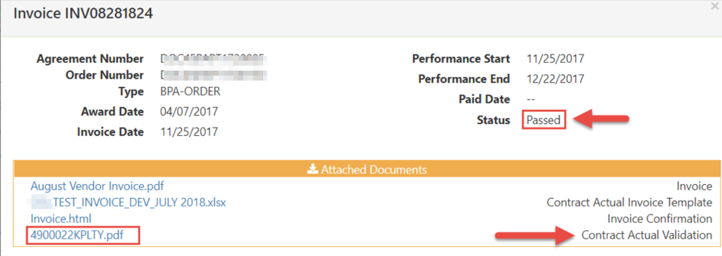

The ‘Invoice Confirmation´ file provides an outline of the invoice submission that includes ‘Invoice Date’, ‘Performance Start’, ‘Performance End’ and ‘Amount Invoiced’ against specific line items. This file is generated in .html and can be saved for your records.

The image below illustrates an example of the ‘Invoice Confirmation’ file

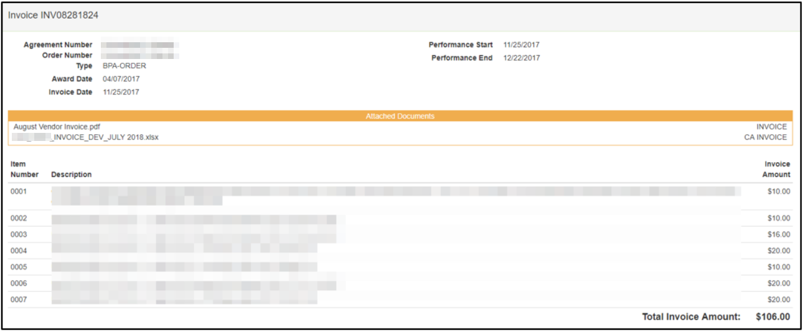

# Gray barView & Search for previously Submitted Invoices

Invoices that have been submitted via the Vendor Portal will be permanently archived for easy lookup and reference. The ‘Invoices’ tab contains a detailed view of all invoices submitted by the vendor, including the ‘Invoice Number’, ‘Amount’, ‘Status’, and associated payment information.

The image below illustrates the ‘Invoices’ tab

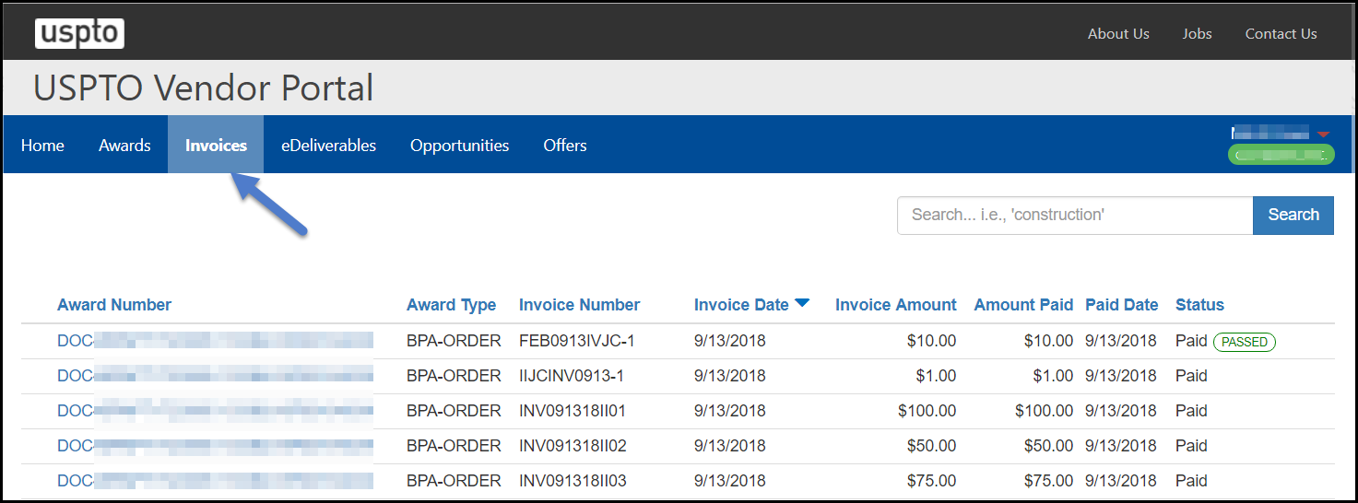

A specific invoice action can be located by entering the invoice number in the search box.

The image below illustrates an invoice number in the search box

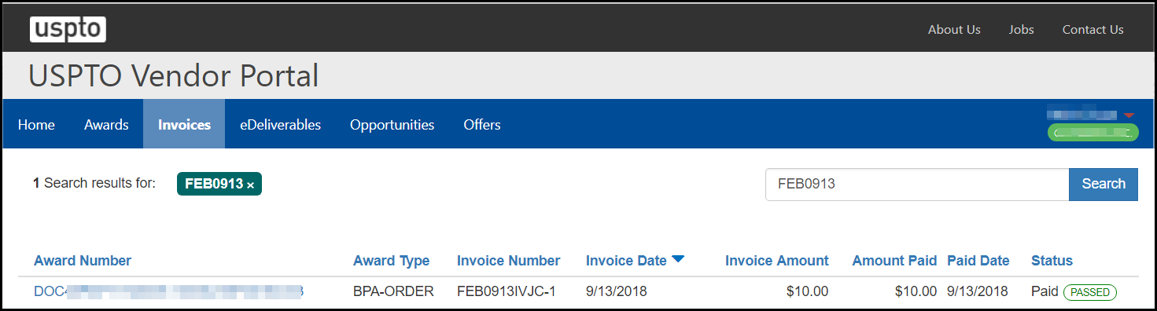

Click on the returned result. This will display a summary of the invoice submission, including attached documents.

The image below illustrates a summary of the invoice submission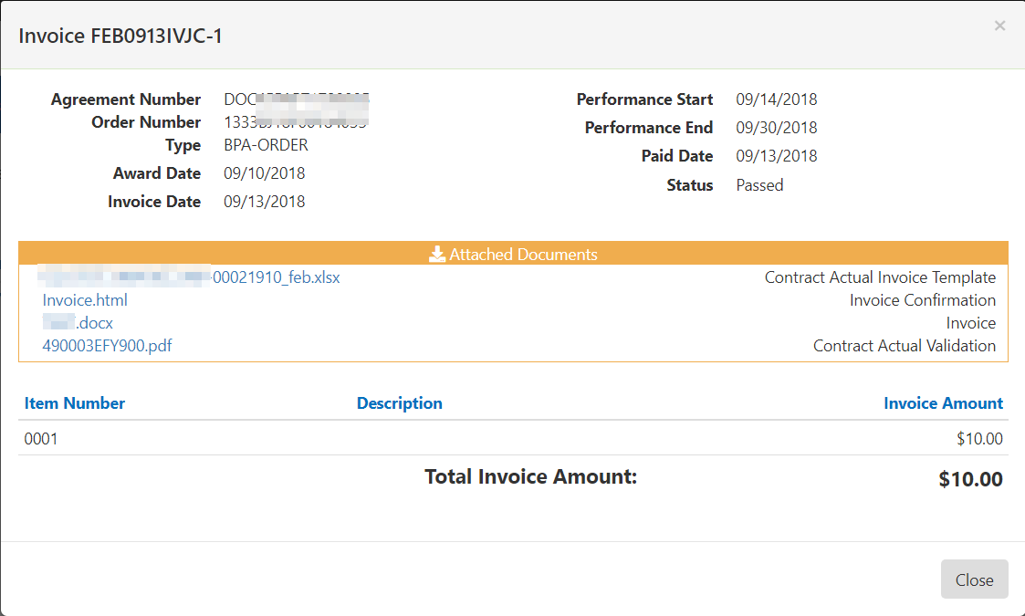

# Gray barView Payment status

When a payment is made on the invoice, the status will update to ‘Paid’. The ‘Amount Paid’ and ‘Paid Date’ will also be reflected.

The image below illustrates the ‘Invoices’ tab and applicable values for each invoice

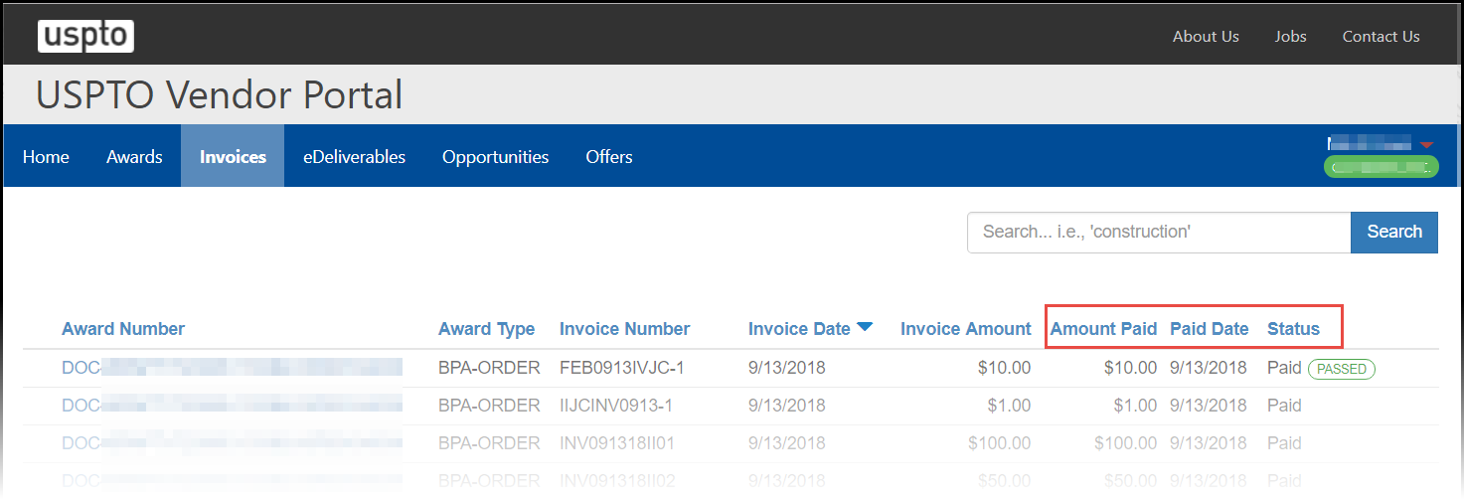

# Gray boxContact Us

We’d love to hear from you! Your questions and comments about Vendor Portal help us make improvements that enhance user experience.

* For **more information** on Vendor Portal, visit us online athttps://www.uspto.gov/about-us/vendor-information/vendor-portal-information
* For **technical support or questions** about Vendor, give us a call or send us an email.
  + [VendorPortalHelp@USPTO.gov](mailto:MomentumHelpDesk@USPTO.gov)
* For questions related to Invoices, eDeliverables and Awards; please contact the USPTO Contracting Office personnel or the Contracting Officer Representative (COR) named on the award